**LAB FILE REPORT**

Final Record

for

CSE3502-Information Security Management

**

*Submitted by*

**Aryaman Mishra-19BCE1027**

*To*

**Dr.Ayesha SK**

**BACHELOR OF TECHNOLOGY**

*in*

**COMPUTER SCIENCE AND ENGINEERING**



April 2022

**Table of contents**

**Content Page no.**

* Lab 1:CPT…………………………………………………………..3
* Lab 2:Encryption………………………….......................................20
* Lab 3:ACL………………………………………………………….22
* Lab 4:VLAN…………………………………..................................39
* Lab 5:VPN………………………..………………………………..70
* Lab 6:NAT……………..…………………………………………..79
* Lab 7:Firewall………….…………………………………………..111
* Lab 8: Burpsuite Configuration…..……….………………………..122
* Lab 9:Bruteforce Attack Burpsuite……………..…………………134
* Lab 10:DVWA Bruteforce………………………………………..154
* Lab 11:Information Hiding Tool…………………………………166
* Lab 12:Exploring Information Auditing Tool……………………176

**LAB 1**

**Aryaman Mishra**

**19BCE1027**

**LAB 1**

**AIM:**Create Topology in Cisco Packet Tracer and implement Static and RIP Protocol for Packet Transfer.

**Tools Used**:Cisco Packet Tracer.

**Experiment:**

Create Topology.

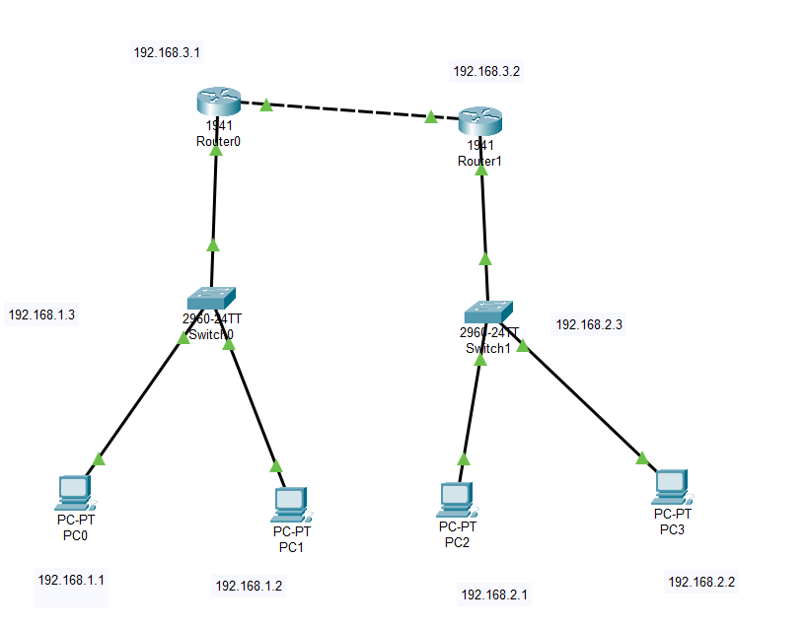

Configure IP Address and Default Gateway Configuration for the 4 PC Devices.

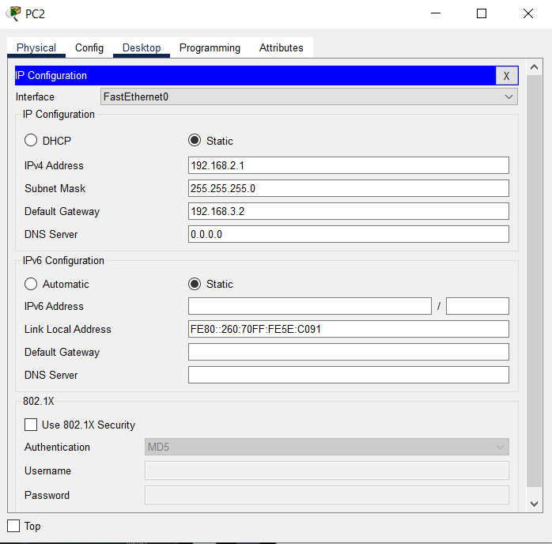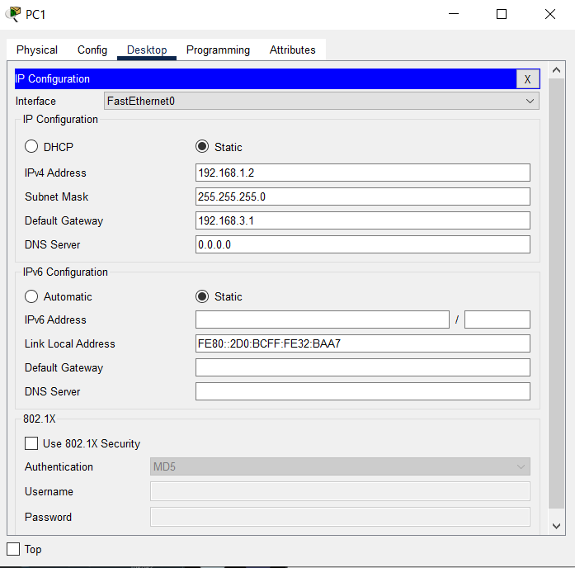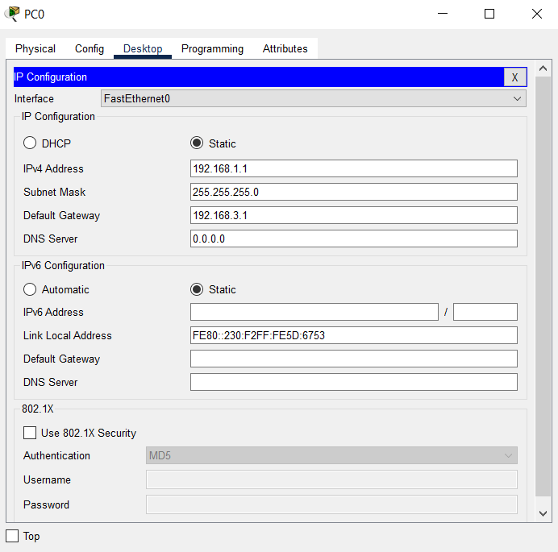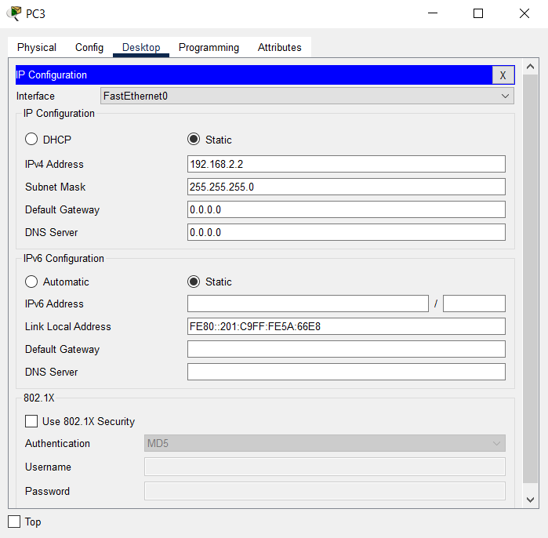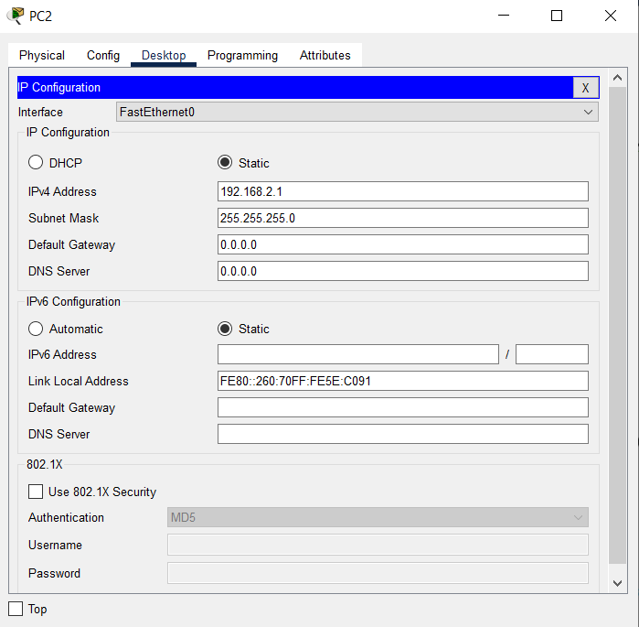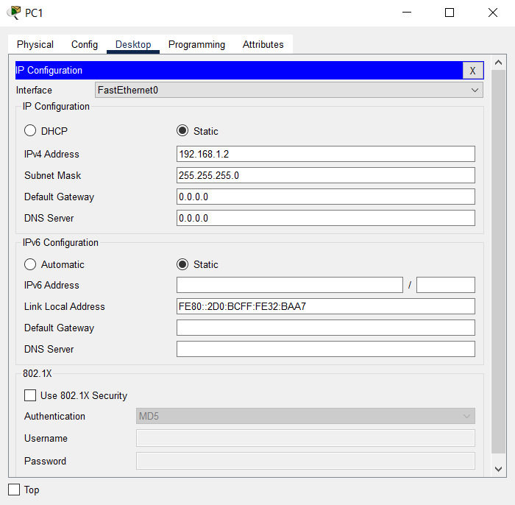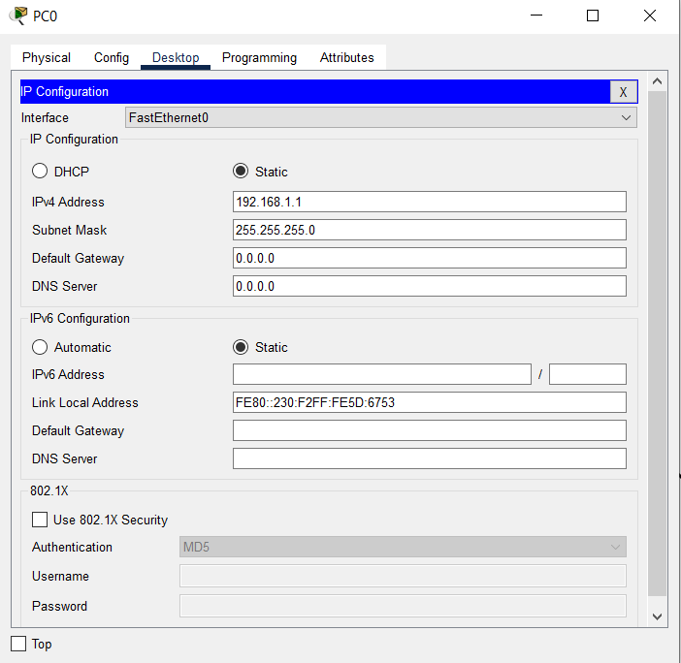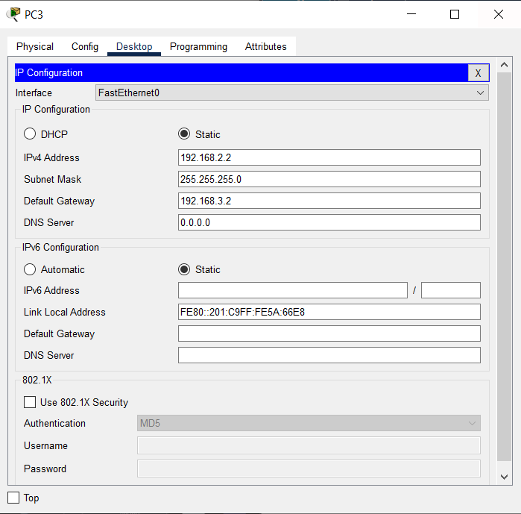

Assign IPv4 Address,Ports and Subnets of Routers.

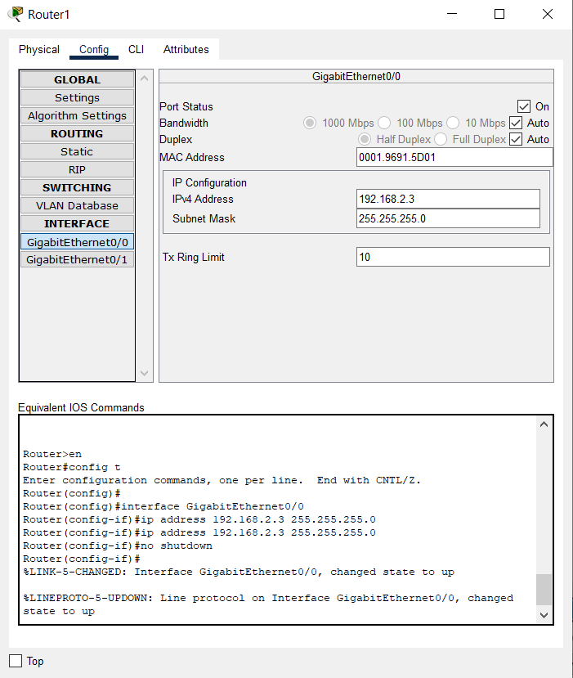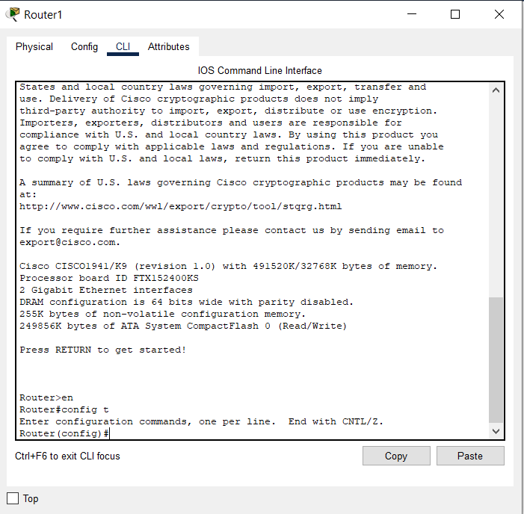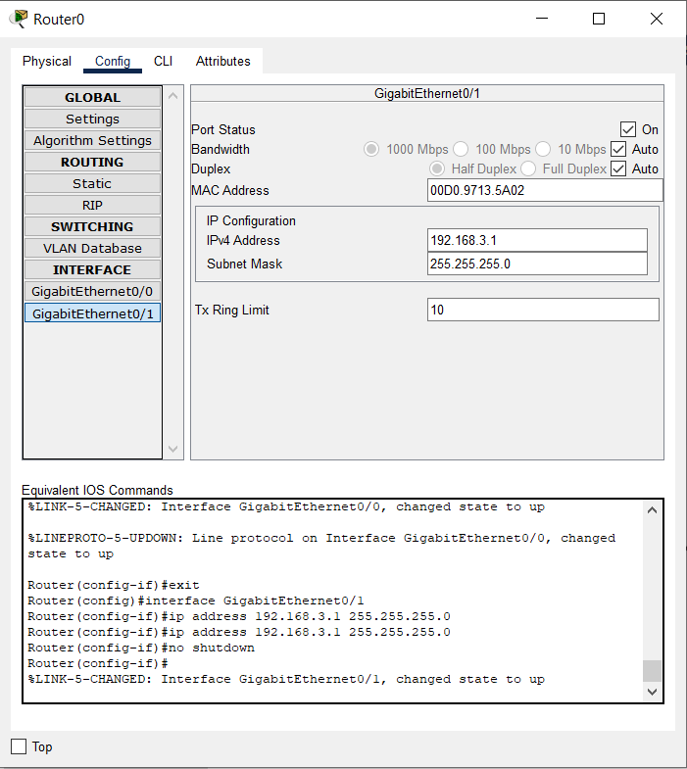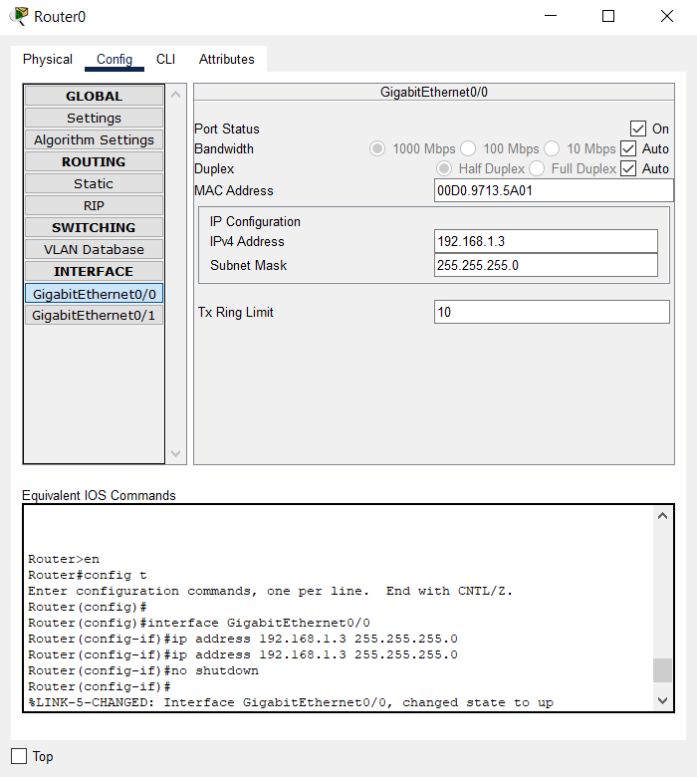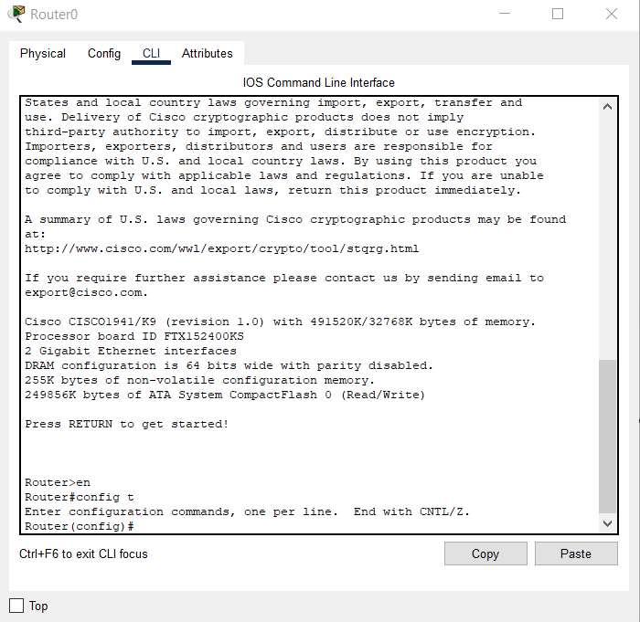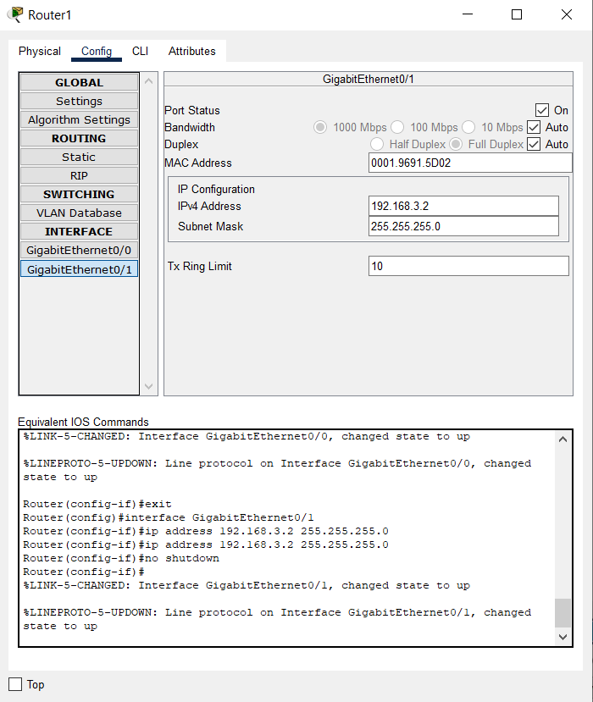

Assign Static and RIP routes for Router0 and Router1.

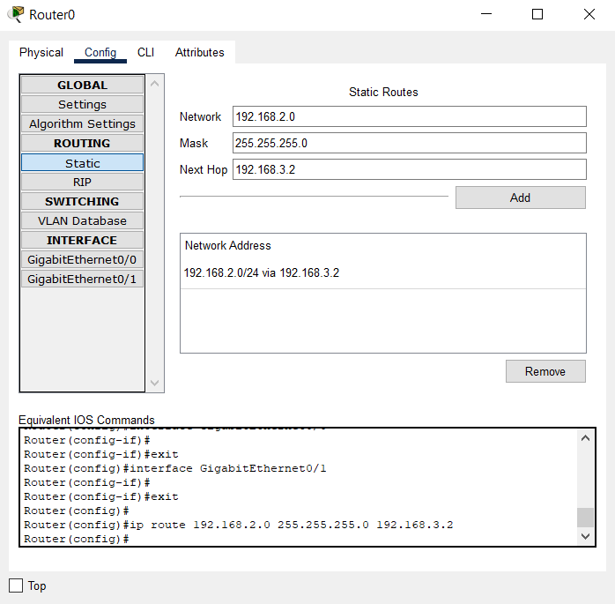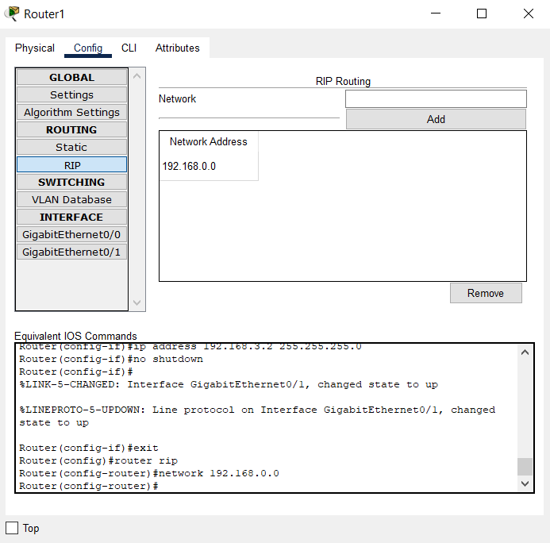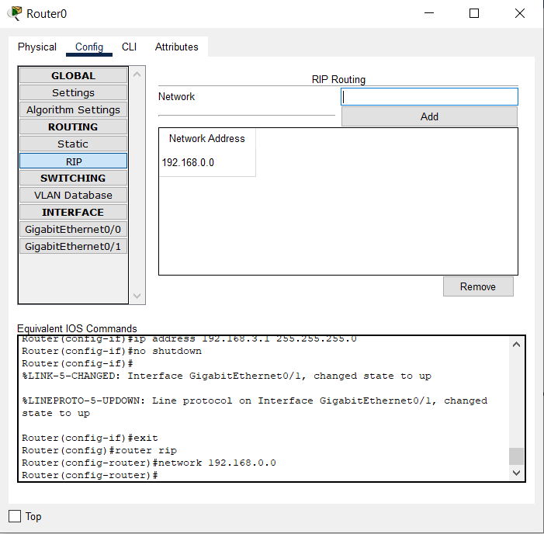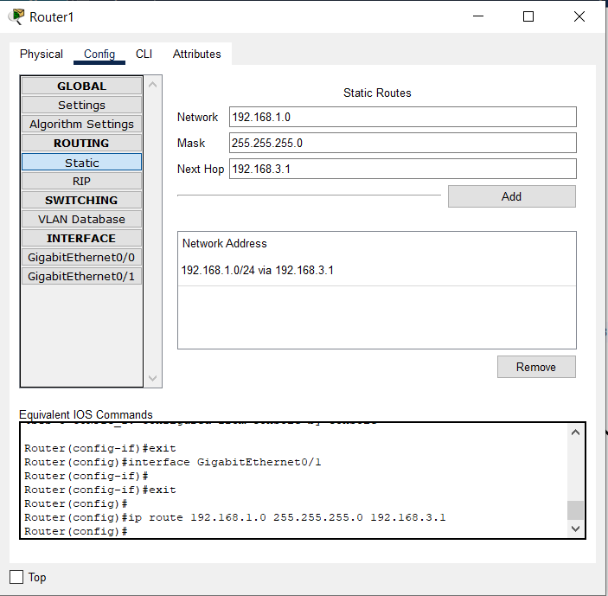

**Observation:**

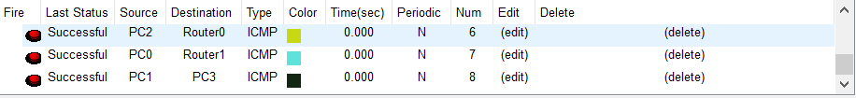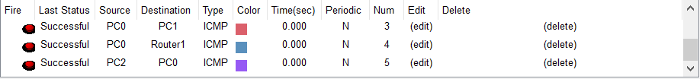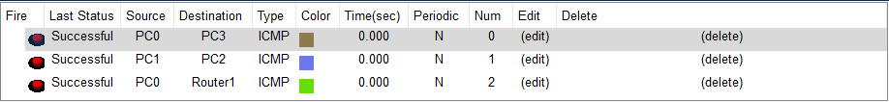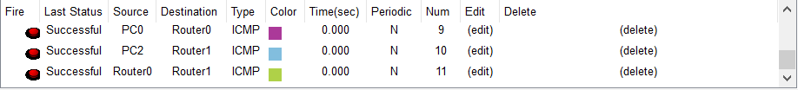

**Conclusion**:Topology has been successfully created and executed.

**LAB 2**

**Aryaman Mishra**

**19BCE1027**

**Experiment 2**

Aim: Implement caeser cipher encryption technique for a **text file** or audio file.

**Code:**

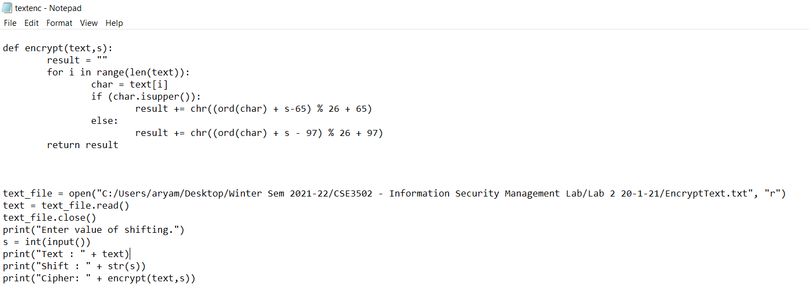

def encrypt(text,s):

result = ""

for i in range(len(text)):

char = text[i]

if (char.isupper()):

result += chr((ord(char) + s-65) % 26 + 65)

else:

result += chr((ord(char) + s - 97) % 26 + 97)

return result

text_file = open("C:/Users/aryam/Desktop/Winter Sem 2021-22/CSE3502 - Information Security Management Lab/Lab 2 20-1-21/EncryptText.txt", "r")

text = text_file.read()

text_file.close()

print("Enter value of shifting.")

s = int(input())

print("Text : " + text)

print("Shift : " + str(s))

print("Cipher: " + encrypt(text,s))

**Output:**

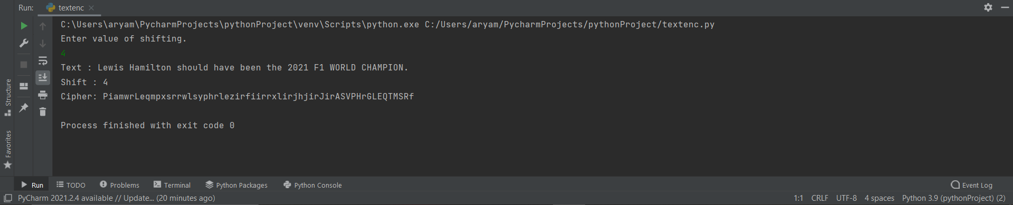

**Conclusion:**

Cipher for Text file has been successfully implemented for a text file and output for text file containing “Lewis Hamilton should have been the 2021 WORLD CHAMPION” is denoted in output screenshot.

**LAB 3**

**Aryaman Mishra**

**19BCE1027**

**EXPERIMENT 3:ACCESS CONTROL LISTS**

**Topology**

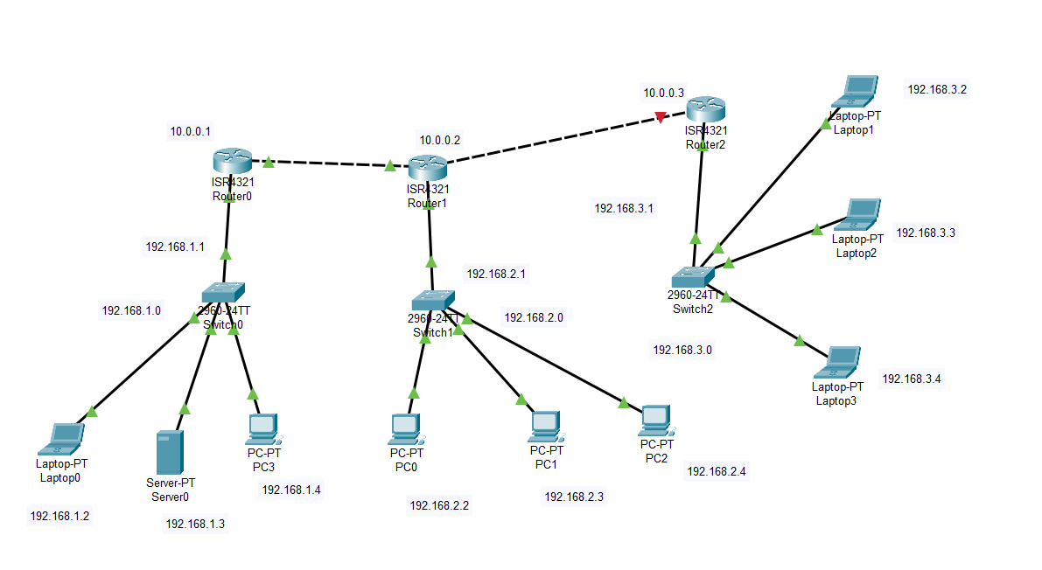

**System Configurations**

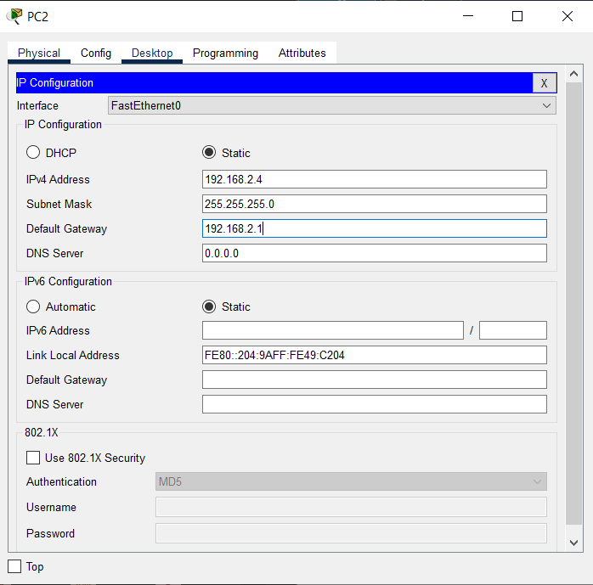

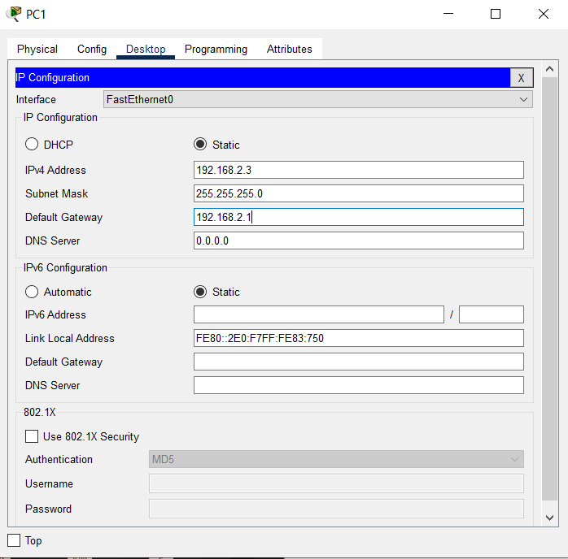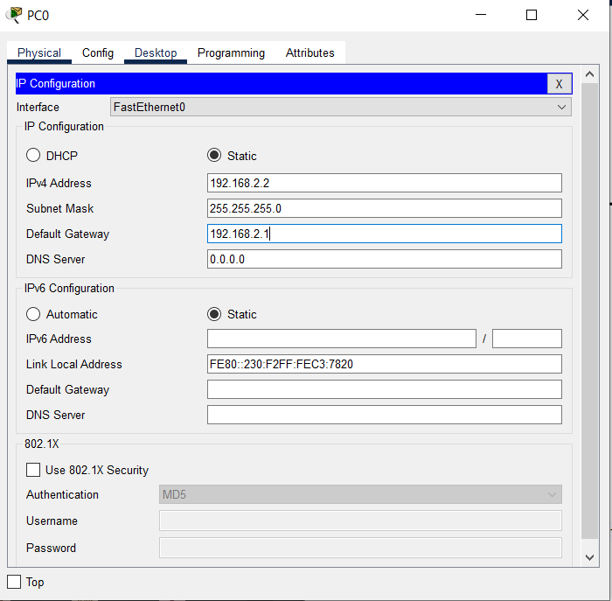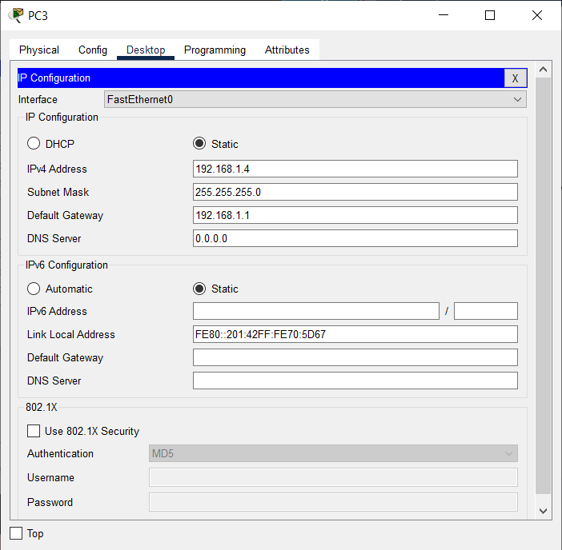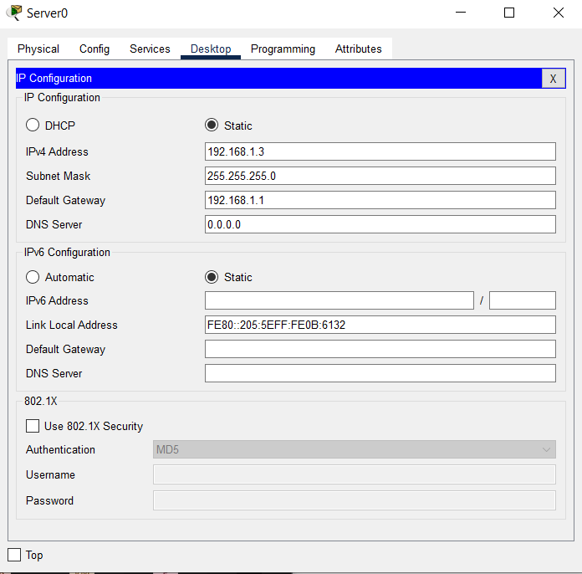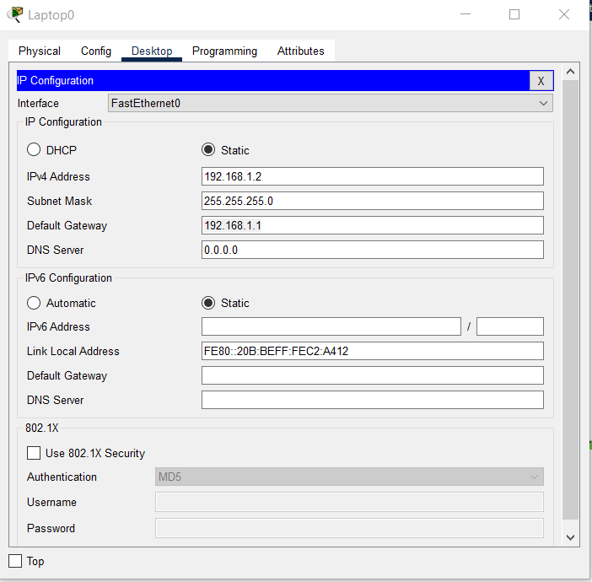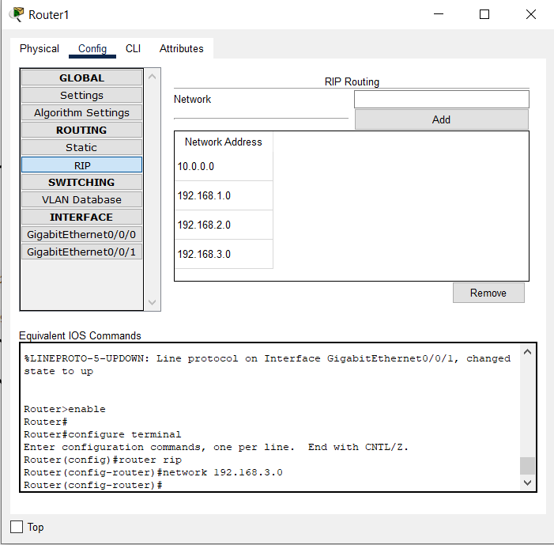

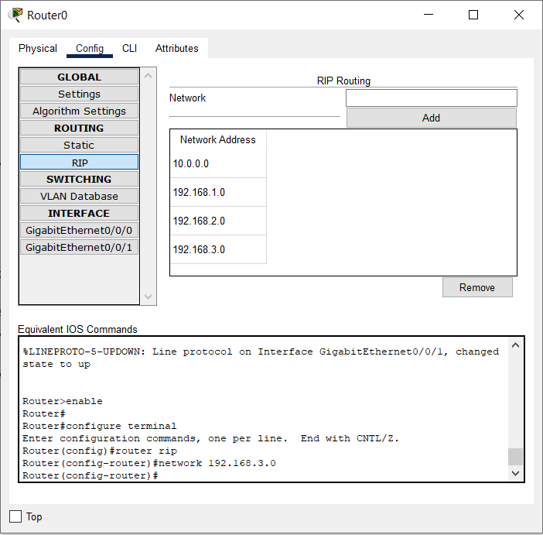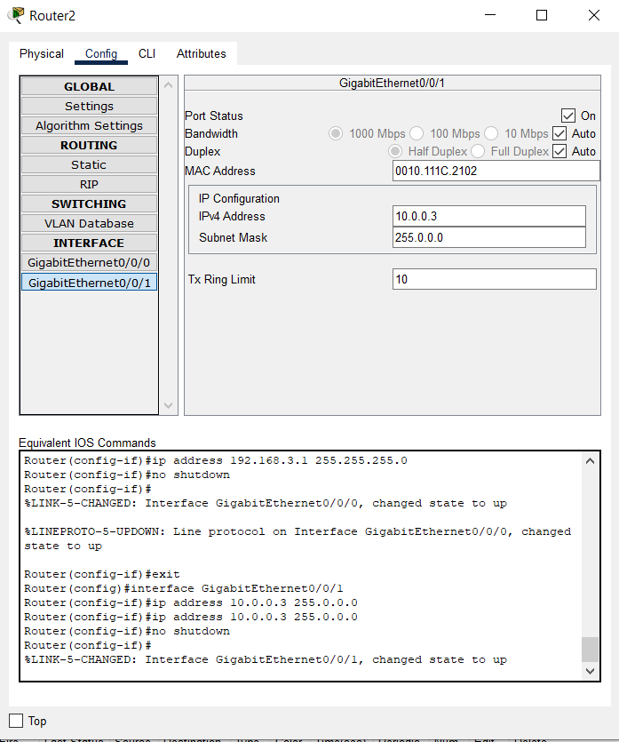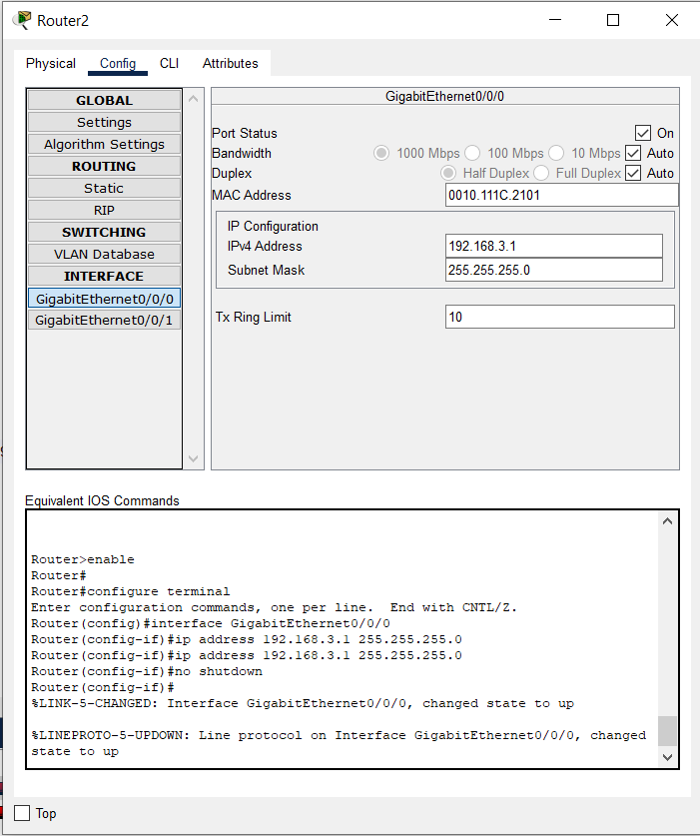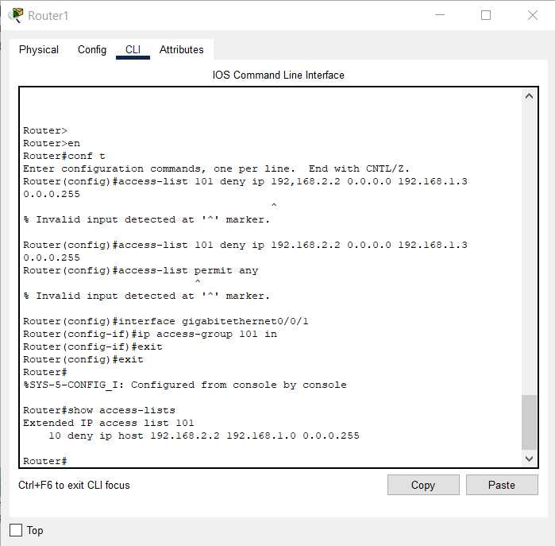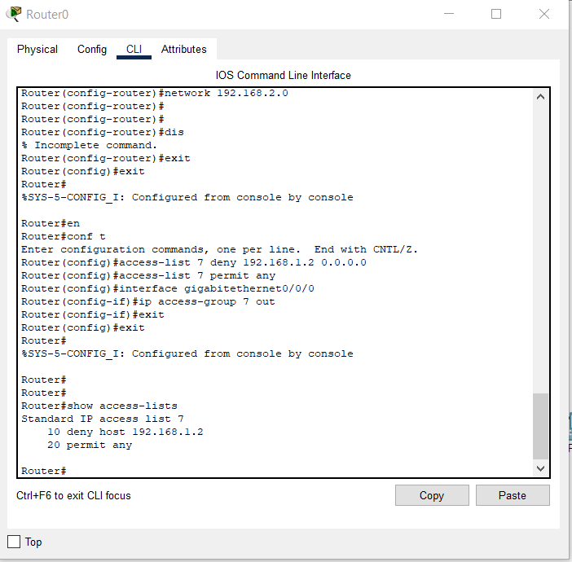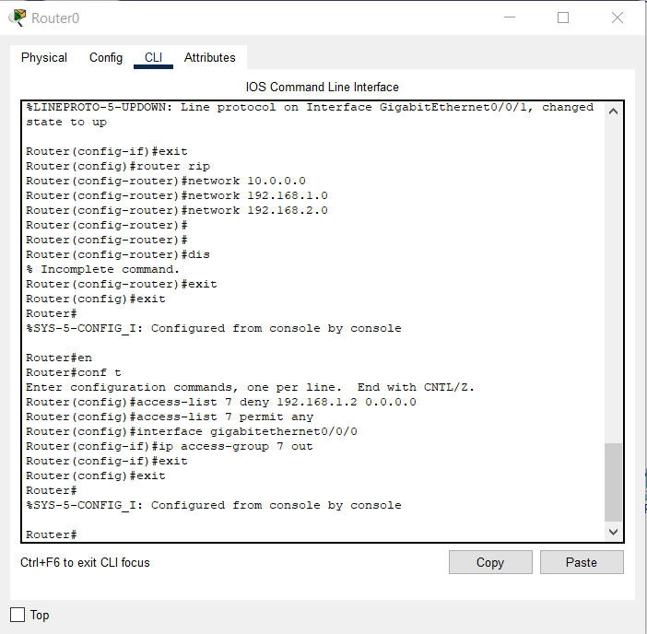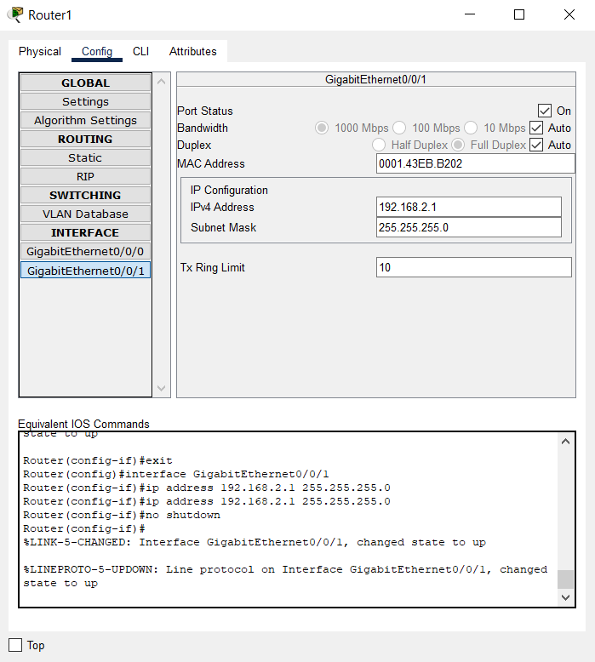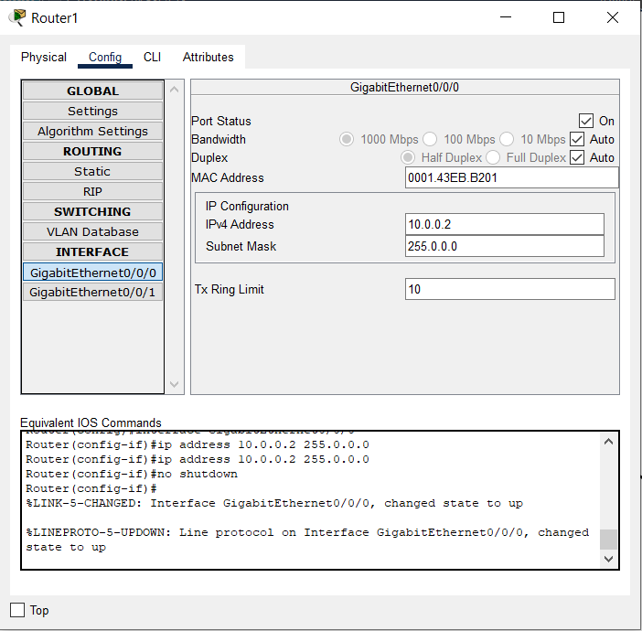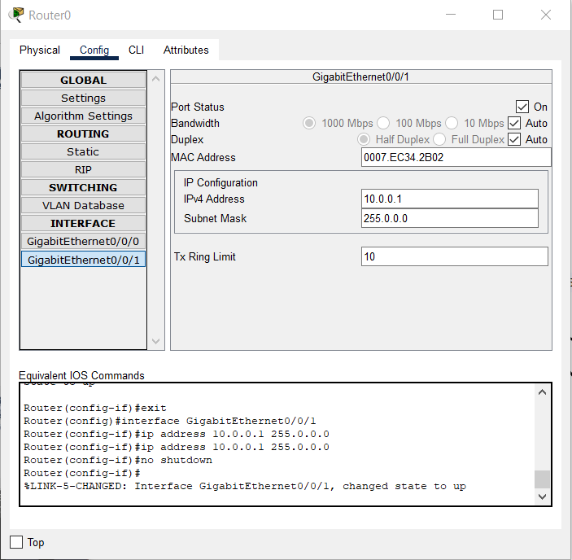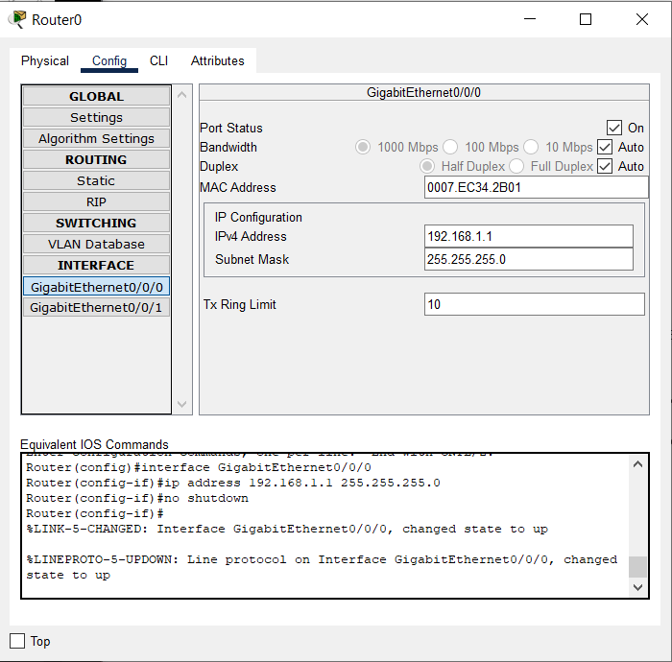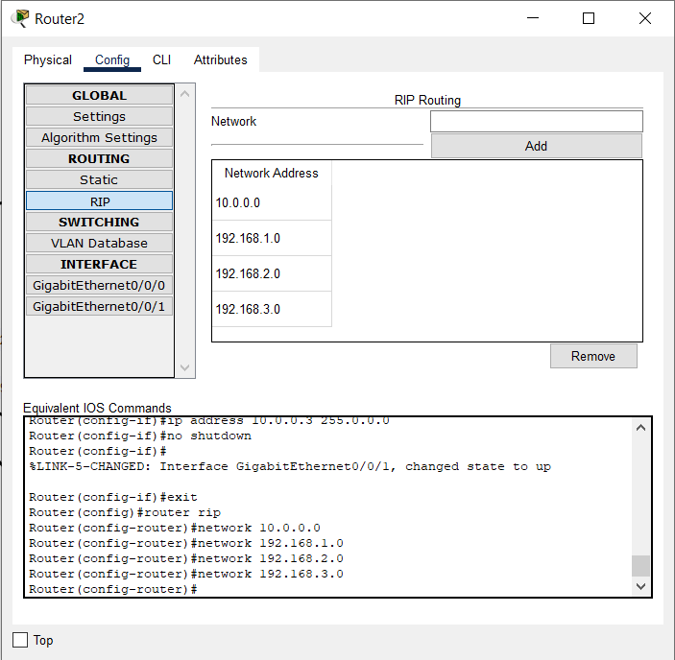

**Results:**

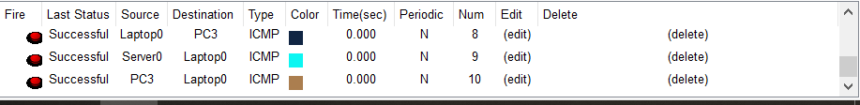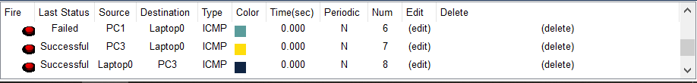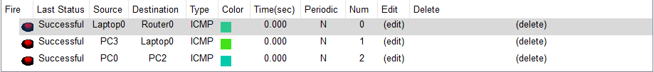

**Inference:**

Access Control Lists (ACL) are used to filter network traffic on Cisco routers. In order to filter network traffic, ACLs control if routed packets have to be forwarded or blocked at the ingress or egress router interface. The router checks each packet to determine whether to forward or drop the packet based on the criteria specified in the ACL applied to the interface.

IP ACL types

Two types of IP ACL can be configured in Cisco Packet Tracer 7.2 :

* Standard ACLs : This is the oldest ACL type which can be configured on Cisco routers. Traffic is filtered based on the source IP address of IP packets. The access-list number can be any number from 1 to 99. This kind of ACL has to be placed near the destination to avoid blocking legitimate trafic from the source.

access-list 1 permit 10.2.25.0 0.0.0.255  
access-list 1 deny any

* Extended ACLs : Introduced in IOS version 8.3, the extended ACLs are more complex and allow filtering of the IP traffic based on a combination of multiple criterias : source IP address, destination IP address, TCP or UDP port, protocol, .... In numbered ACLs, the access-list number can be any number from 100 to 199 or 2000 to 2699 (available in IOS versions >12.0.1). Such ACLs can also be named access lists in which the ACL number is replaced by a keyword. This kind of ACL has to be placed near the source as it allows fine grained control to ressources accessed. Placing the ACL near the destination will make the trafic travel through the network before beeing blocked, resulting in bandwidth waste.

access-list 1 permit ip 10.2.25.0 0.0.0.255 10.1.0.0 0.0.255.255  
access-list 101 permit icmp any 10.1.0.0 0.0.255.255 echo  
access-list 1 deny ip any any

A wildcard mask is a [mask](https://en.wikipedia.org/wiki/Mask_(computing)) of [bits](https://en.wikipedia.org/wiki/Bit) that indicates which parts of an [IP address](https://en.wikipedia.org/wiki/IP_address) are available for examination. In the [Cisco IOS](https://en.wikipedia.org/wiki/Cisco_IOS), they are used in several places, for example:

* To indicate the size of a network or subnet for some routing protocols, such as [OSPF](https://en.wikipedia.org/wiki/OSPF).
* To indicate what IP addresses should be permitted or denied in [access control lists](https://en.wikipedia.org/wiki/Access_control_list) (ACLs).

A wildcard mask can be thought of as an inverted [subnet mask](https://en.wikipedia.org/wiki/Subnet_mask). For example, a subnet mask of 255.255.255.0 (binary equivalent = 11111111.11111111.11111111.00000000) inverts to a wildcard mask of 0.0.0.255 (binary equivalent = 00000000.00000000.00000000.11111111).

A wild card mask is a matching rule.[[2]](https://en.wikipedia.org/wiki/Wildcard_mask#cite_note-matching-2) The rule for a wildcard mask is:

* 0 means that the equivalent bit must match
* 1 means that the equivalent bit does not matter

Any wildcard bit-pattern can be masked for examination. For example, a wildcard mask of 0.0.0.254 (binary equivalent = 00000000.00000000.00000000.11111110) applied to IP address 10.10.10.2 (00001010.00001010.00001010.00000010) will match even-numbered IP addresses 10.10.10.0, 10.10.10.2, 10.10.10.4, 10.10.10.6 etc. Same mask applied to 10.10.10.1 (00001010.00001010.00001010.00000001) will match odd-numbered IP addresses 10.10.10.1, 10.10.10.3, 10.10.10.5 etc.

A network and wildcard mask combination of 1.1.1.1 0.0.0.0 would match an interface configured exactly with 1.1.1.1 only, and nothing else.

Wildcard masks are used in situations where subnet masks may not apply. For example, when two affected hosts fall in different subnets, the use of a wildcard mask will group them together.

**CONCLUSION:**

**ACCESS CONTROL LOSTS HAVE BEEN SUCCESFULLY IMPLEMENTED IN CISCO PACKET TRACER.**

**LAB 4**

**Aryaman Mishra**

**19BCE1027**

**EXPERIMENT 4**:VLANS AND INTER-VLANS(Class and Post-Lab Topology Included)

**AIM**:Implement VLAN and Inter-VLAN for same/new topology and explore Inter-VLAN.

**Topology:**

(CLASS) 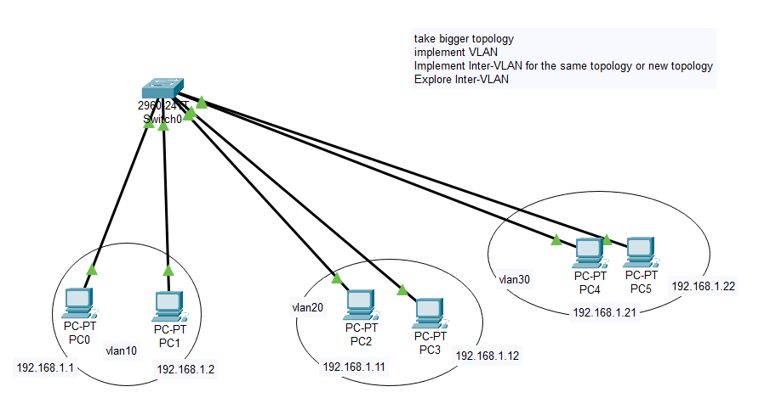

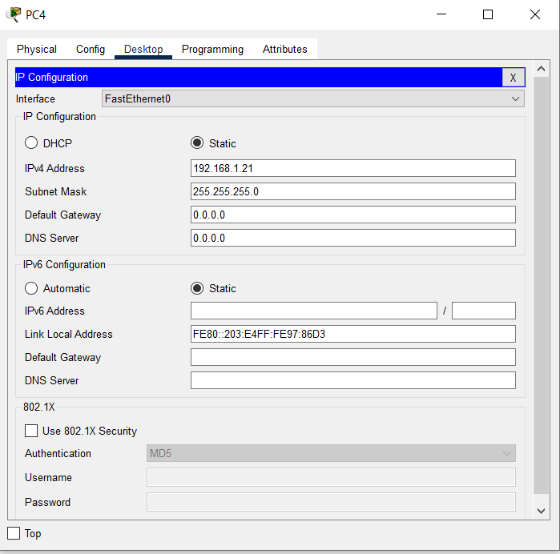

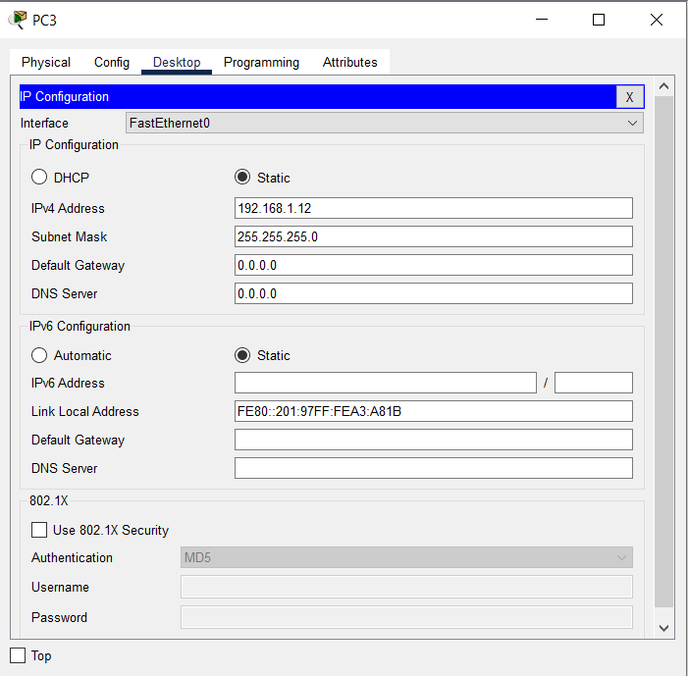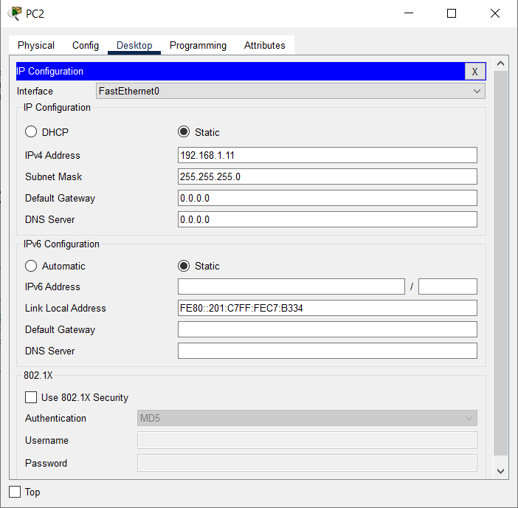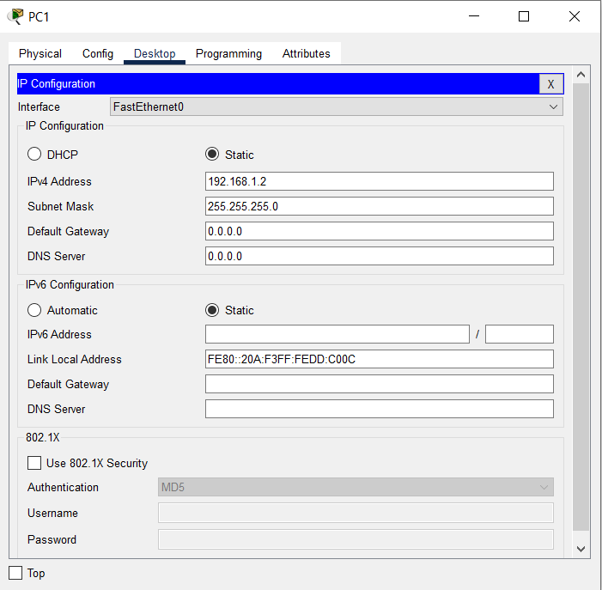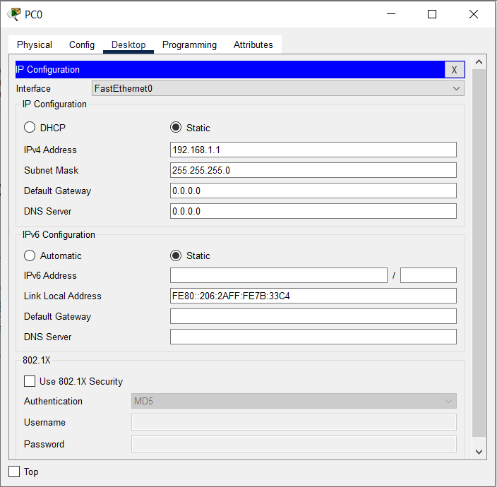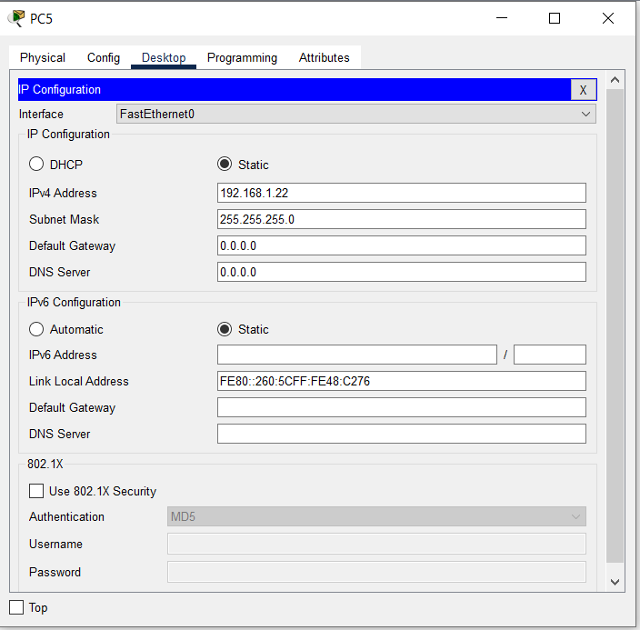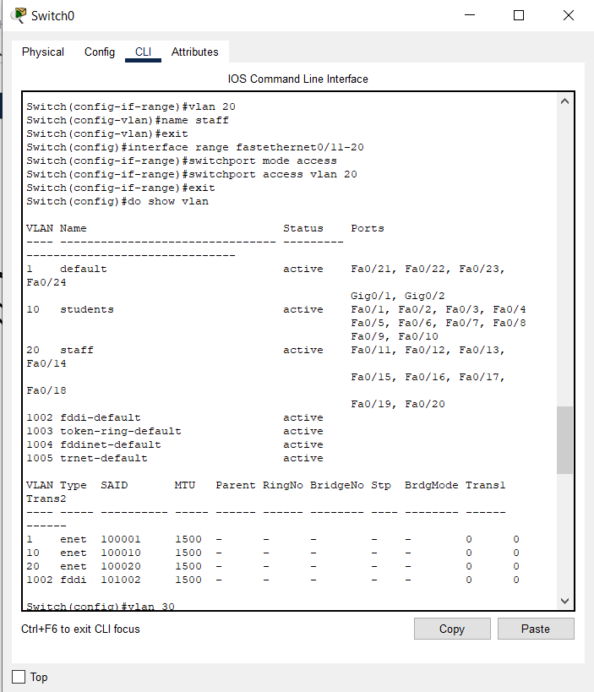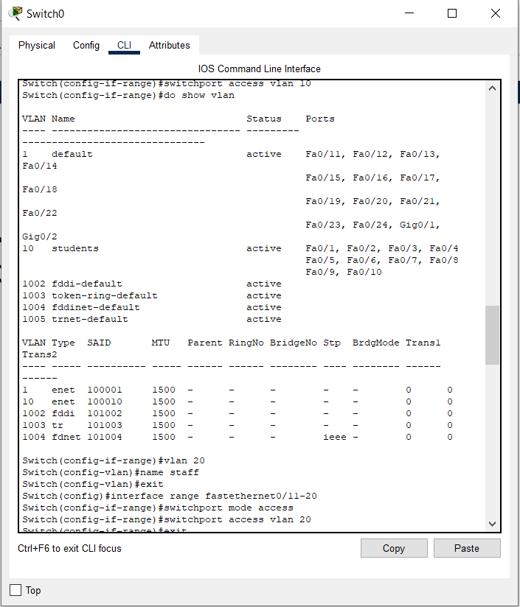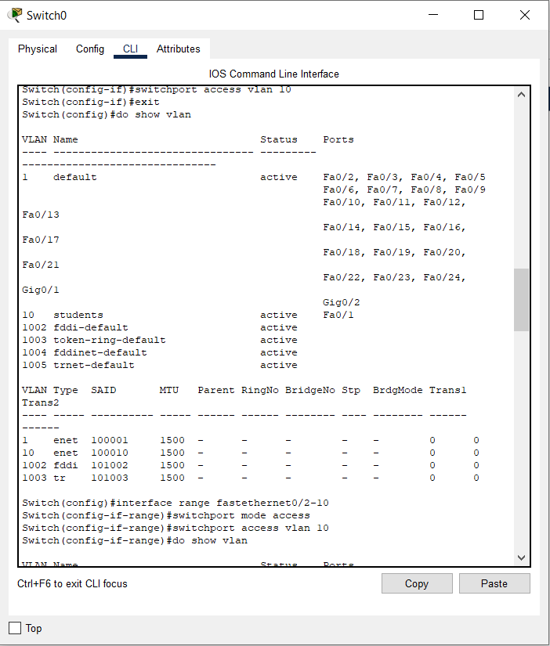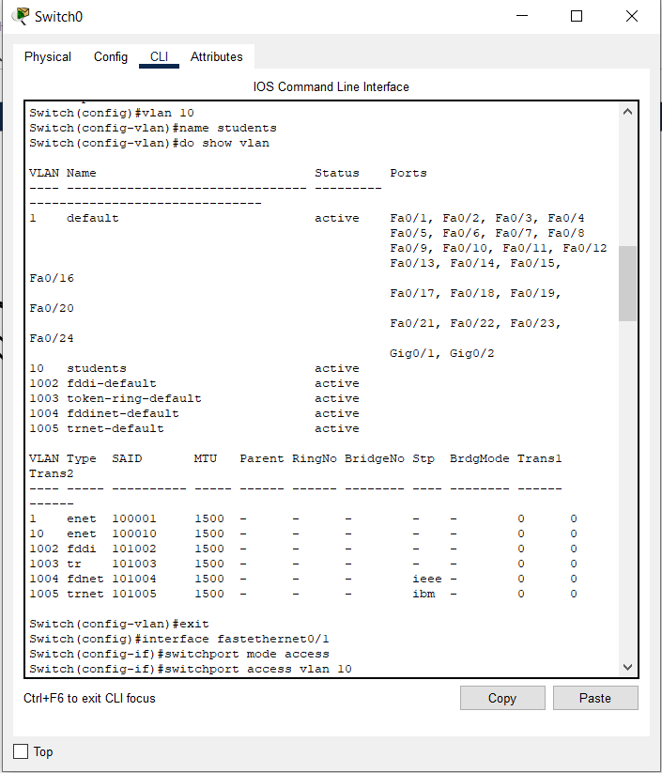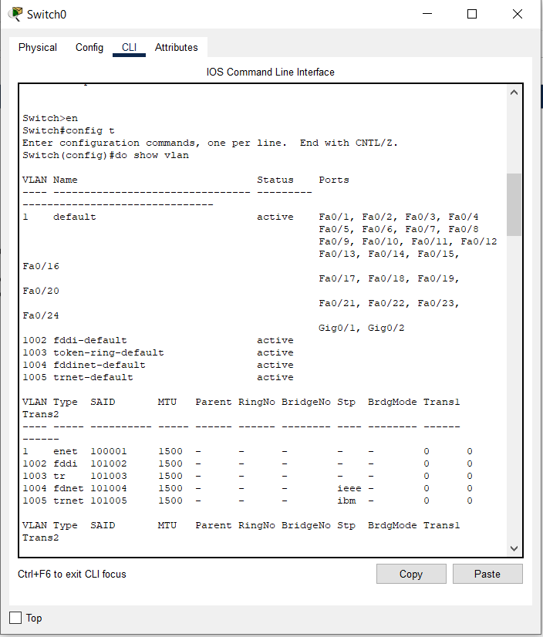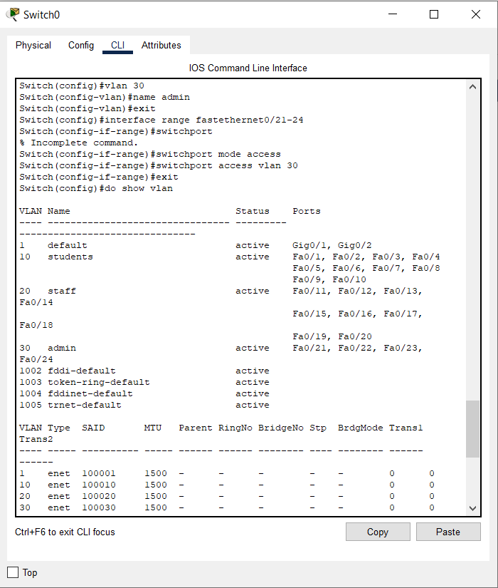

Pinging other endpoint devices

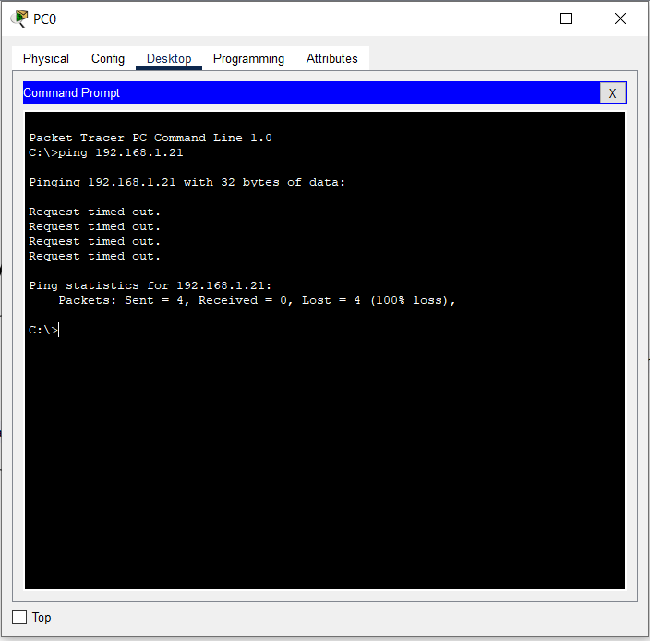

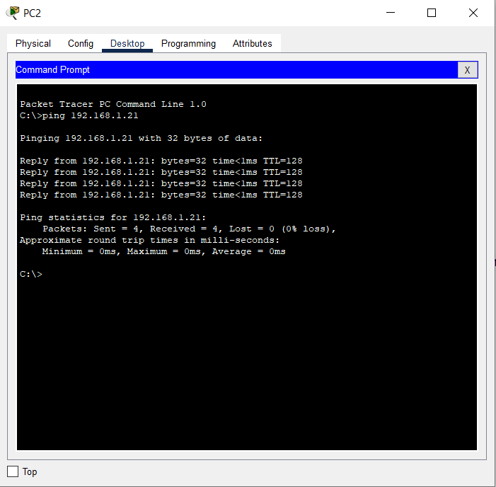

: 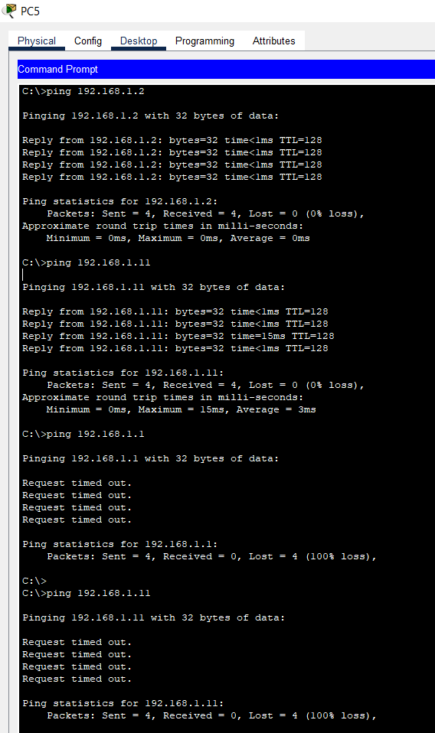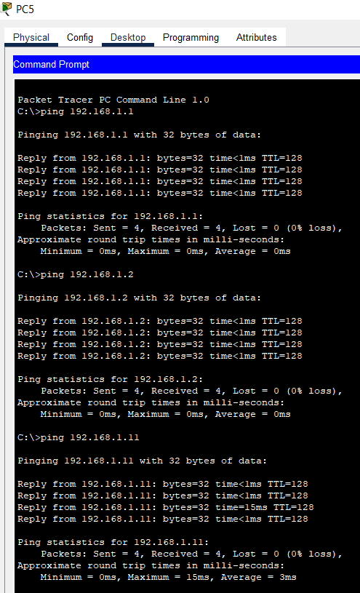

Sending Packets from one VLAN to another: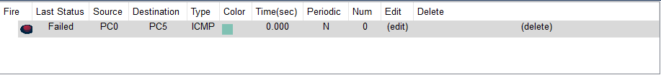

(POST-LAB)

Topo;ogy

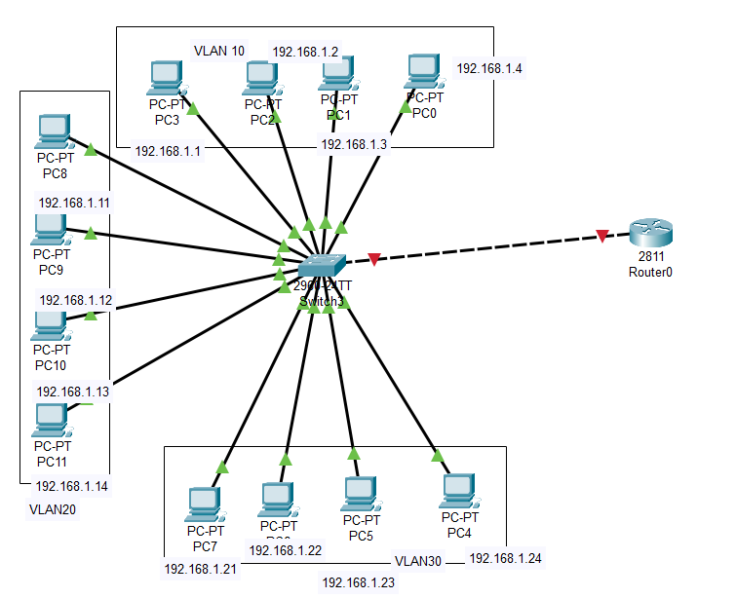

Configurations:

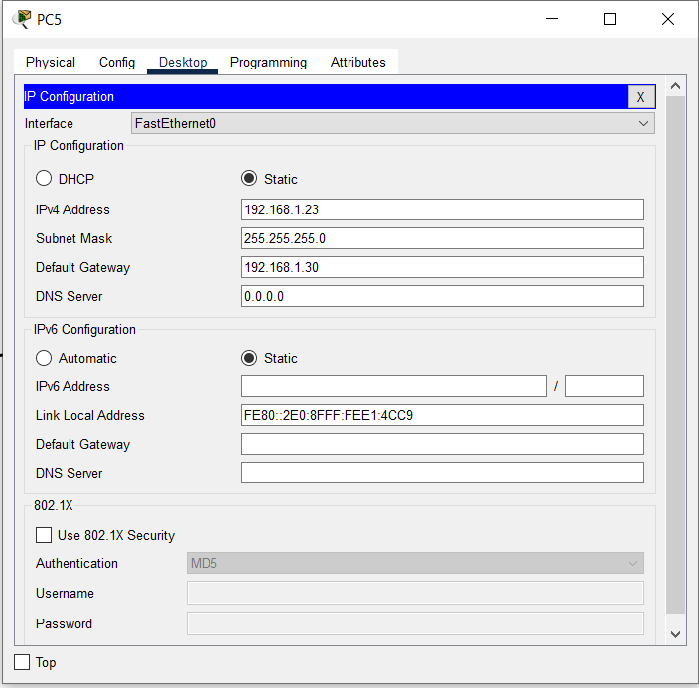

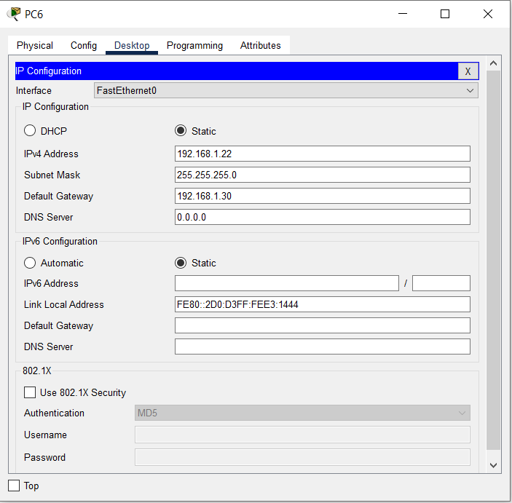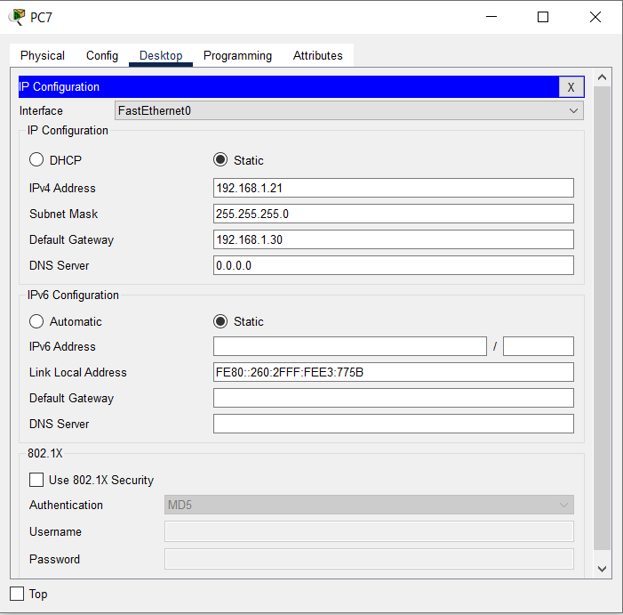

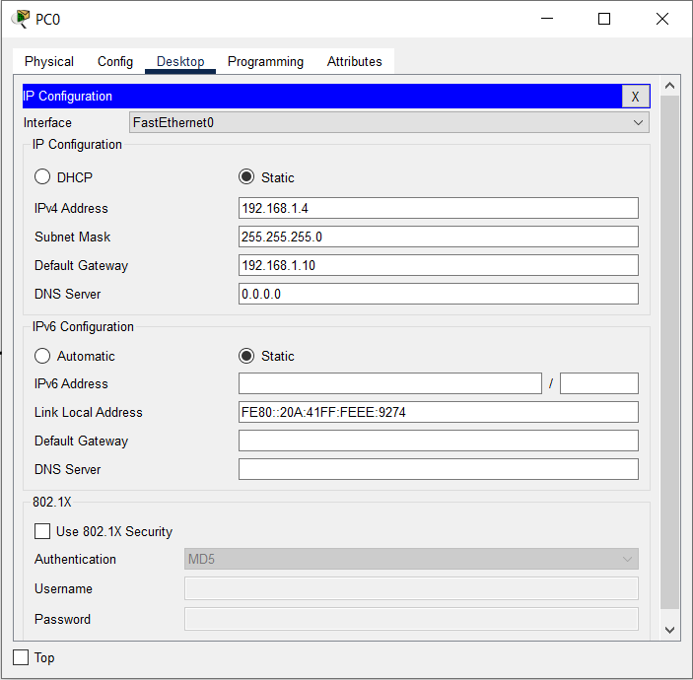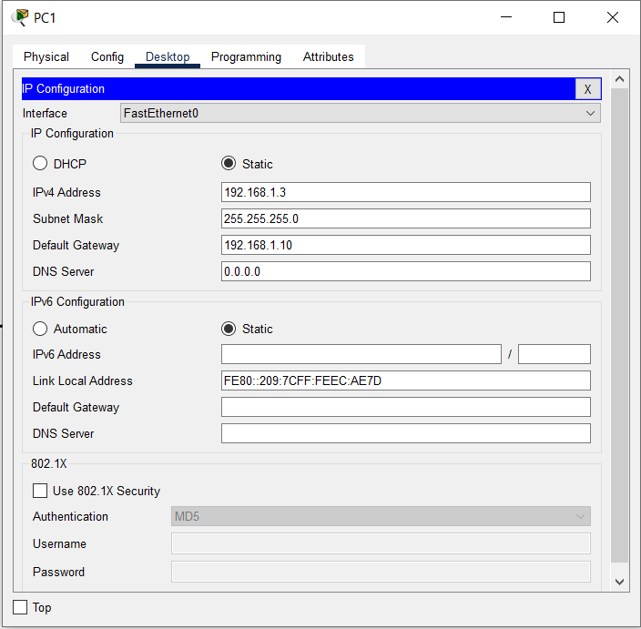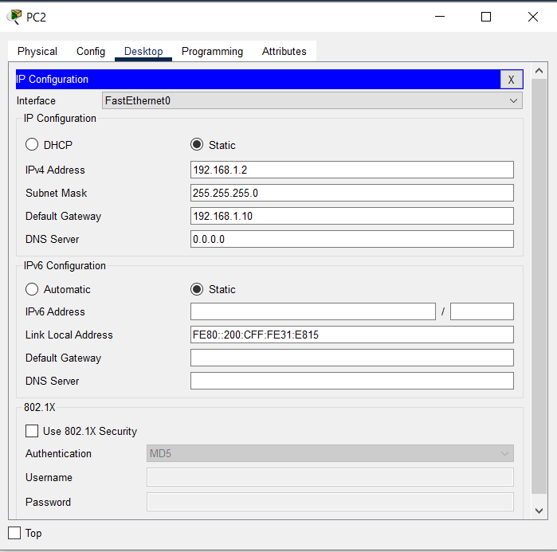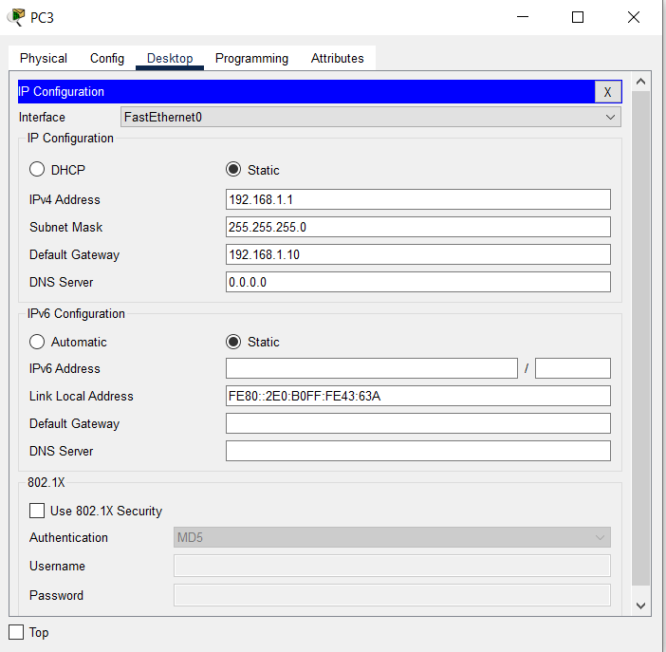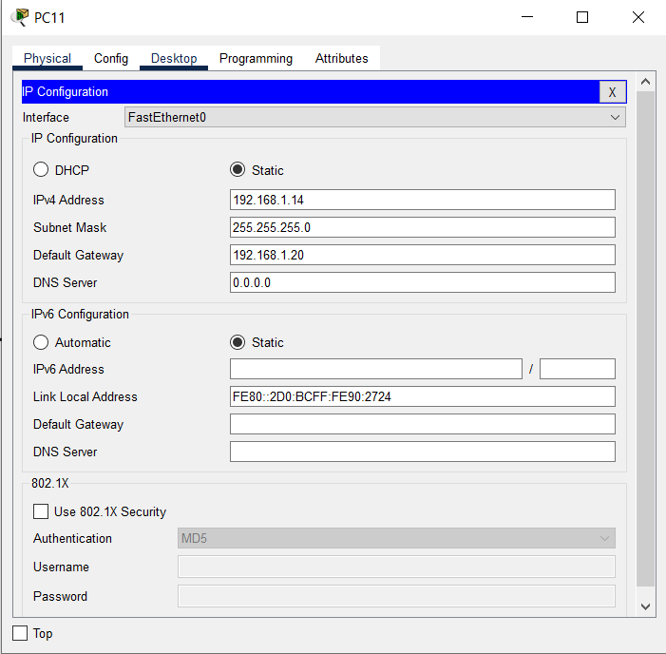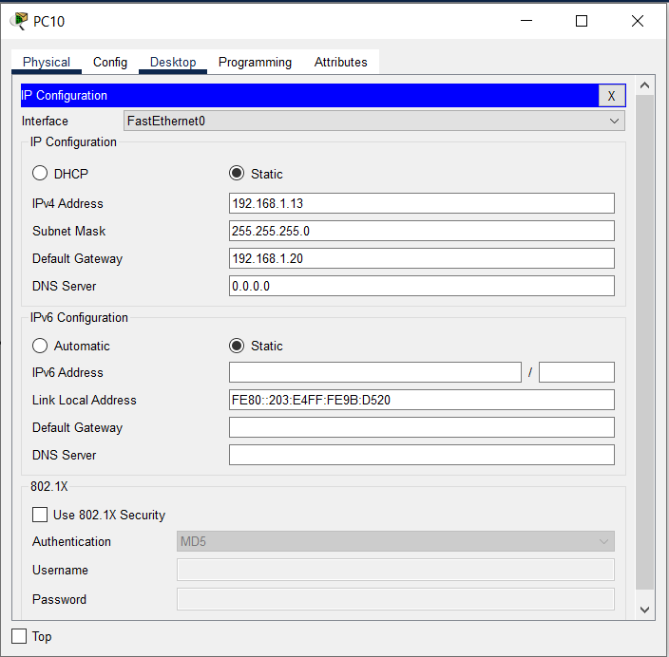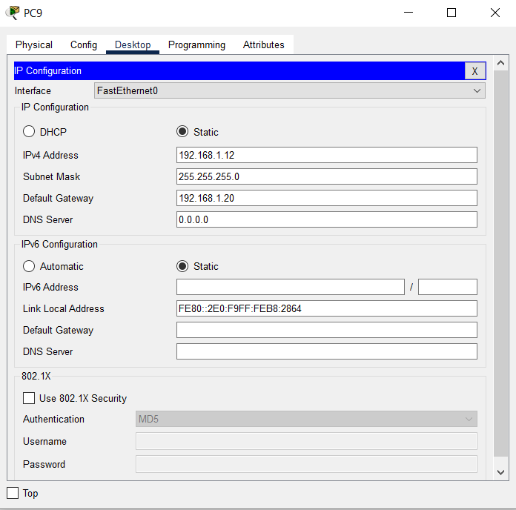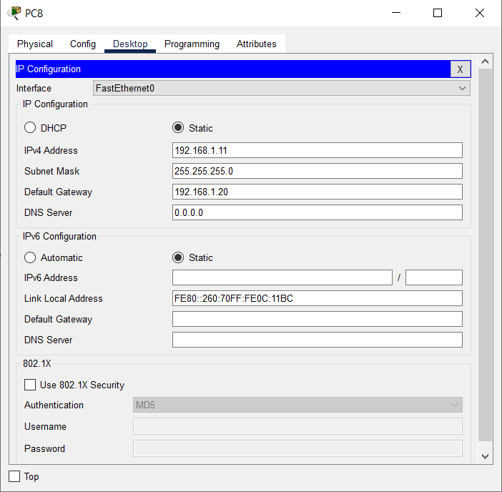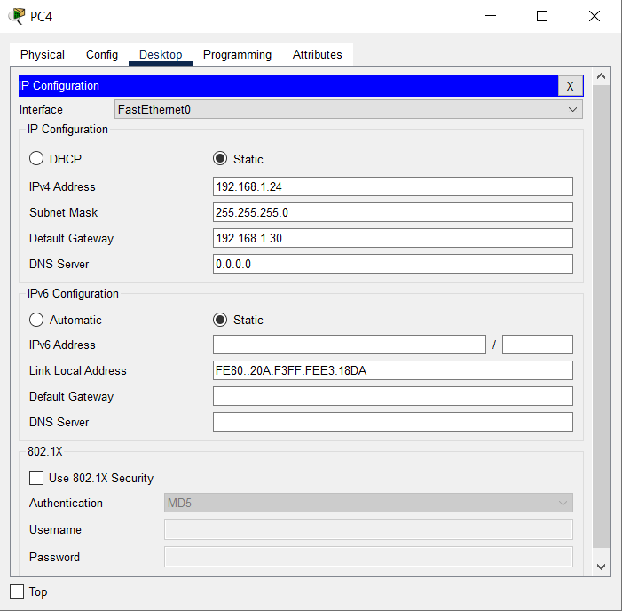 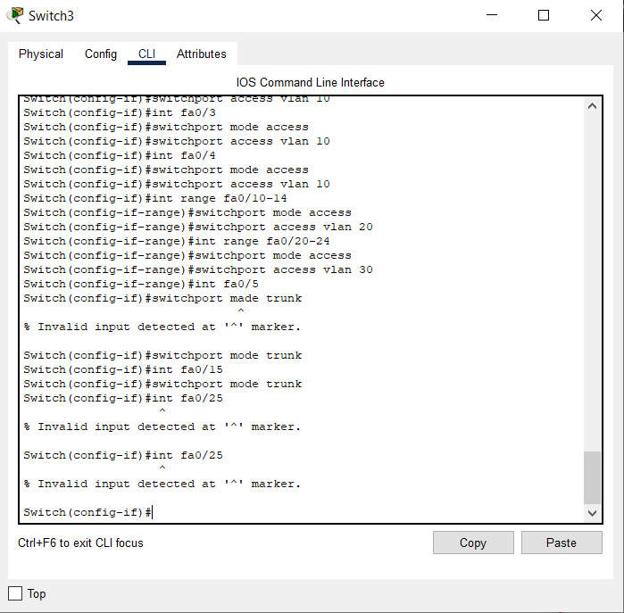

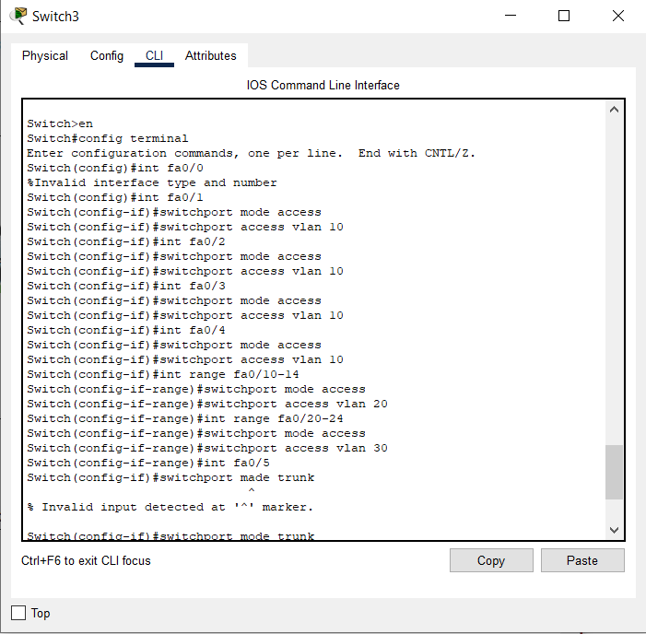

SENDING PACKETS FROM ONE DEVICES TO ANOTHER:

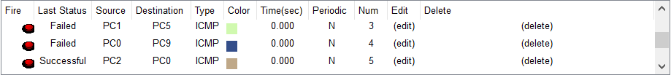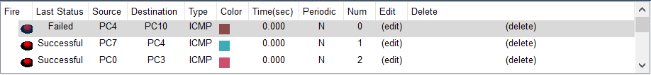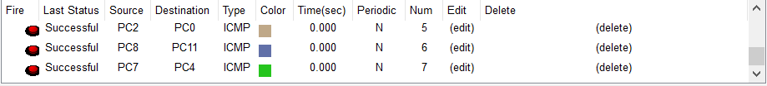

INTER-VLAN

Topology: 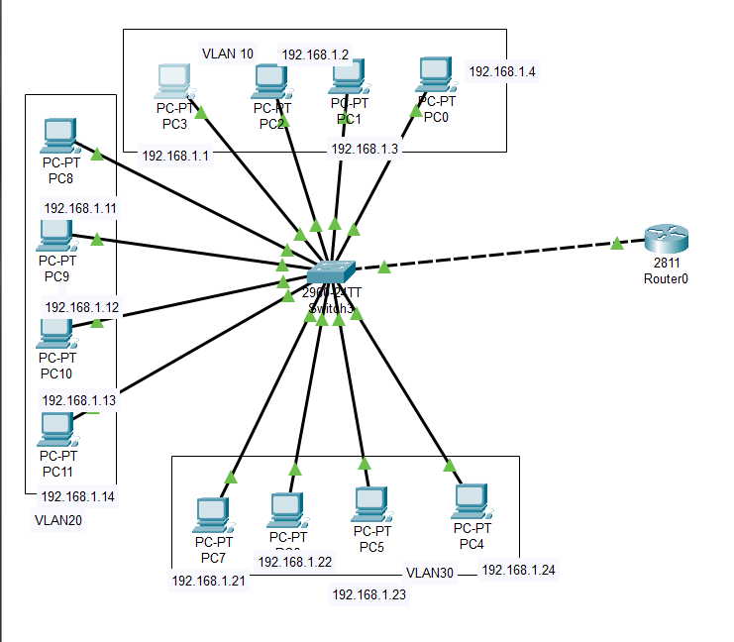

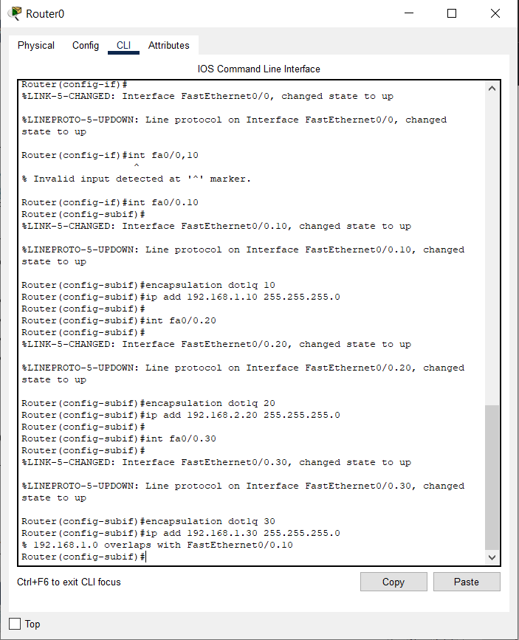

Router Configuration:

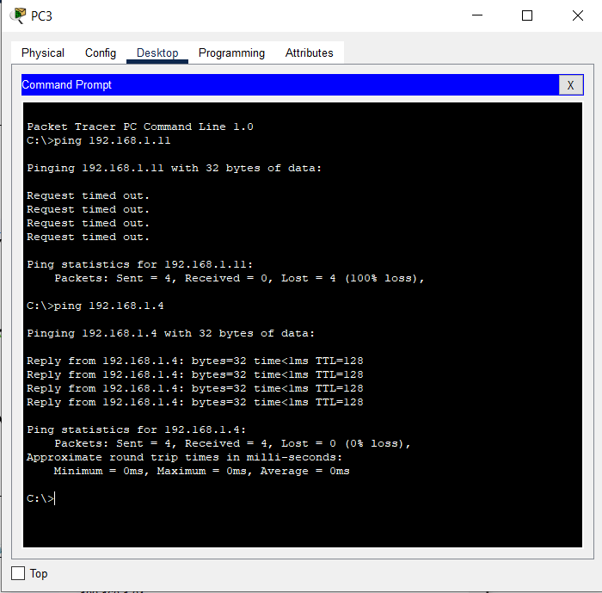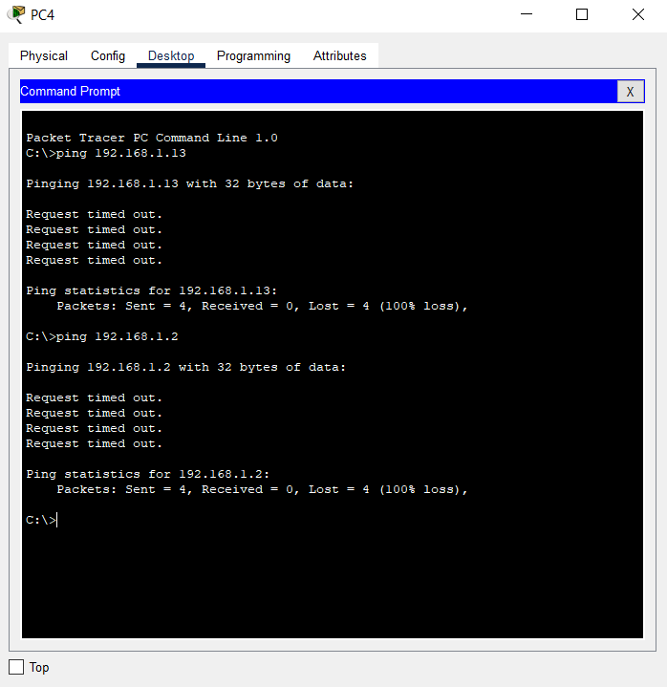

**Inference**

A Virtual LAN (**VLAN)** is simply a logical LAN, just as its name suggests. VLANs have similar characteristics with those of  physical LANs, only  that  with VLANs, you can logically group  hosts even if they are physically  located on separate LAN segments.

We treat each VLAN as a separate subnet or broadcast domain. For this reason, to move packets from one VLAN to another, we have to use a router or  a layer 3 switch.

VLANs are configured on switches by placing some interfaces into one broadcast domain and some interfaces into another.

An *access port* is  assigned to a single VLAN . These ports are configured for switch ports that connect to devices with a normal network card, for example a PC in a network.

A *trunk port* on the other hand is a port that can be connected to another switch or router. This port can carry traffic of multiple VLANs.

Test inter-VLAN connectivity.

Here we’ll test connectivity between computers in different VLANs . Don’t forget that its the router that enables  inter-VLAN routing.

Ping PC3 in VLAN  20 from PC1 in VLAN 10. If everything is well configured, then ping should work perfectly.

**Conclusion:**

VLAN and inter-VLAN has been successfully implemented.

**LAB 5**

**Aryaman Mishra**

**19BCE1027**

**VPN Configuration**

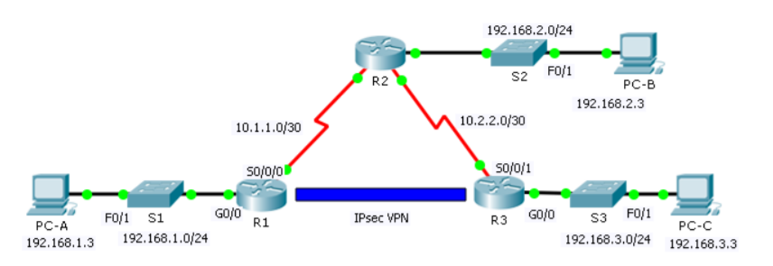

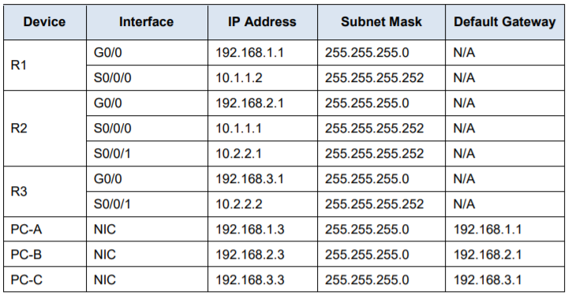

1. Starting configurations for R1, ISP, and R3. Paste to global config mode :

hostname R1

interface g0/1

ip address 192.168.1.1 255.255.255.0

no shut

interface g0/0

ip address 209.165.100.1 255.255.255.0

no shut

exit

ip route 0.0.0.0 0.0.0.0 209.165.100.2

hostname ISP

interface g0/1

ip address 209.165.200.2 255.255.255.0

no shut

interface g0/0

ip address 209.165.100.2 255.255.255.0

no shut

exit

hostname R3

interface g0/1

ip address 192.168.3.1 255.255.255.0

no shut

interface g0/0

ip address 209.165.200.1 255.255.255.0

no shut

exit

ip route 0.0.0.0 0.0.0.0 209.165.200.2

2. Make sure routers have the security license enabled:

show version

license boot module c1900 technology-package securityk9

copy run start

reload

3. Configure IPsec on the routers at each end of the tunnel (R1 and R3)

!R1

crypto isakmp policy 10

encryption aes 256

authentication pre-share

group 5

!

crypto isakmp key secretkey address 209.165.200.1

!

crypto ipsec transform-set R1-R3 esp-aes 256 esp-sha-hmac

!

crypto map IPSEC-MAP 10 ipsec-isakmp

set peer 209.165.200.1

set pfs group5

set security-association lifetime seconds 86400

set transform-set R1-R3

match address 100

!

interface GigabitEthernet0/0

crypto map IPSEC-MAP

!

access-list 100 permit ip 192.168.1.0 0.0.0.255 192.168.3.0 0.0.0.255

!R3

crypto isakmp policy 10

encryption aes 256

authentication pre-share

group 5

!

crypto isakmp key secretkey address 209.165.100.1

!

crypto ipsec transform-set R3-R1 esp-aes 256 esp-sha-hmac

!

crypto map IPSEC-MAP 10 ipsec-isakmp

set peer 209.165.100.1

set pfs group5

set security-association lifetime seconds 86400

set transform-set R3-R1

match address 100

!

interface GigabitEthernet0/0

crypto map IPSEC-MAP

!

R3

access-list 100 permit ip 192.168.3.0 0.0.0.255 192.168.1.0 0.0.0.255

R1

access-list 100 permit ip 192.168.1.0 0.0.0.255 192.168.3.0 0.0.0.255

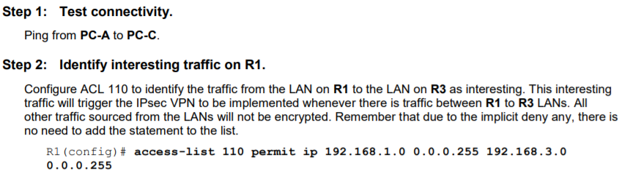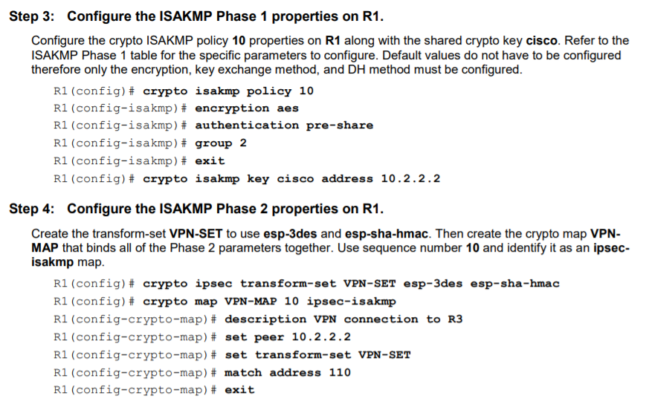

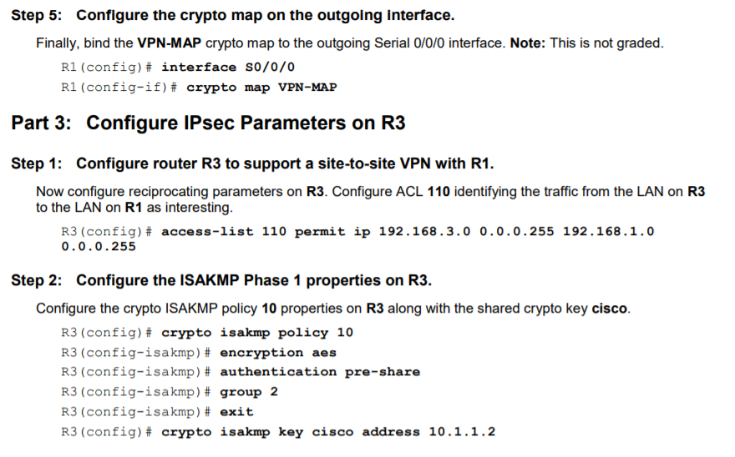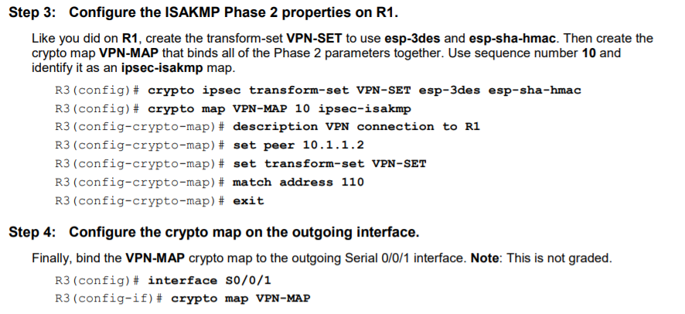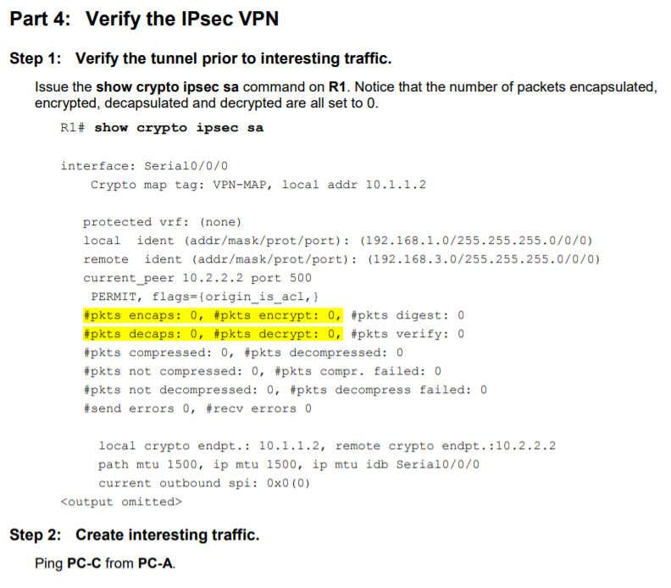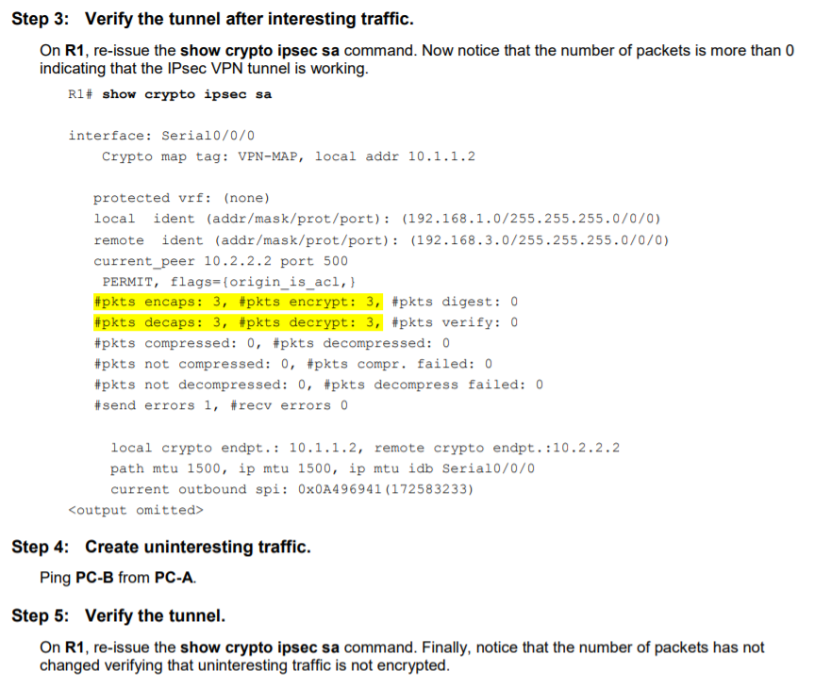

Output on next Page:

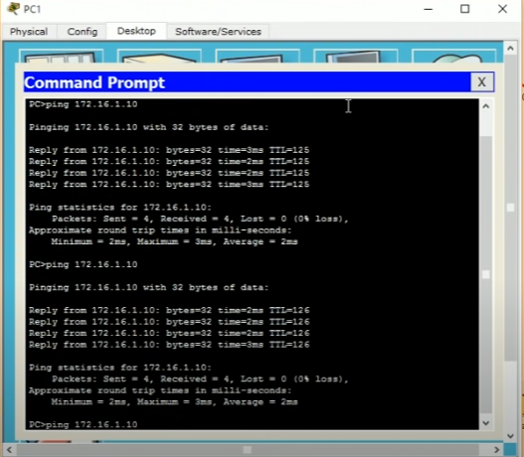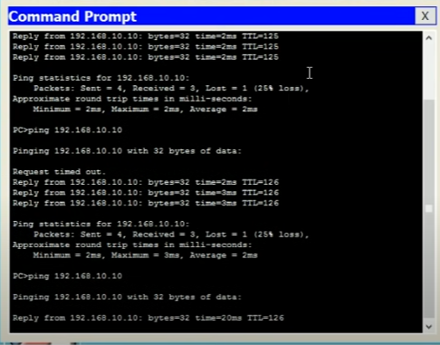

**LAB 6**

**ARYAMAN MISHRA**

**19BCE1027**

**NAT AND PAT**

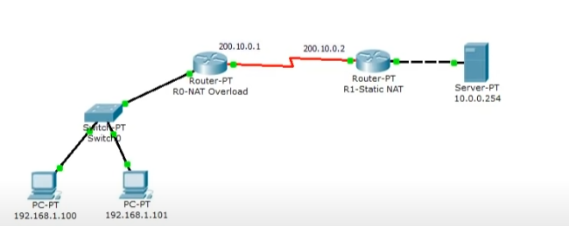

To assign IP address in Laptop click Laptop and click Desktop and IP configuration and Select Static and set IP address.

Two interfaces of Router1 are used in topology; FastEthernet0/0 and Serial 0/0/0.

By default interfaces on router are remain administratively down during the start up. We need to configure IP address and other parameters on interfaces before we could actually use them for routing. Interface mode is used to assign the IP address and other parameters. Interface mode can be accessed from global configuration mode. Following commands are used to access the global configuration mode.

Router>enable

Router# configure terminal

Enter configuration commands, one per line. End with CNTL/Z.

Router(config)#

Before we configure IP address in interfaces let’s assign a unique descriptive name to router.

Router(config)#hostname R1

R1#

Now execute the following commands to set IP address in FastEthernet 0/0 interface.

R1(config)#interface FastEthernet0/0

R1(config-if)#ip address 10.0.0.1 255.0.0.0

R1(config-if)#no shutdown

R1(config-if)#exit

interface FastEthernet 0/0 command is used to enter in interface mode.

ip address 10.0.0.1 255.0.0.0 command assigns IP address to interface.

no shutdown command is used to bring the interface up.

exit command is used to return in global configuration mode.

Serial interface needs two additional parameters clock rate and bandwidth. Every serial cable has two ends DTE and DCE. These parameters are always configured at DCE end.

We can use show controllers interface command from privilege mode to check the cable’s end.

R1(config)#exit

R1#show controllers serial 0/0/0

Interface Serial0/0/0

Hardware is PowerQUICC MPC860

DCE V.35, clock rate 2000000

[Output omitted]

Fourth line of output confirms that DCE end of serial cable is attached. If you see DTE here instead of DCE skip these parameters.

Now we have necessary information let’s assign IP address to serial interface.

R1#configure terminal

R1(config)#interface Serial0/0/0

R1(config-if)#ip address 100.0.0.1 255.0.0.0

R1(config-if)#clock rate 64000

R1(config-if)#bandwidth 64

R1(config-if)#no shutdown

R1(config-if)#exit

R1(config)#

Router#configure terminal Command is used to enter in global configuration mode.

Router(config)#interface serial 0/0/0 Command is used to enter in interface mode.

Router(config-if)#ip address 100.0.0.1 255.0.0.0 Command assigns IP address to interface.

Router(config-if)#clock rate 64000

In real life environment this parameter controls the data flow between serial links and need to be set at service provider’s end. In lab environment we need not to worry about this value. We can use any valid rate here.

Router(config-if)#bandwidth 64

Bandwidth works as an influencer. It is used to influence the metric calculation of EIGRP or any other routing protocol which uses bandwidth parameter in route selection process.

Router(config-if)#no shutdown Command brings interface up.

Router(config-if)#exit Command is used to return in global configuration mode.

We will use same commands to assign IP addresses on interfaces of Router2. We need to provided clock rate and bandwidth only on DCE side of serial interface. Following command will assign IP addresses on interface of Router2.

Initial IP configuration in R2

Router>enable

Router#configure terminal

Router(config)#hostname R2

R2(config)#interface FastEthernet0/0

R2(config-if)#ip address 192.168.1.1 255.255.255.0

R2(config-if)#no shutdown

R2(config-if)#exit

R2(config)#interface Serial0/0/0

R2(config-if)#ip address 100.0.0.2 255.0.0.0

R2(config-if)#no shutdown

R2(config-if)#exit

R2(config)#

That’s all initial IP configuration we need. Now this topology is ready for the practice of static nat.

Configure Static NAT

Static NAT configuration requires three steps: -

Define IP address mapping

Define inside local interface

Define inside global interface

Since static NAT use manual translation, we have to map each inside local IP address (which needs a translation) with inside global IP address. Following command is used to map the inside local IP address with inside global IP address.

Router(config)#ip nat inside source static [inside local ip address] [inside global IP address]

For example in our lab Laptop1 is configured with IP address 10.0.0.10. To map it with 50.0.0.10 IP address we will use following command

Router(config)#ip nat inside source static 10.0.0.10 50.0.0.10

In second step we have to define which interface is connected with local the network. On both routers interface Fa0/0 is connected with the local network which need IP translation.

Following command will define interface Fa0/0 as inside local.

Router(config-if)#ip nat inside

In third step we have to define which interface is connected with the global network. On both routers serial 0/0/0 interface is connected with the global network. Following command will define interface Serial0/0/0 as inside global.

Router(config-if)#ip nat outside

Following figure illustrates these terms.

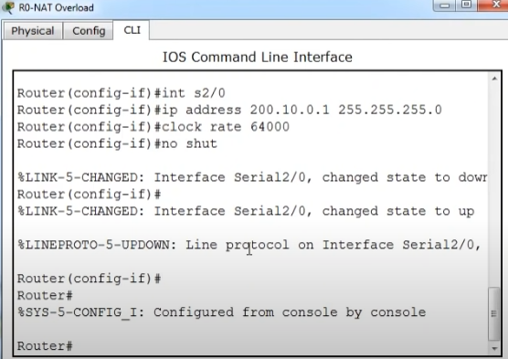

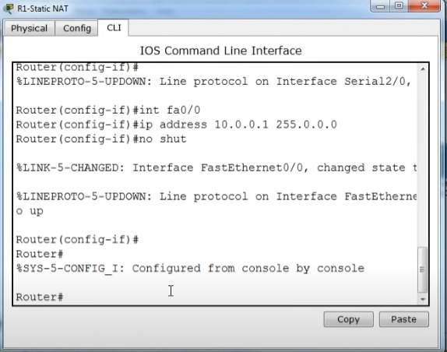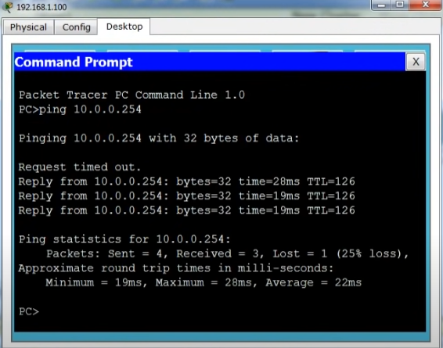

Let’s implement all these commands together and configure the static NAT.

R1 Static NAT Configuration

R1(config)#ip nat inside source static 10.0.0.10 50.0.0.10

R1(config)#interface FastEthernet 0/0

R1(config-if)#ip nat inside

R1(config-if)#exit

R1(config)#

R1(config)#interface Serial 0/0/0

R1(config-if)#ip nat outside

R1(config-if)#exit

For testing purpose I configured only one static translation. You may use following commands to configure the translation for remaining address.

R1(config)#ip nat inside source static 10.0.0.20 50.0.0.20

R1(config)#ip nat inside source static 10.0.0.30 50.0.0.30

**R2 Static NAT Configuration**

R2(config)#ip nat inside source static 192.168.1.10 200.0.0.10

R2(config)#interface FastEthernet 0/0

R2(config-if)#ip nat inside

R2(config-if)#exit

R2(config)#

R2(config)#interface Serial 0/0/0

R2(config-if)#ip nat outside

R2(config-if)#exit

Before we test this lab we need to configure the IP routing. IP routing is the process which allows router to route the packet between different networks. Following tutorial explain routing in detail with examples

[Routing concepts Explained with Examples](https://www.computernetworkingnotes.com/ccna-study-guide/basic-routing-concepts-and-protocols-explained.html)

**Configure static routing in R1**

R1(config)#ip route 200.0.0.0 255.255.255.0 100.0.0.2

Configure static routing in R2

R2(config)#ip route 50.0.0.0 255.0.0.0 100.0.0.1

**Testing Static NAT Configuration**

In this lab we configured static NAT on R1 and R2. On R1 we mapped inside local IP address 10.0.0.10 with inside global address 50.0.0.10 while on R2 we mapped inside local IP address 192.168.1.10 with inside global IP address 200.0.0.10.

| Device | Inside Local IP Address | Inside Global IP Address |
| --- | --- | --- |
| Laptop0 | 10.0.0.10 | 50.0.0.10 |
| Server | 192.168.1.10 | 200.0.0.10 |

To test this setup click Laptop0 and Desktop and click Command Prompt.

Run **ipconfig** command.

Run **ping 200.0.0.10** command.

Run **ping 192.168.1.10** command.

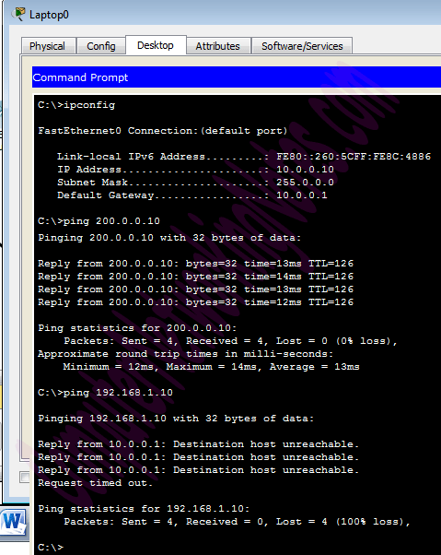

First command verifies that we are testing from correct NAT device.

Second command checks whether we are able to access the remote device or not. A ping reply confirms that we are able to connect with remote device on this IP address.

Third command checks whether we are able to access the remote device on its actual IP address or not. A ping error confirms that we are not able to connect with remote device on this IP address.

Let’s do one more testing. Click **Laptop0** and click **Desktop** and click **Web Browser** and access 200.0.0.10.

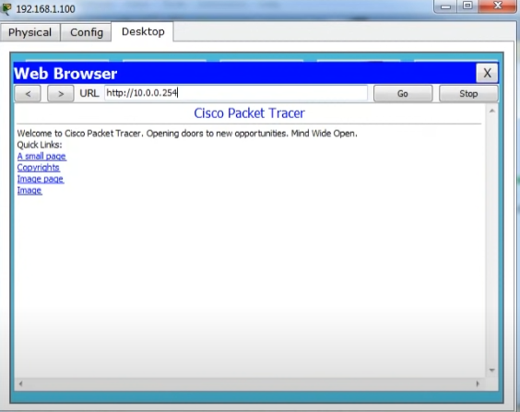

We can also verify this translation on router with **show ip nat translation** command.

Following figure illustrate this translation on router R1.

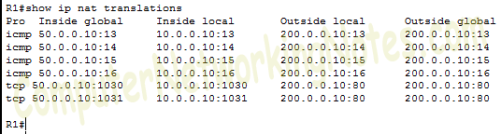

Following figure illustrate this translation on router R2

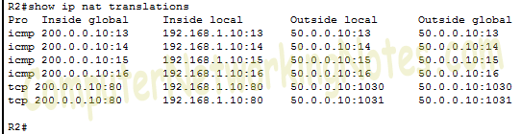

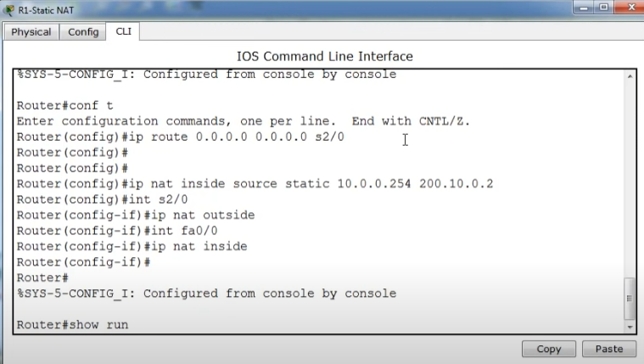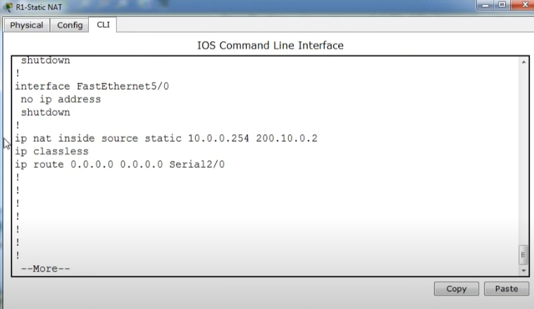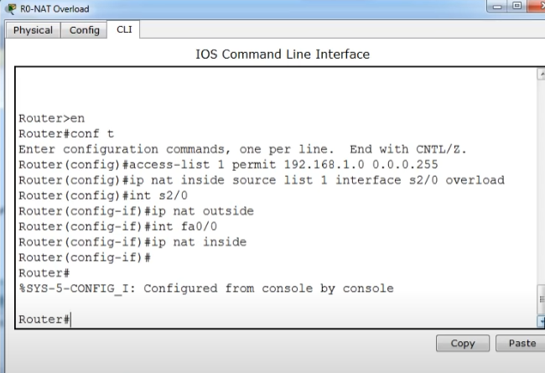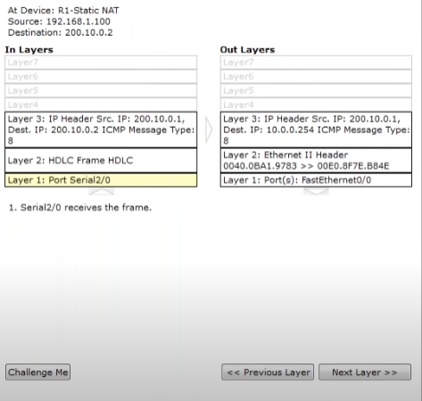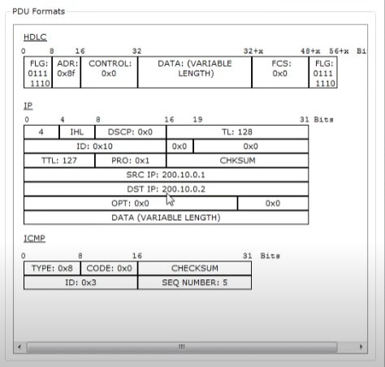

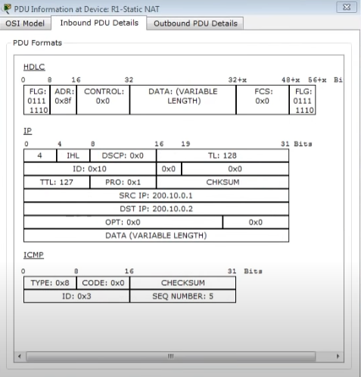

The actual IP address is not listed here because router is receiving packets after the translation. From R1’s point of view remote device’s IP address is 200.0.0.10 while from R2’s point of view end device’s IP address is 50.0.0.10.

This way if NAT is enabled we would not be able to trace the actual end device.

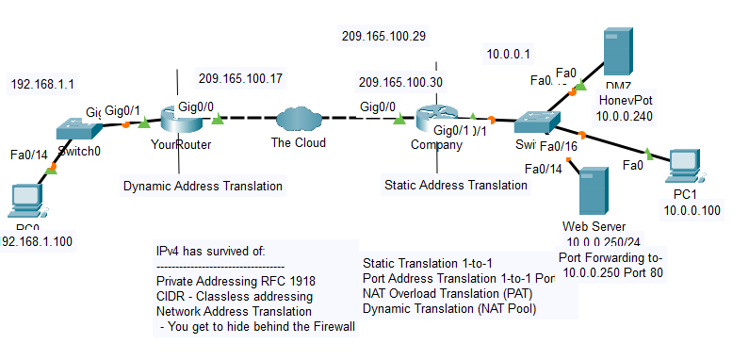

**NEW TOPOLOGY**

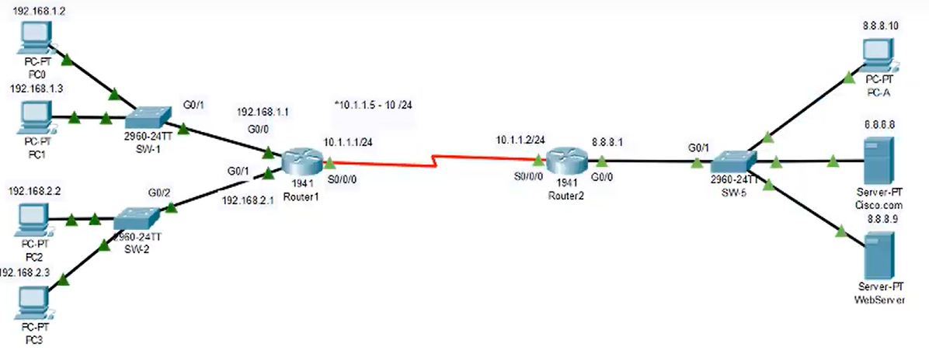

**PC configuration**

**PC0**

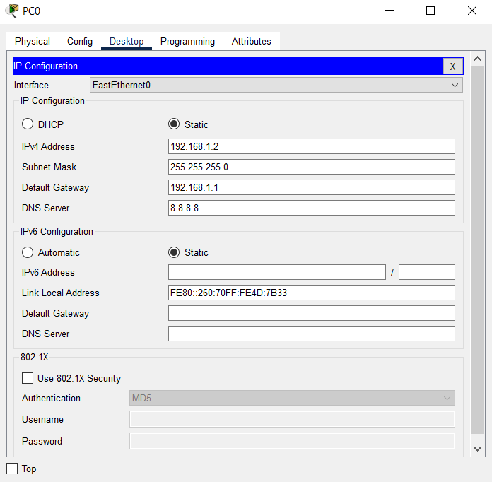

**PC1**

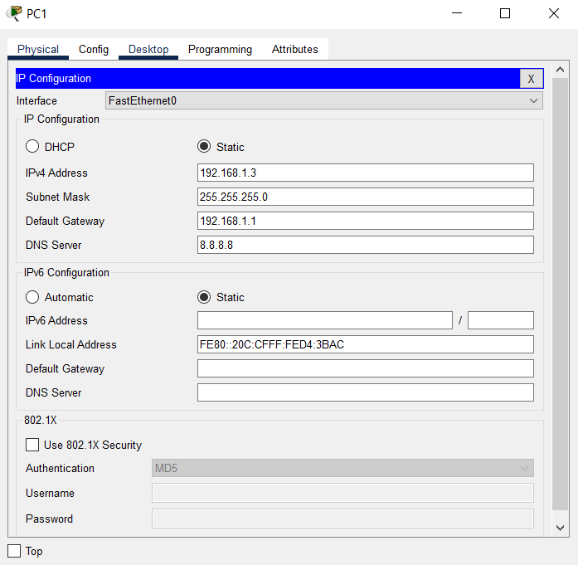

**PC2**

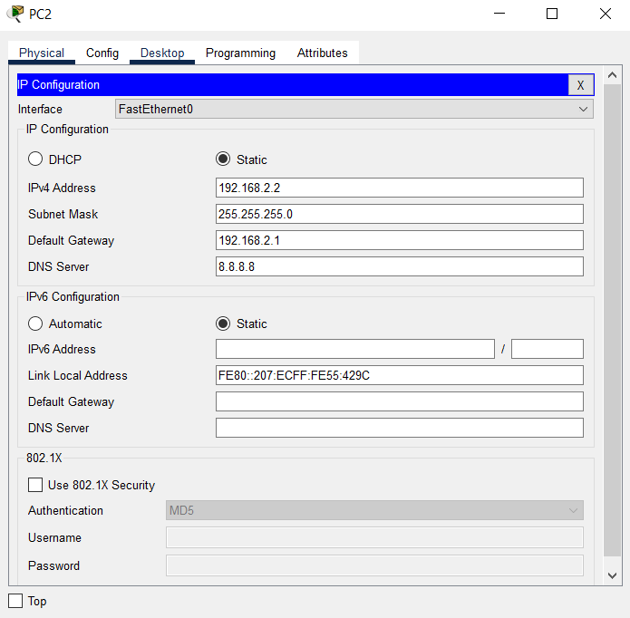

**PC3**

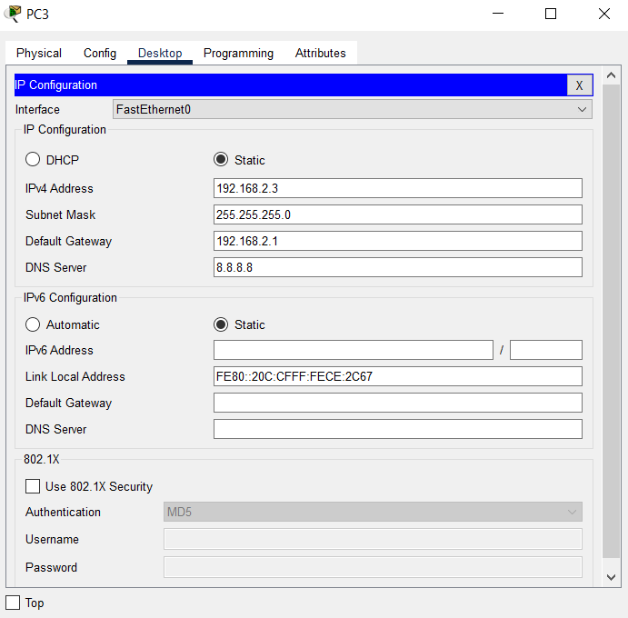

**WEB SERVER**

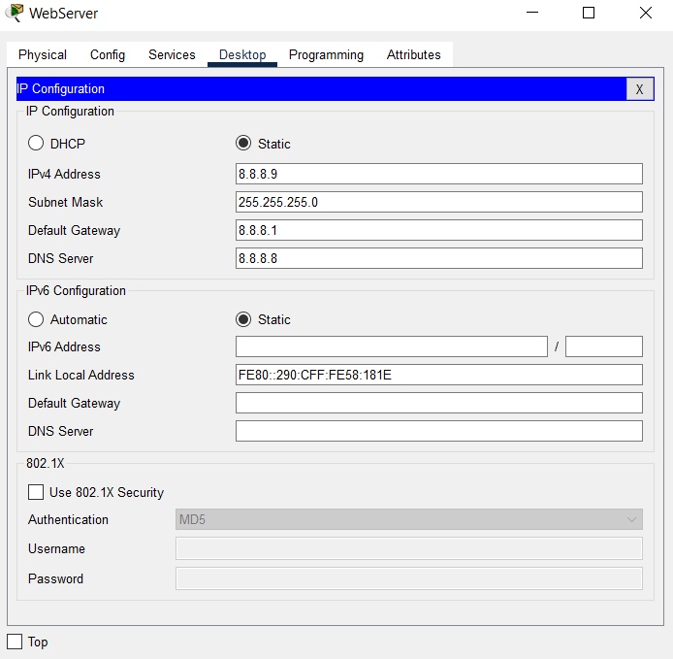

**CISCO.COM**

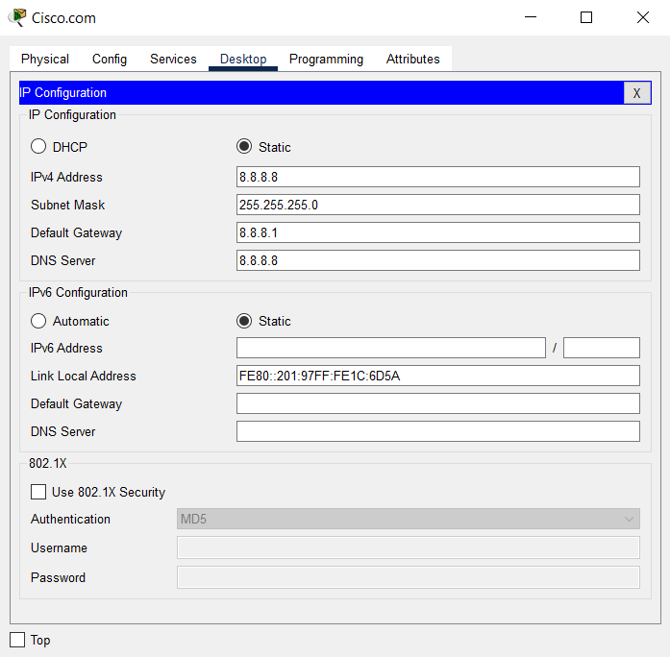

**PC-A**

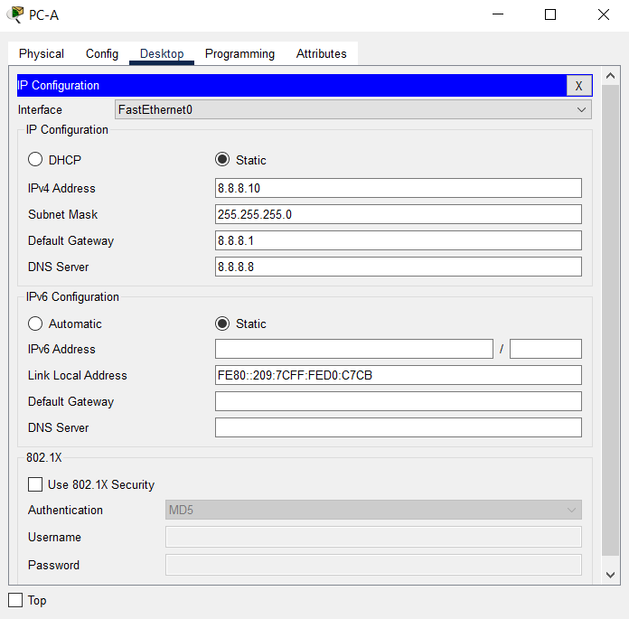

**CHECKING THE PING REQUEST**

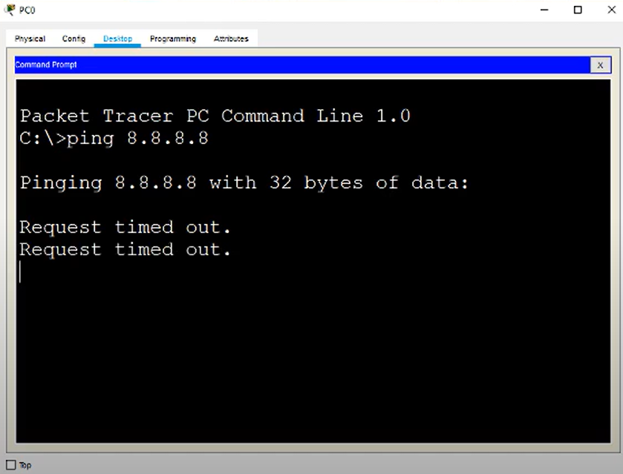

**Router 1941(for more switches) configurations**

**ROUTER 1**

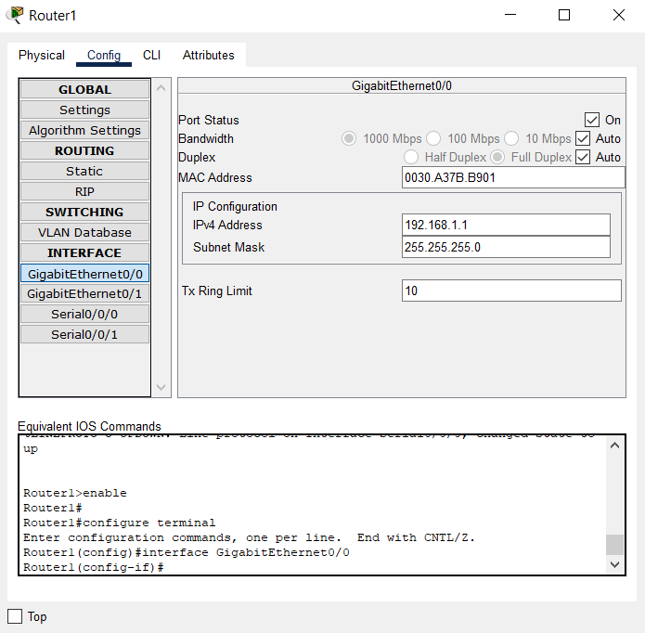

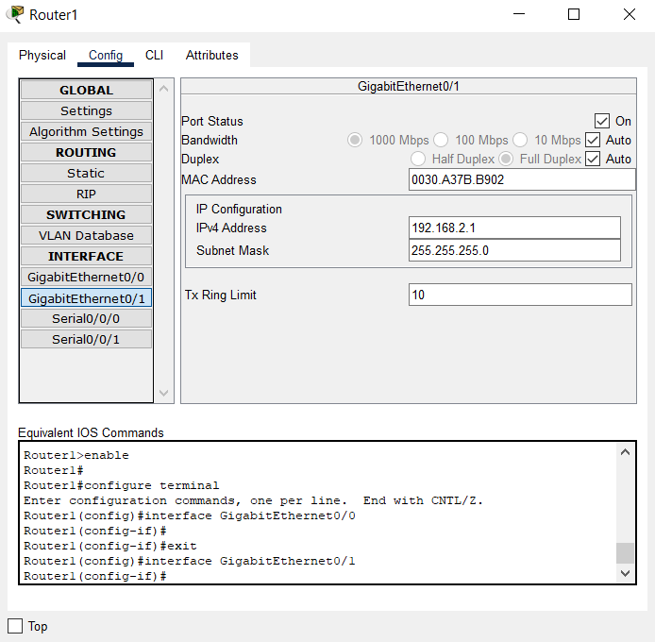

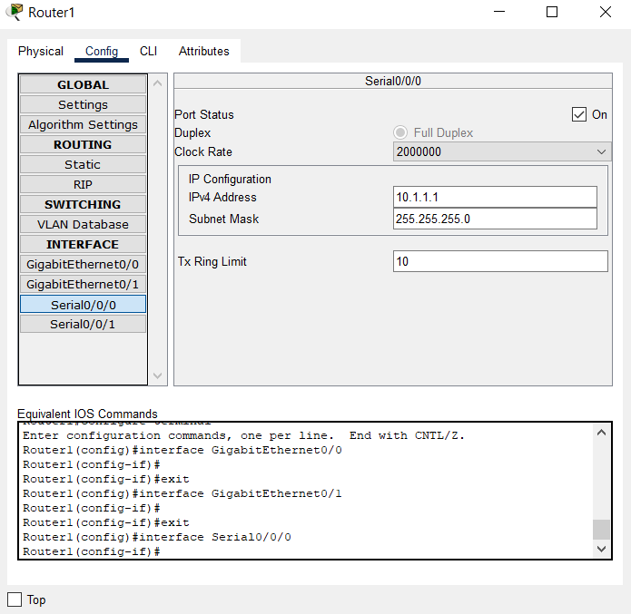

**ROUTER 2**

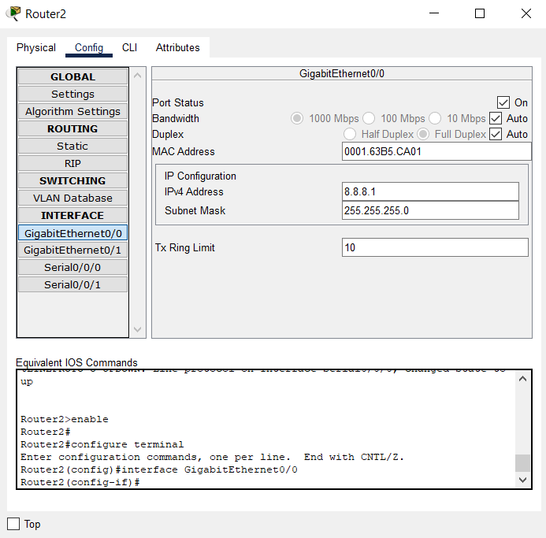

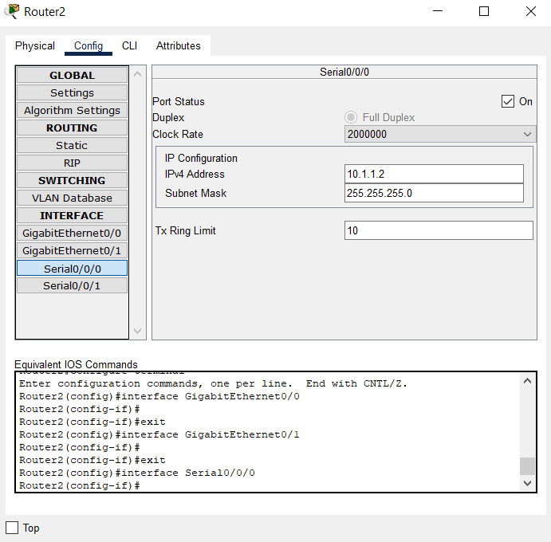

**STATIC NAT**

**NAT of cisco.com device using IP address of 10.1.1.3**

**Static translation**

Commands for static translation

First we mark interfaces as nat outside or nat inside and then using ip nat command to translate public ip address into a private ip address in our case for honeypot.

en

conf t

int g0/0

ip nat out

int g0/1

ip nat inside

ip nat inside source static 192.168.1.2 10.1.1.3

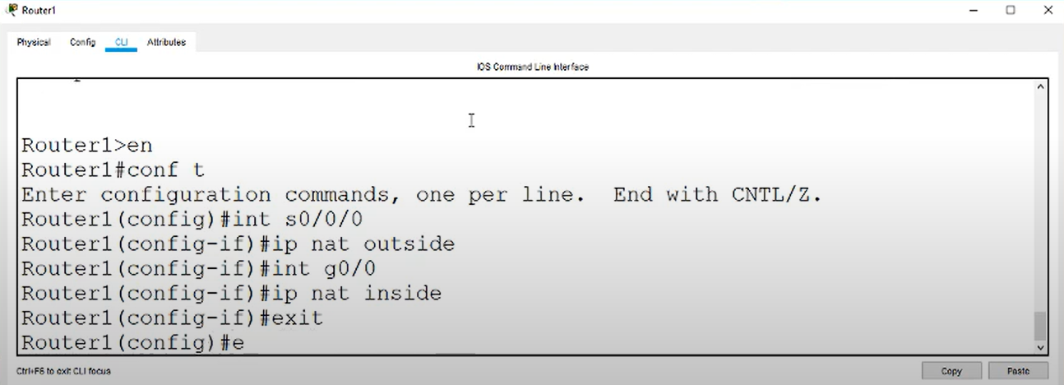

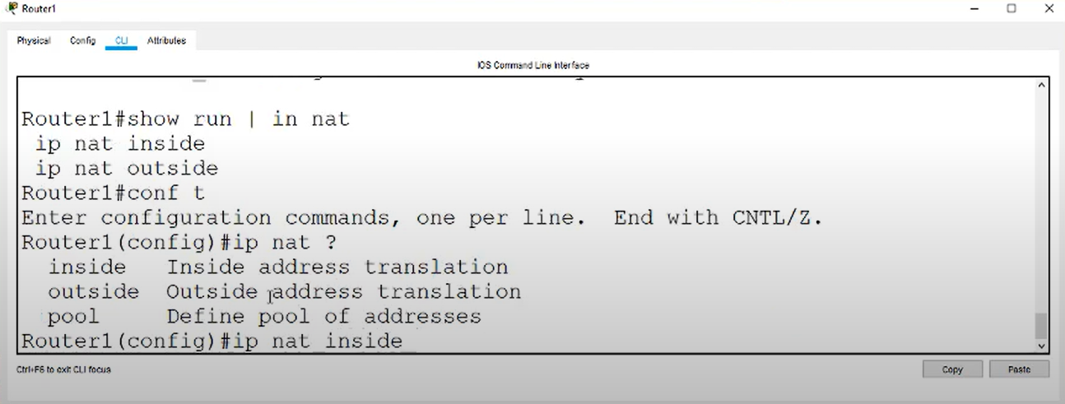

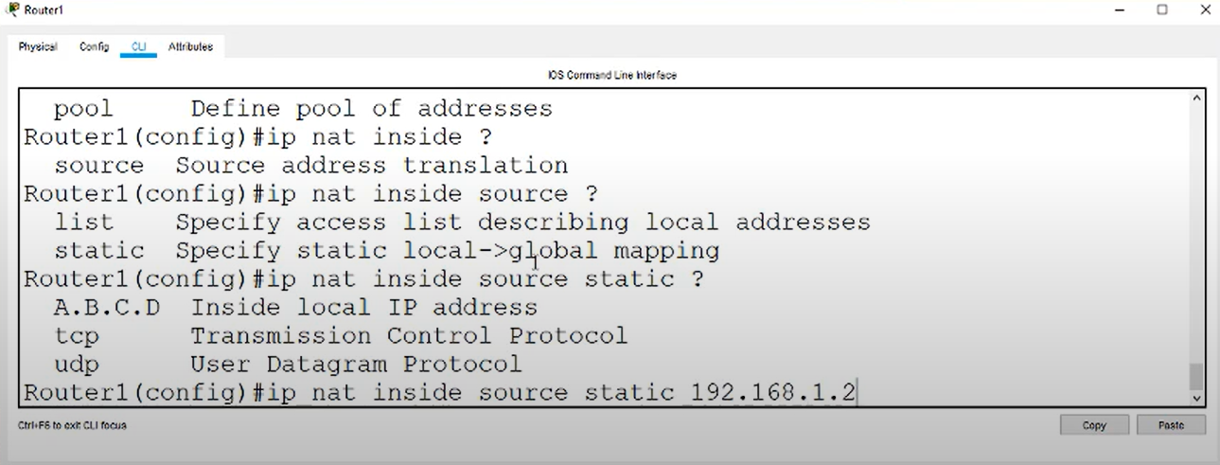

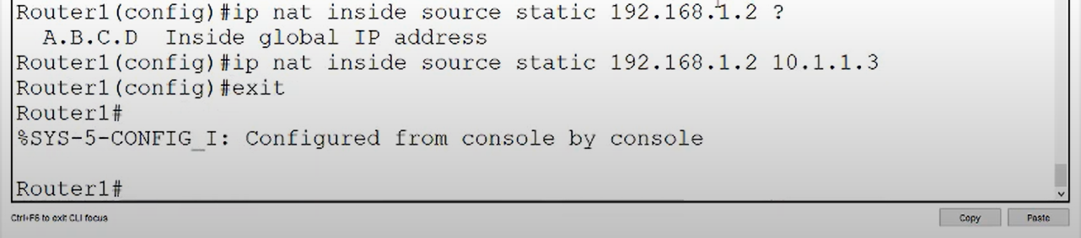

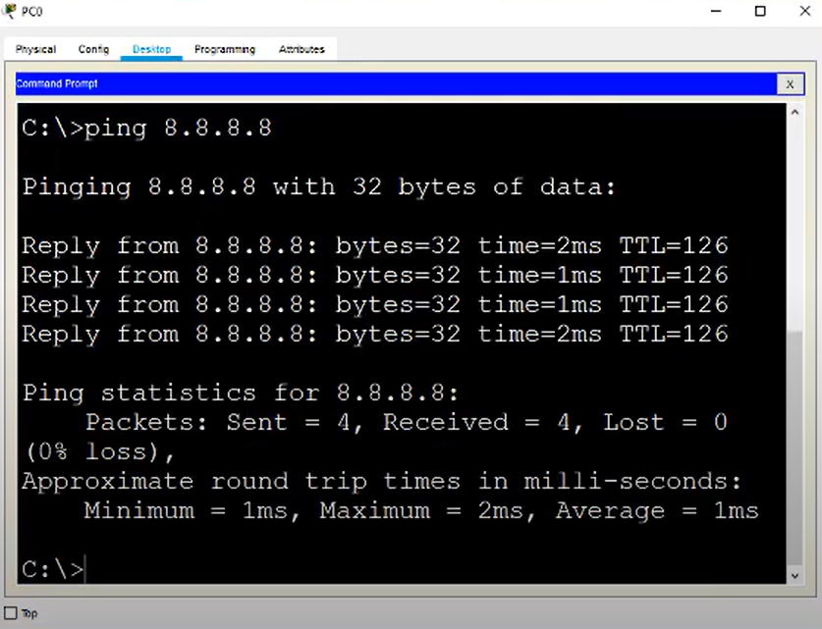

**DYNAMIC NAT**

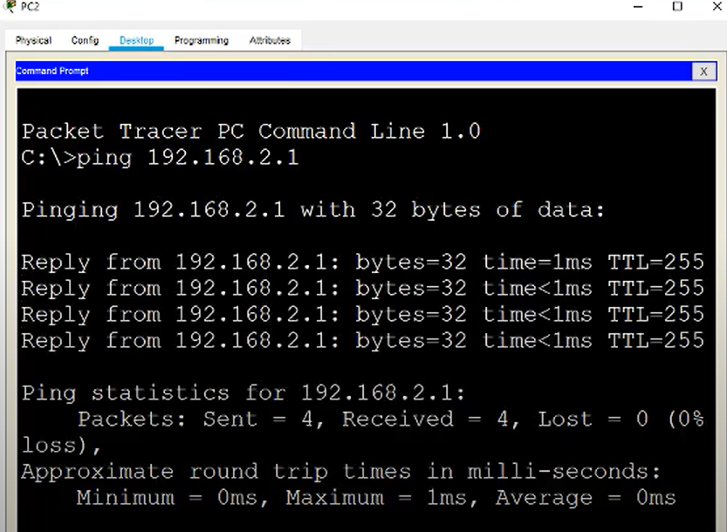

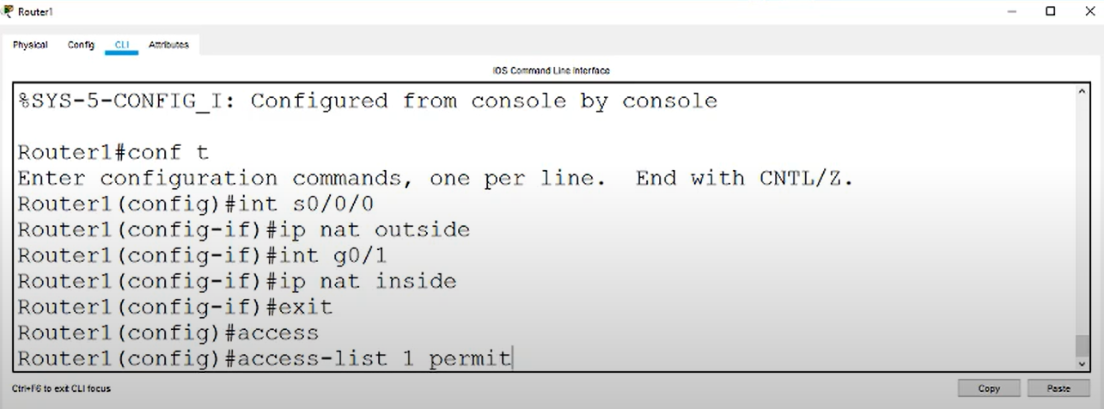

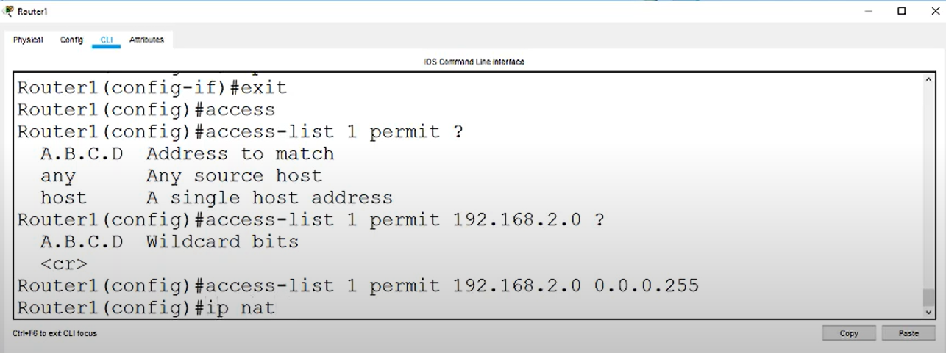

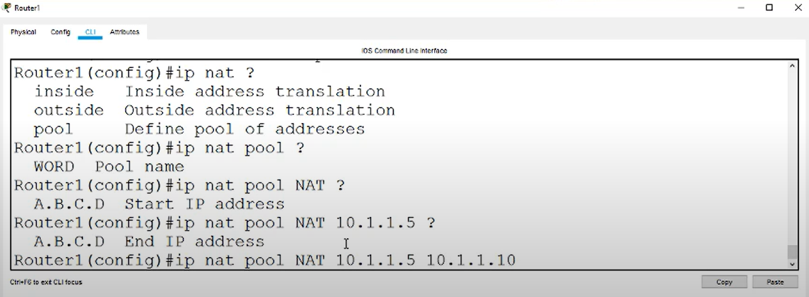

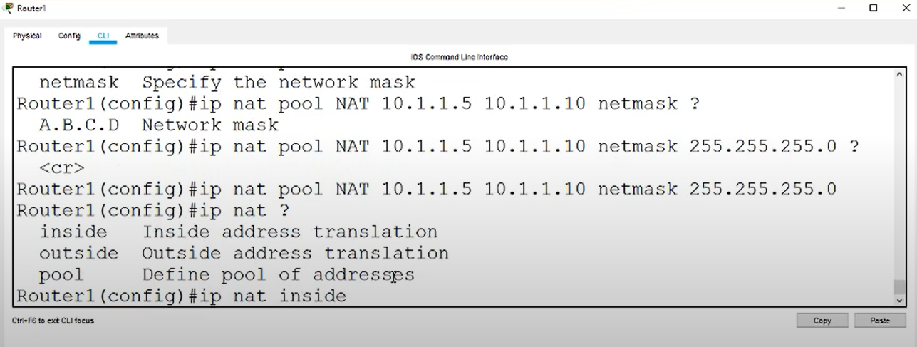

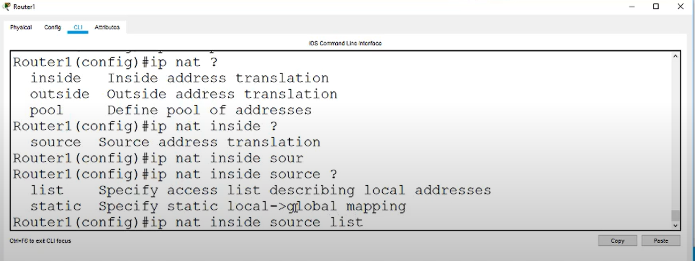

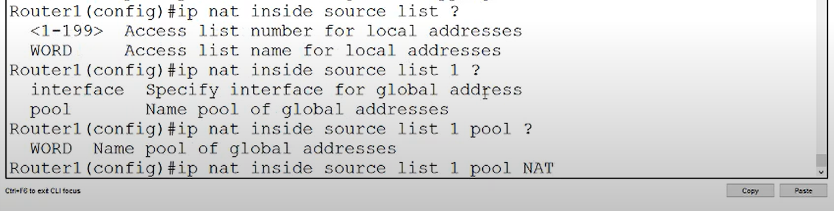

When we put public address from pc0 it gets translated and displays honeypot

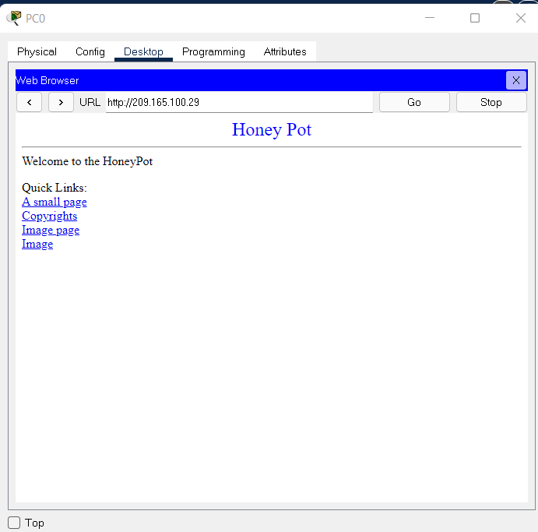

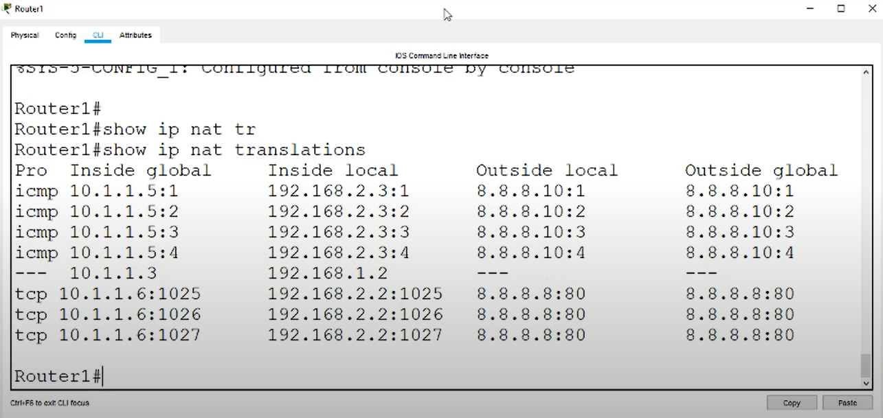

**PAT (Network Overload Translation)**

To translate any computer’s ip address across the network of 192.168.1.0

We use PAT.

Commands

access-list 1 permit 192.168.1.0 0.0.0.255

ip nat inside source list 10 interface g0/0 overload

**Port Address Translation**

Now we want the server to be only available for port 80.

Earlier there was just static translation over all ports but now we will restrict it to only port 80.

**Commands**

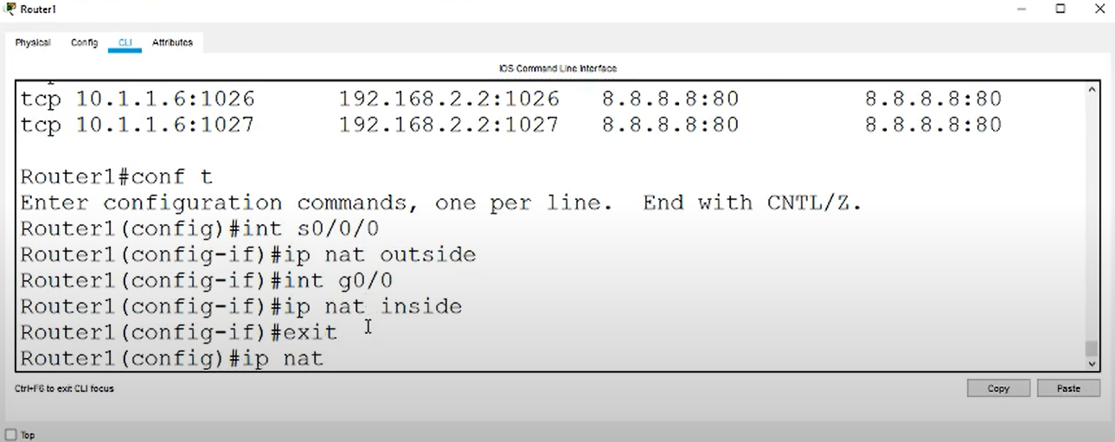

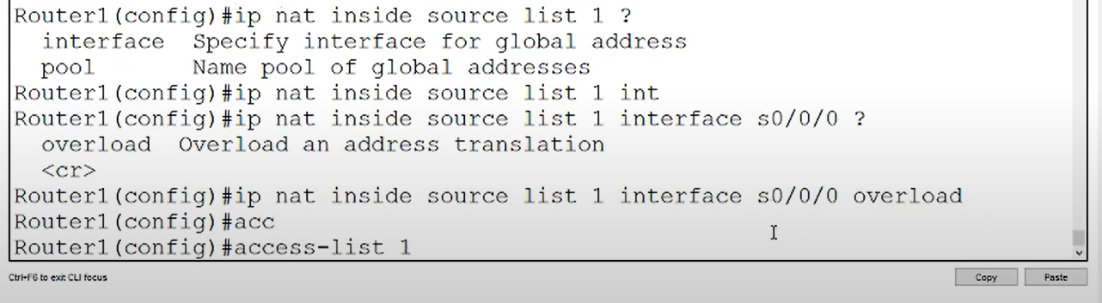

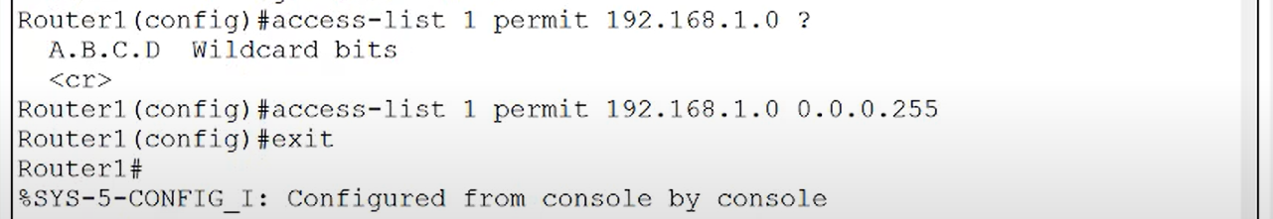

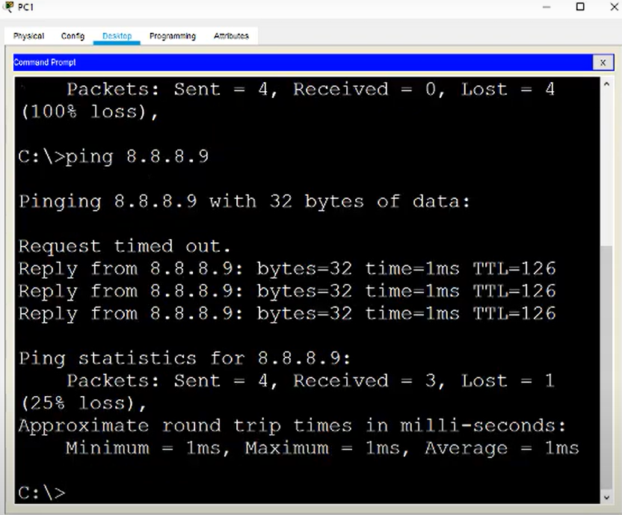

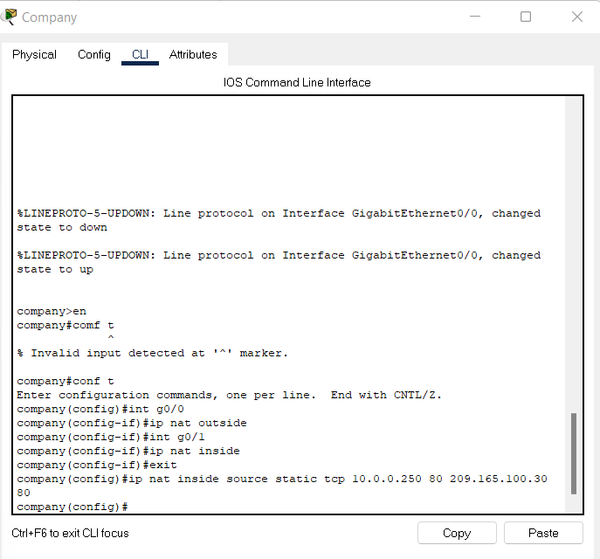

On typing ip address it hits other web server and displays output

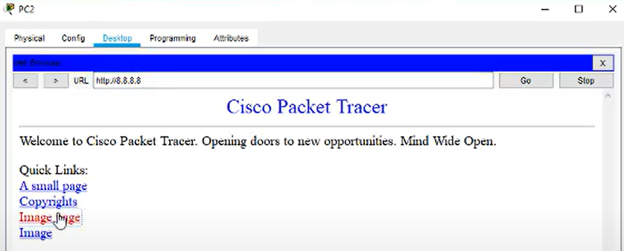

This was the port forwarding to 10.0.0.250 port 80

**Conclusion:Static NAT,dynamic NAT and PAT have been successfully implemented.**

**LAB 7**

**ARYAMAN MISHRA**

**19BCE1027**

**LAB 7**

**AIM:** Create a network topology with a CISCO ASA Firewall, Router, Switch, 3 PCs and a Server. Here, a PC is to be connected with ASA Firewall and two PCs are to be connected with switch. Do the following:

1. Create two VLANs

2. Configure the Router, Server and Firewall.

3. Ensure the firewall functionality by demonstrating the packet transmission between the PCs and Server.

4. Apply NAT

5. Use DHCP and ICMP protocols

6. Ping the connected PCs

Experiment:

Create a Topology

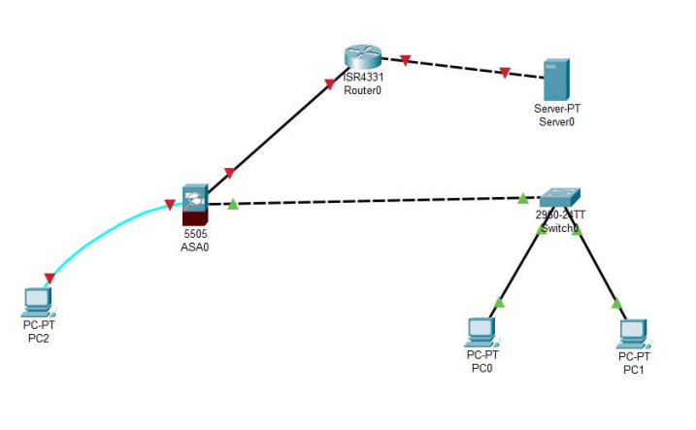

Turn on the routers.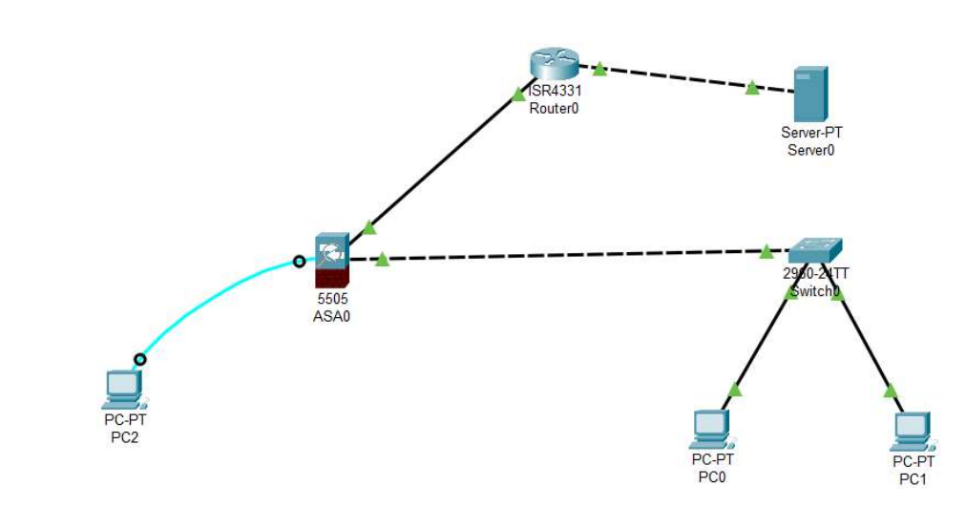Configuring 1 st VLAN with firewall.

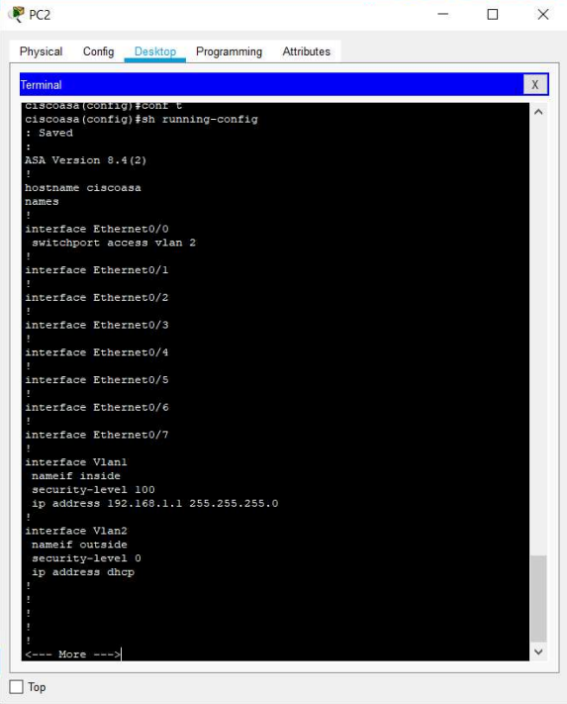

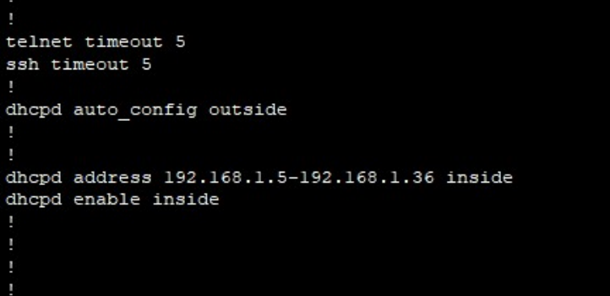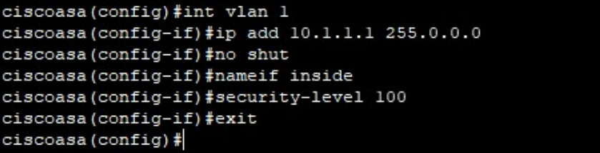

Setting the IP Address on Router 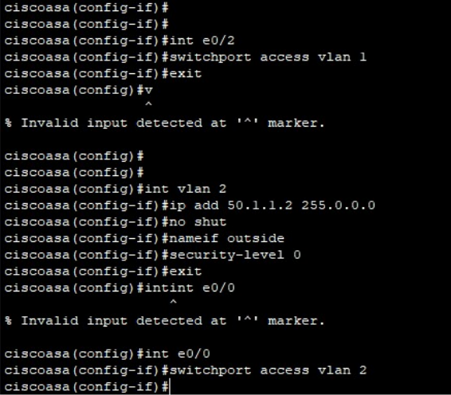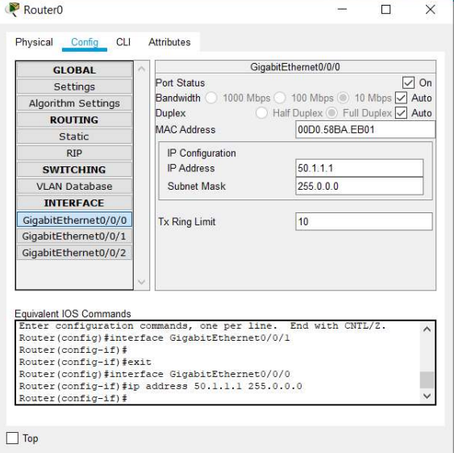

Setting the IP Address on Router 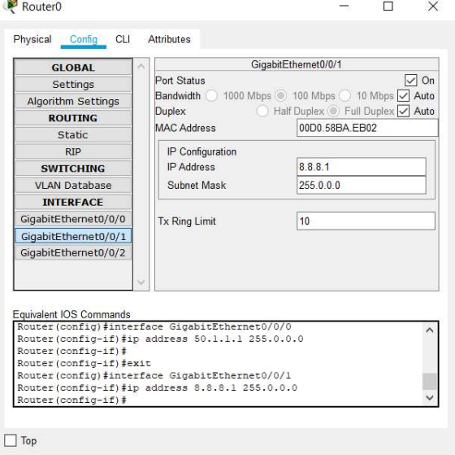

Setting the IP Address on the Server 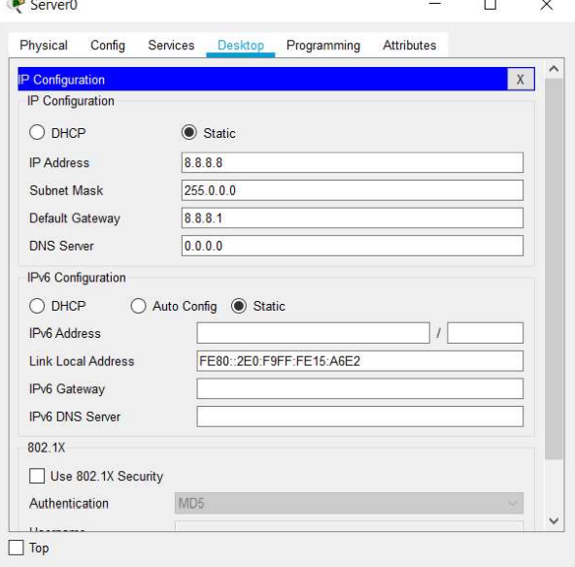

Setting DHCPD range for Firewall via the PC-2 and the DNS IP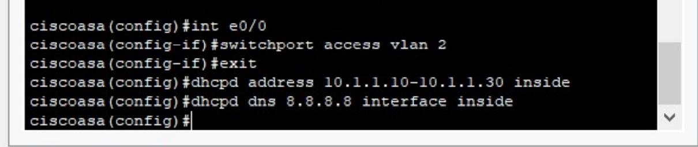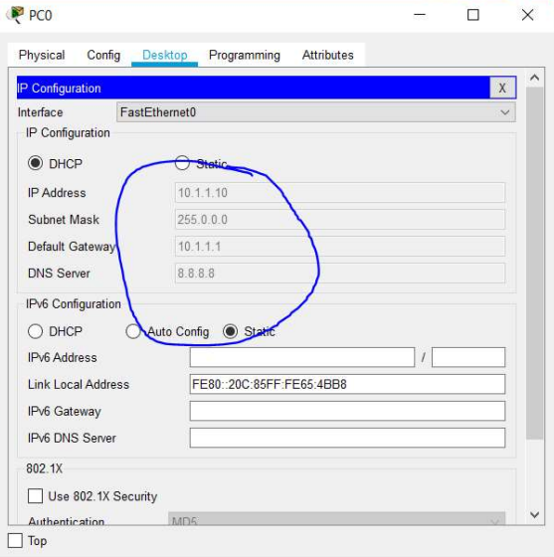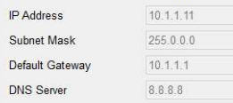

Setting up OSPF on the Router

Setting up OSPF on the Router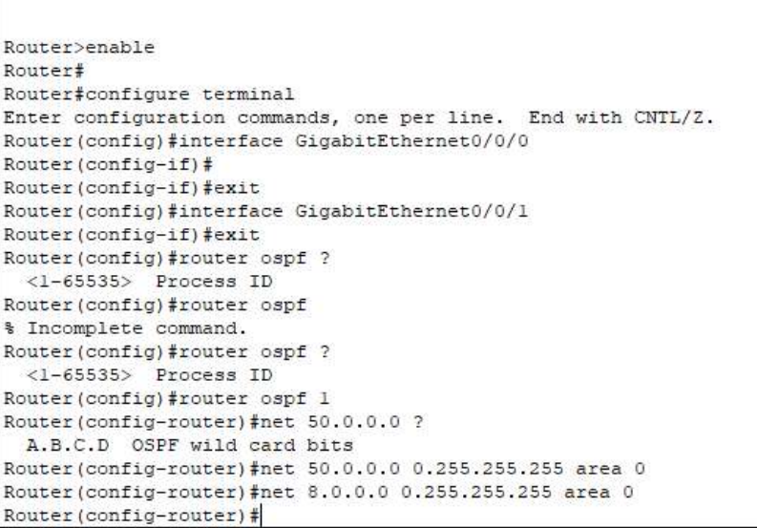

Enable NAT on ASA

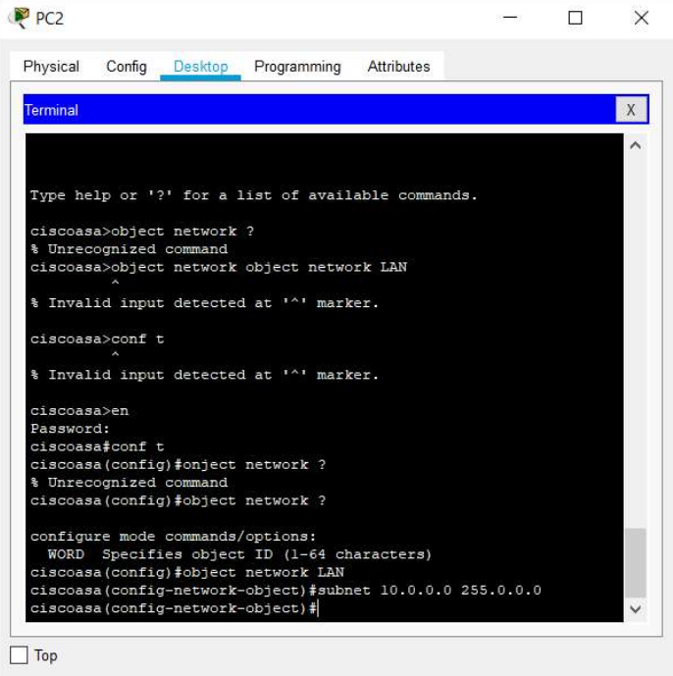

Enable NAT on ASA 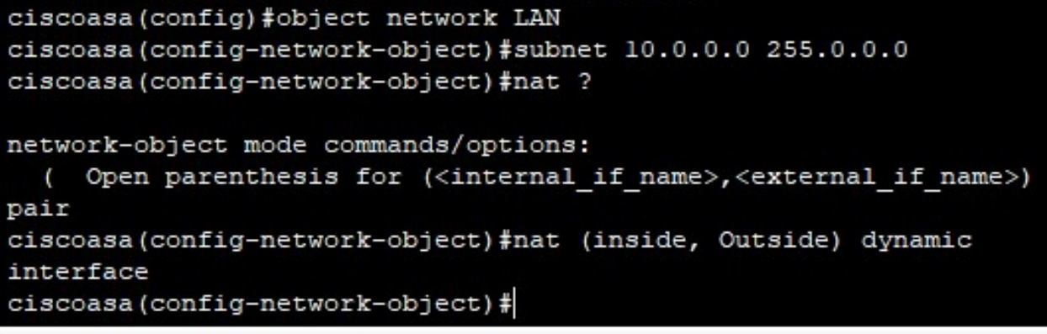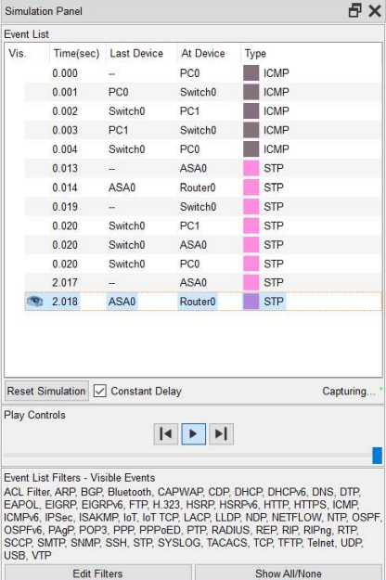

All steps have been successfully implemented and executed.

**LAB 8**

**Aryaman Mishra**

**19BCE1027**

**LAB 8-CA CERTIFICATE IN BURP SUITE**

Launch Burp suite from command line.

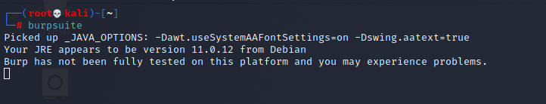

Select temporary Project and choose Burp default settings..

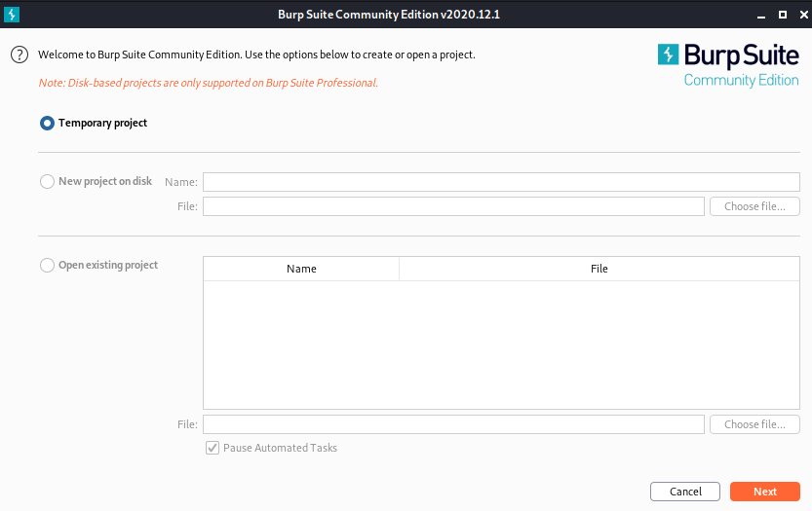

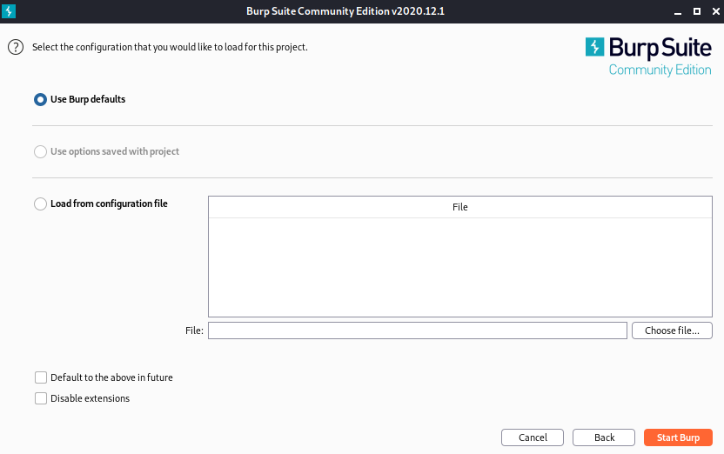

Go to Proxy tab and then to options.

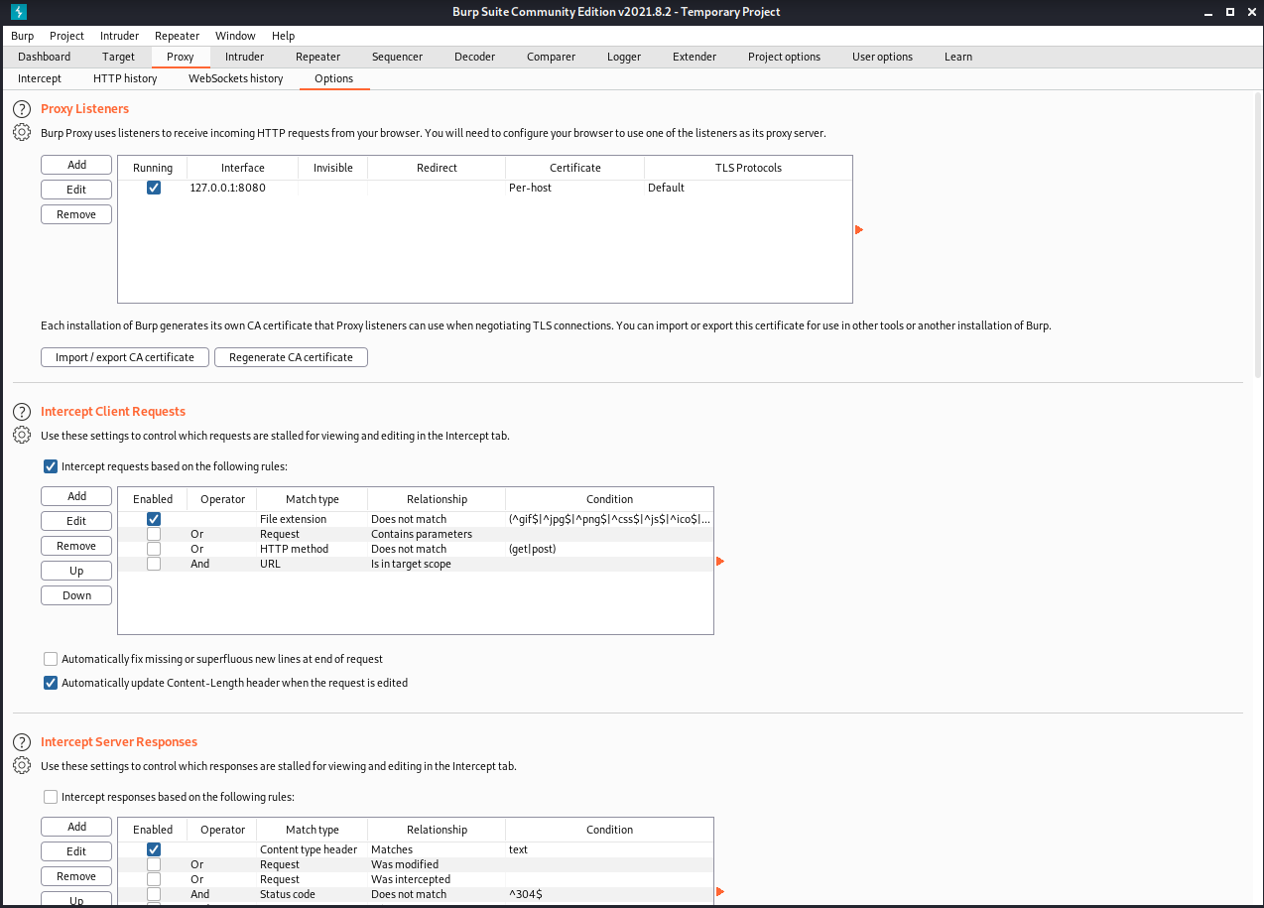

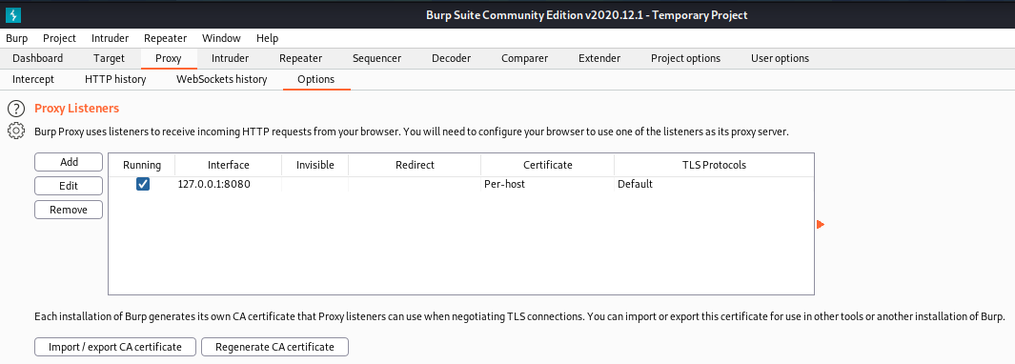

Burp is listening on this port and this interface.

The socket is 127.0.0.1:8080(loopback interface).Any request on this specific loopback interface will be captured by Burp.

We cannot send any request on the loopback interface so we will open Firefox browser.

Now Burp is ready to see requests from the browser.

To redirect requests on the proxy and not server,we will have to configure our Browser.

Mention target IP address on Manual settings.

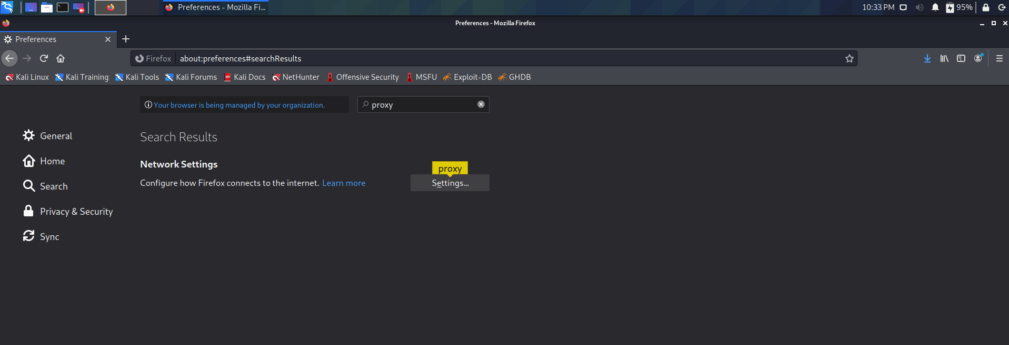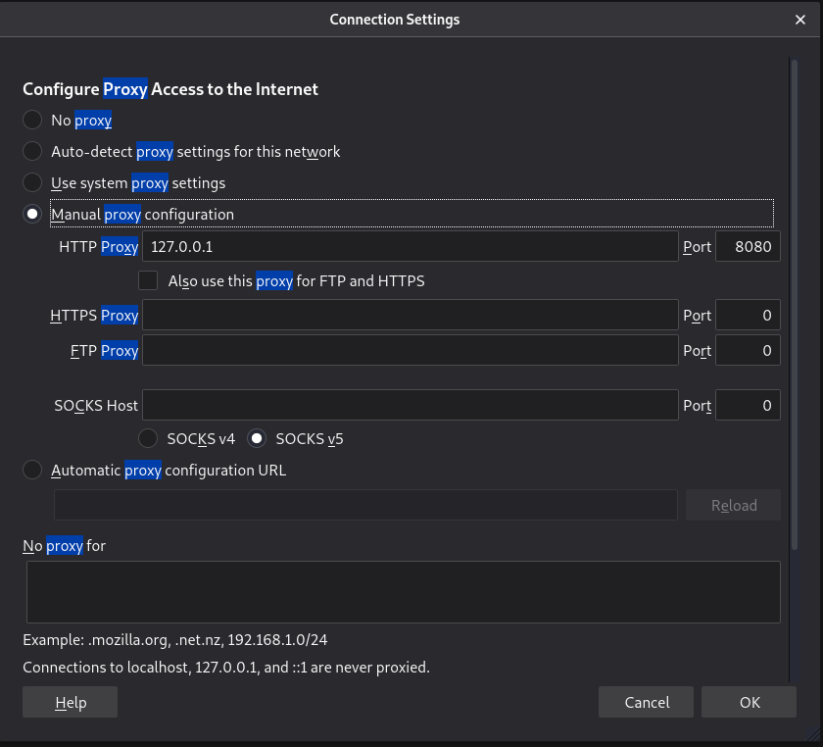

Any request will go through our Proxy.

Select Manual proxy option and type proxy ip same as that on burpsuite i.e. 127.0.0.1:8080.

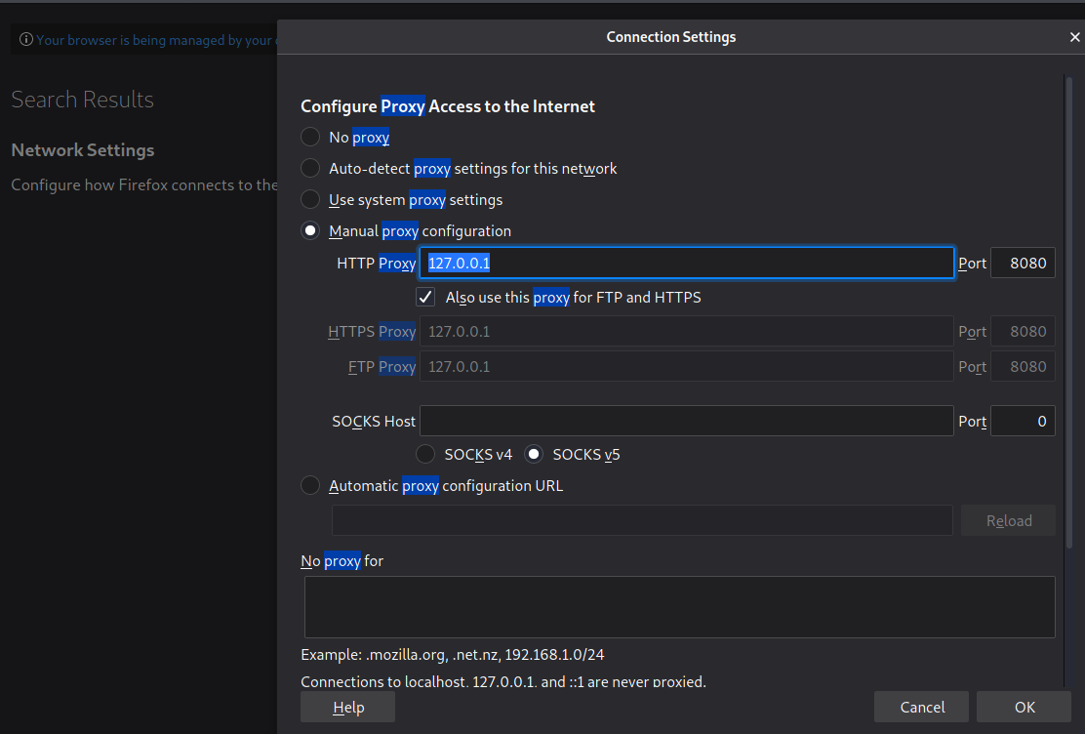

Now we will try to open a demo test website at **http://demo.testfire.net.**

Test site not loading when intercept is on for proxy as request reaches the proxy.



Intercept is highlighted orange.

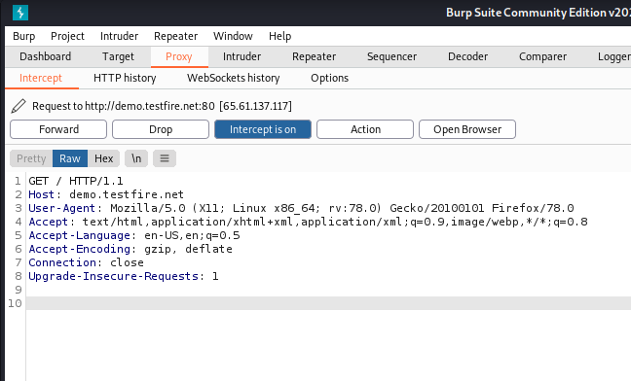

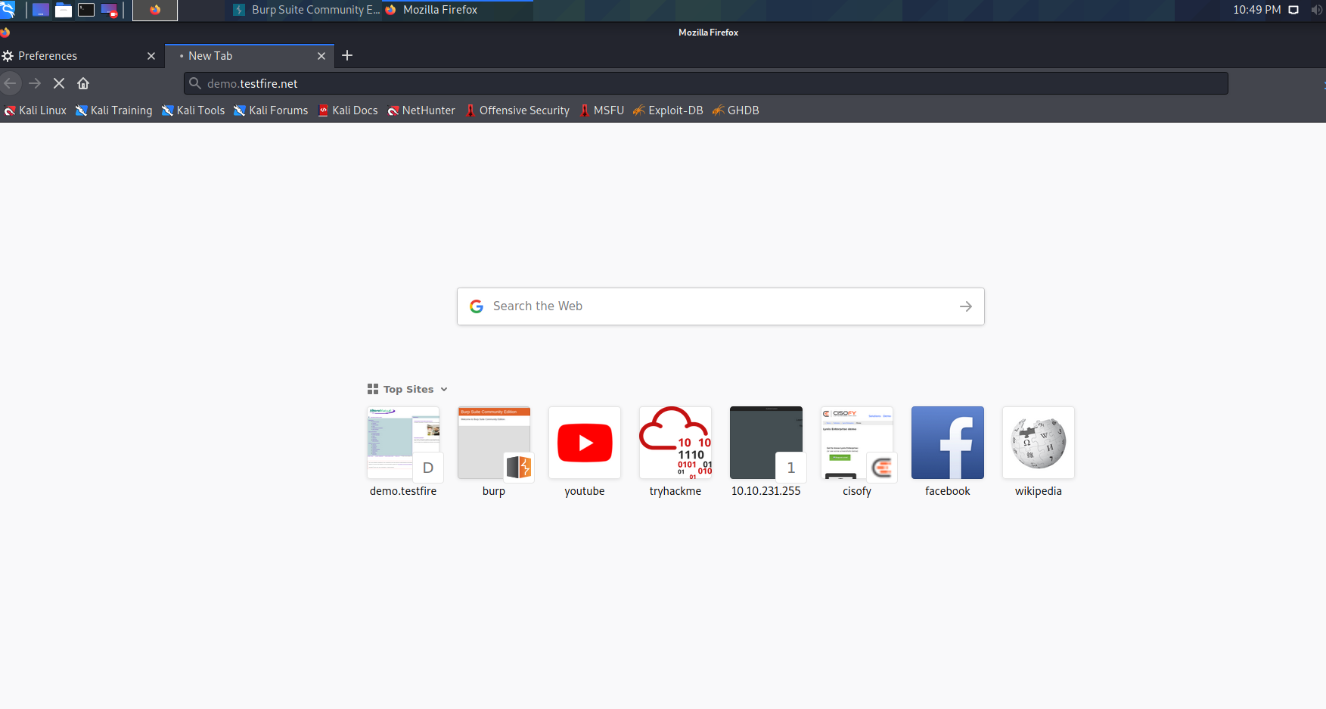

When intercept is off it will allow them to pass through.

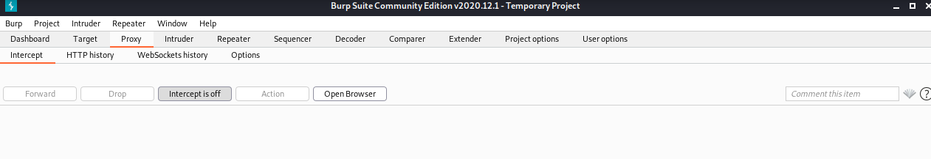

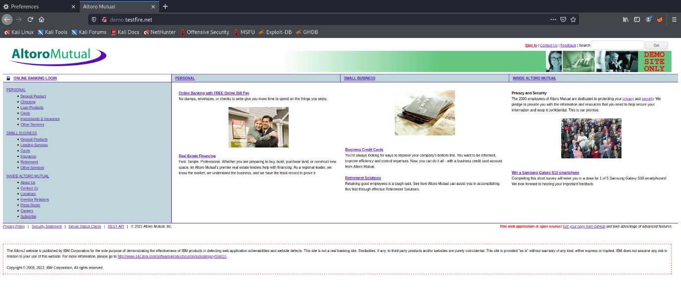

Download some CA certificates for burp in our browser so that the sites run.

Download certificate

Go to site <http://burp>

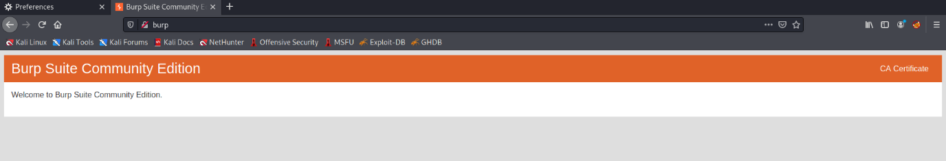

Click on CA certificate

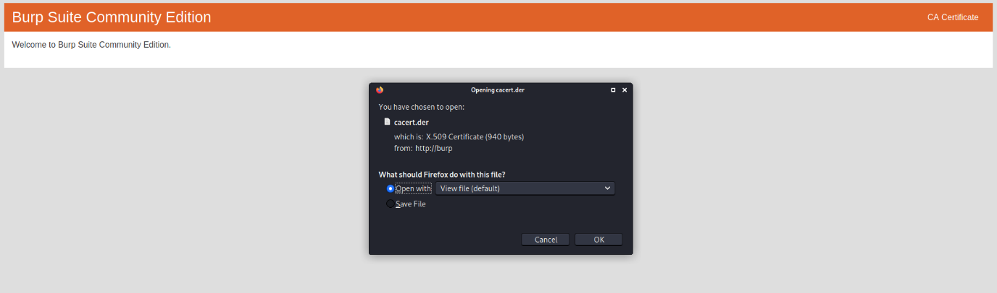

Download the certificate.

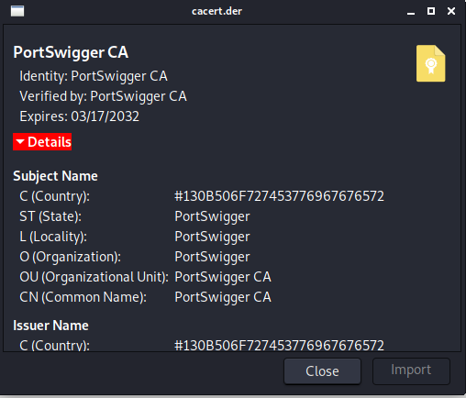

Import the certificates.

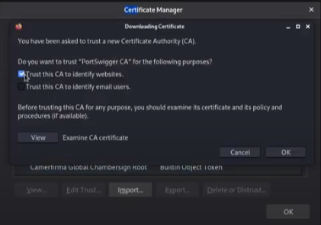

Download FoxyProxy add-on in Firefox.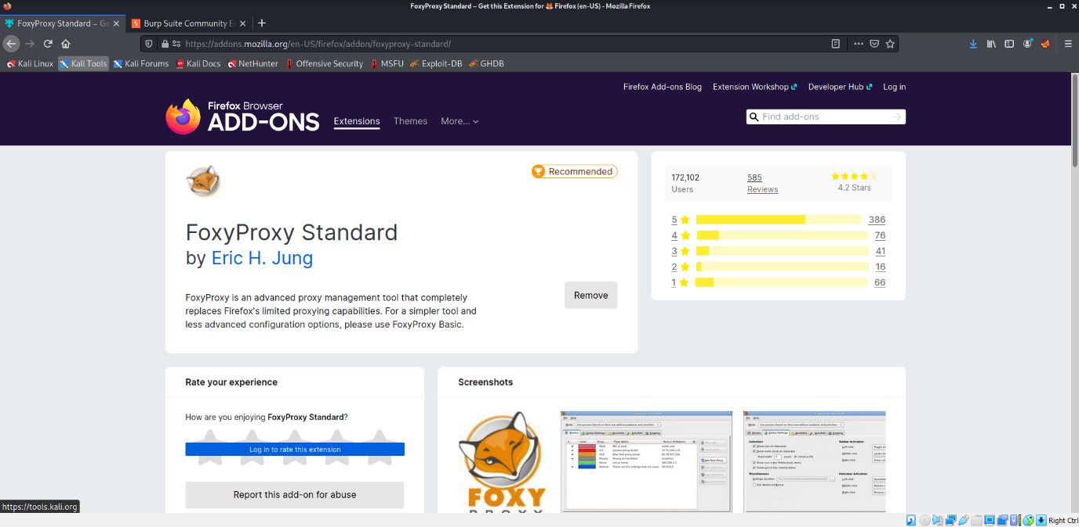

Click on options.

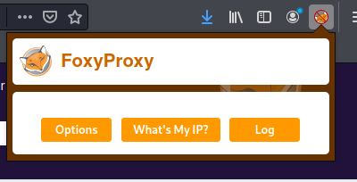

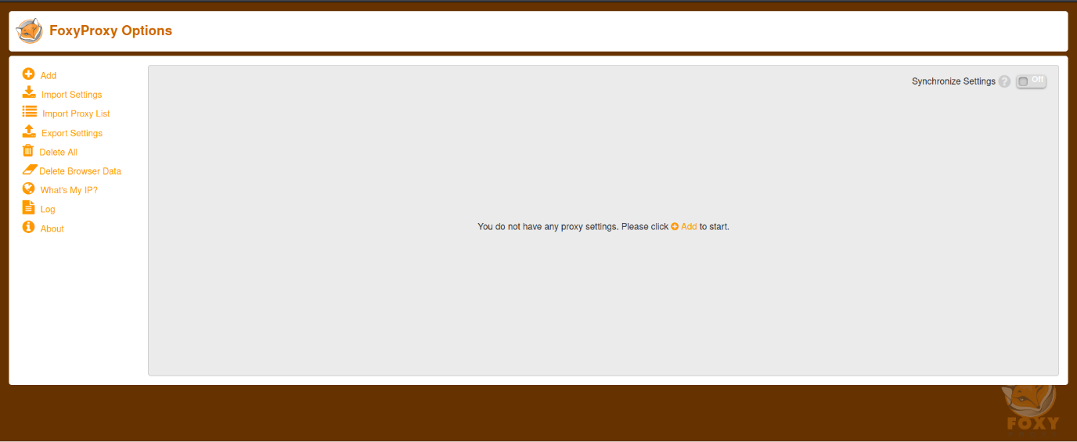

Fill proxy details and hit ‘save.’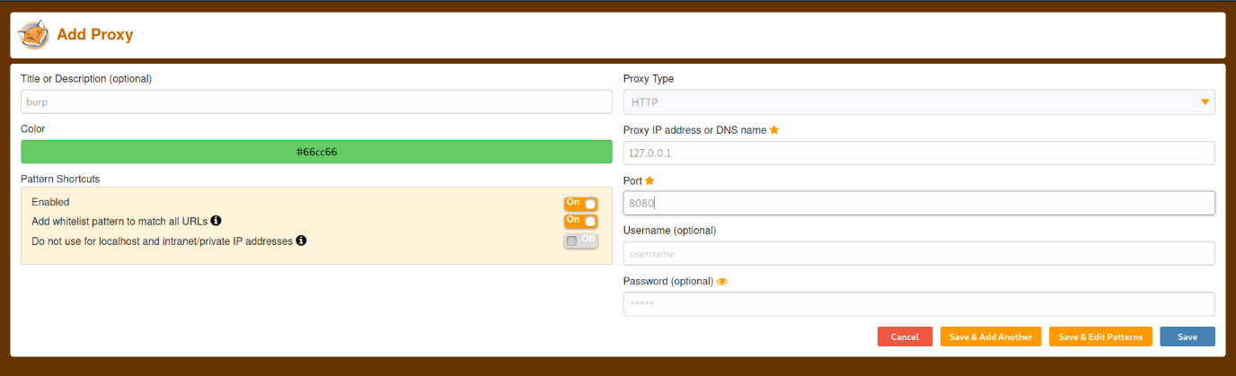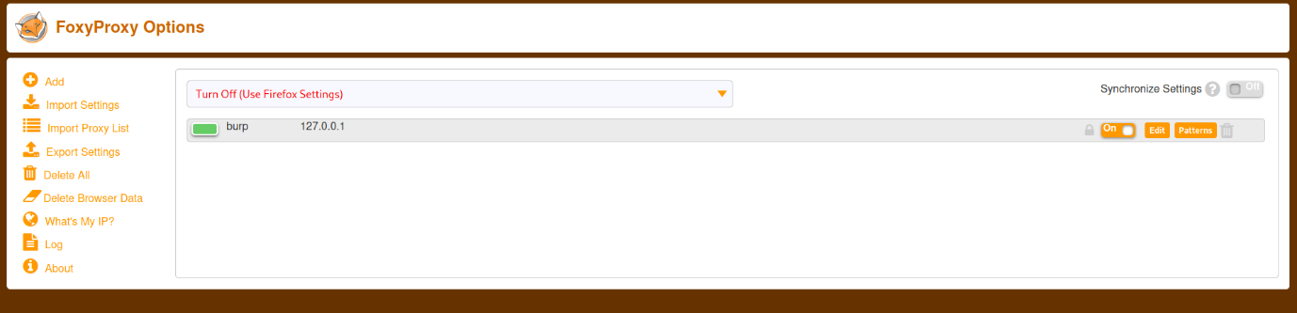

Revert to default settings in browser preferences.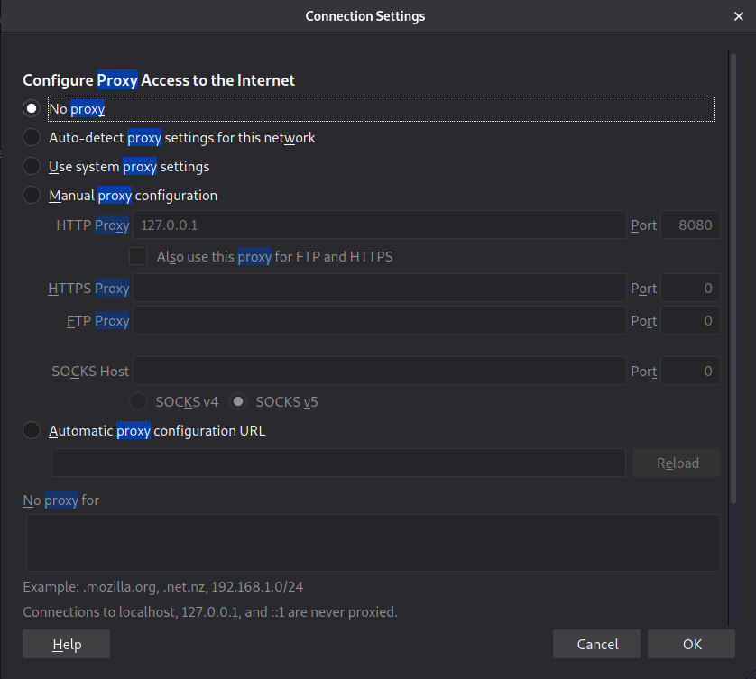

Enable burp proxy option in plugin. 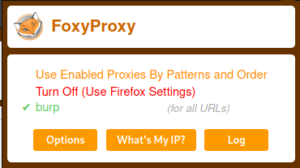

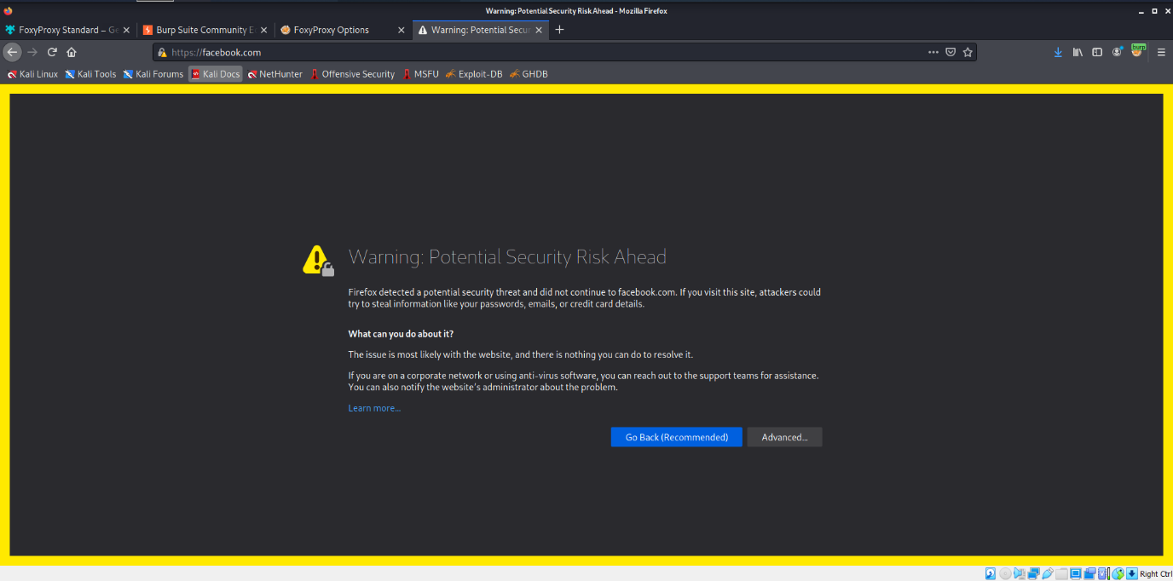 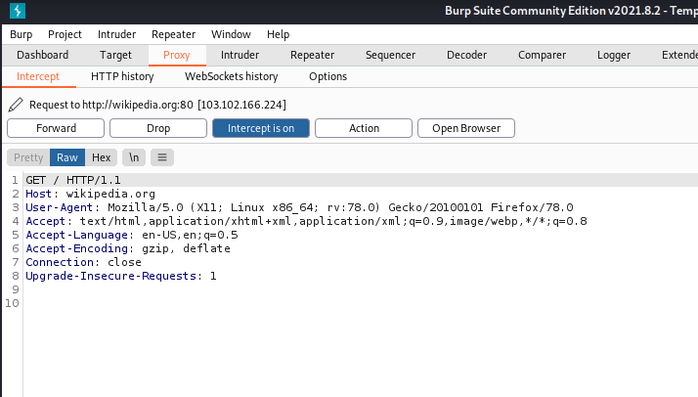

All requests will go through Proxy by Foxyproxy and not browser settings now.

**Conclusion:Burp suite and Proxy settings have been successfully implemented with their respective operations.**

**LAB 9**

Aryaman Mishra

19BCE1027

Sniper (Single payload attack)

This uses a single set of payloads. It targets each payload position in turn, and places each payload into that position in turn. Positions that are not targeted for a given request are not affected - the position markers are removed and any enclosed text that appears between them in the template remains unchanged. This attack type is useful for fuzzing a number of request parameters individually for common vulnerabilities. The total number of requests generated in the attack is the product of the number of positions and the number of payloads in the payload set.

Battering ram (Single payload attack)

This uses a single set of payloads. It iterates through the payloads, and places the same payload into all of the defined payload positions at once. This attack type is useful where an attack requires the same input to be inserted in multiple places within the request (e.g. a username within a Cookie and a body parameter). The total number of requests generated in the attack is the number of payloads in the payload set.

Pitchfork

This uses multiple payload sets. There is a different payload set for each defined position (up to a maximum of 20). The attack iterates through all payload sets simultaneously, and places one payload into each defined position. In other words, the first request will place the first payload from payload set 1 into position 1 and the first payload from payload set 2 into position 2; the second request will place the second payload from payload set 1 into position 1 and the second payload from payload set 2 into position 2, etc. This attack type is useful where an attack requires different but related input to be inserted in multiple places within the request (e.g. a username in one parameter, and a known ID number corresponding to that username in another parameter). The total number of requests generated in the attack is the number of payloads in the smallest payload set.

Cluster bomb

This uses multiple payload sets. There is a different payload set for each defined position (up to a maximum of 20). The attack iterates through each payload set in turn, so that all permutations of payload combinations are tested. I.e., if there are two payload positions, the attack will place the first payload from payload set 2 into position 2, and iterate through all the payloads in payload set 1 in position 1; it will then place the second payload from payload set 2 into position 2, and iterate through all the payloads in payload set 1 in position 1. This attack type is useful where an attack requires different and unrelated or unknown input to be inserted in multiple places within the request (e.g. when guessing credentials, a username in one parameter, and a password in another parameter). The total number of requests generated in the attack is the product of the number of payloads in all defined payload sets - this may be extremely large. 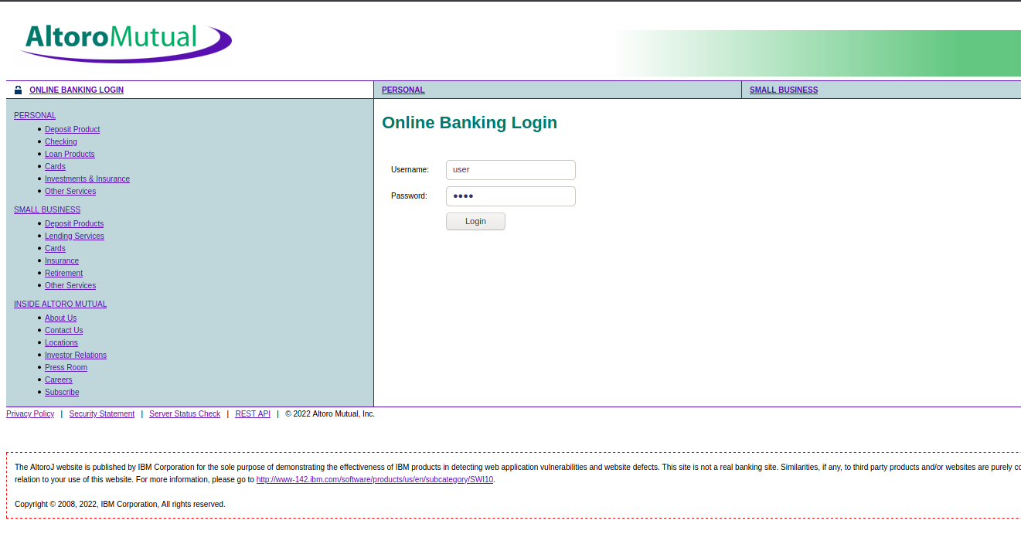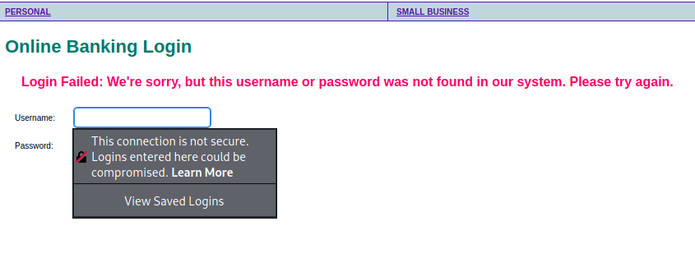

Pitchfork

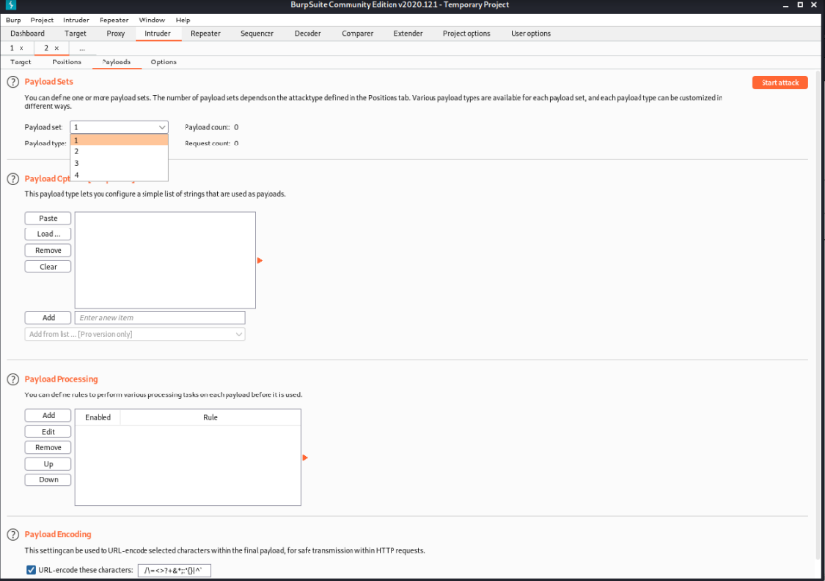

Cluster Bomb

Payload

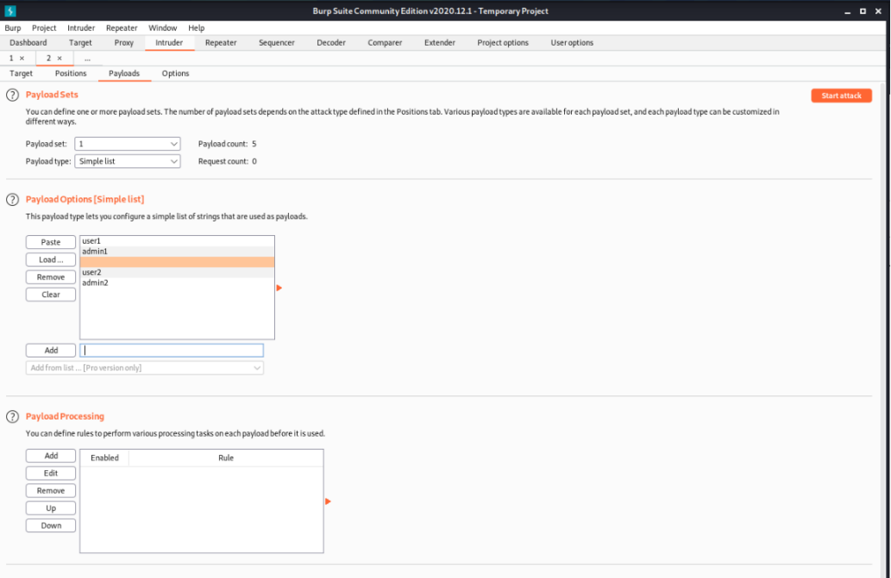

For sniper attack

Start attack

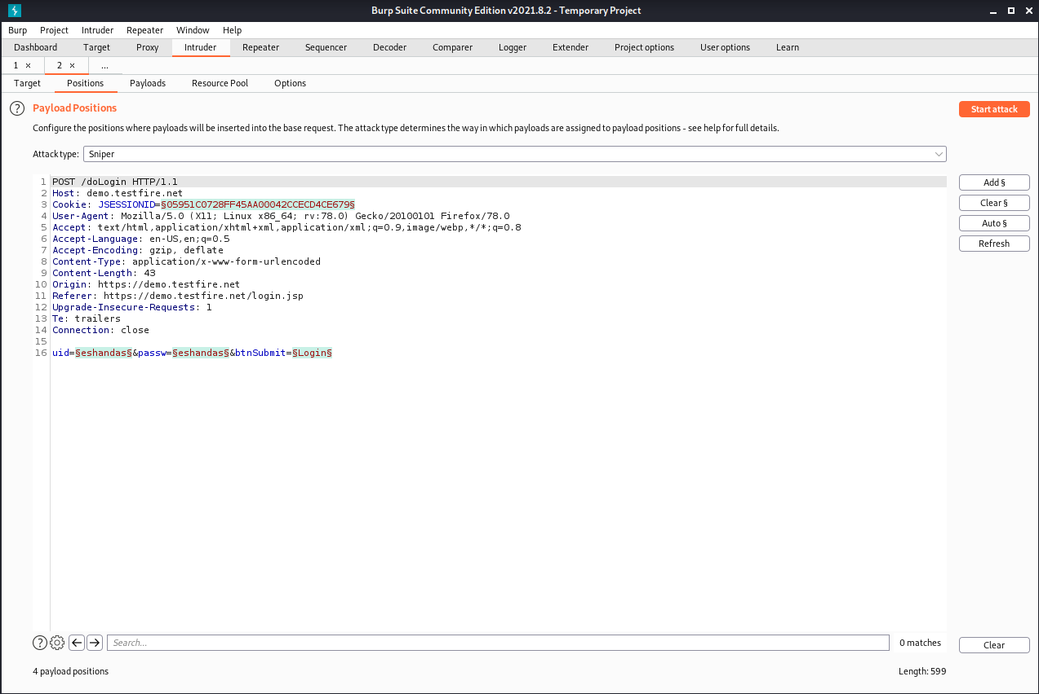

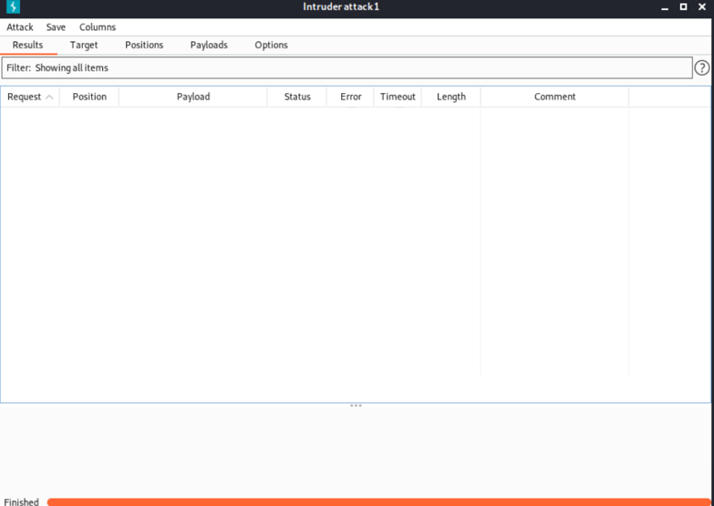

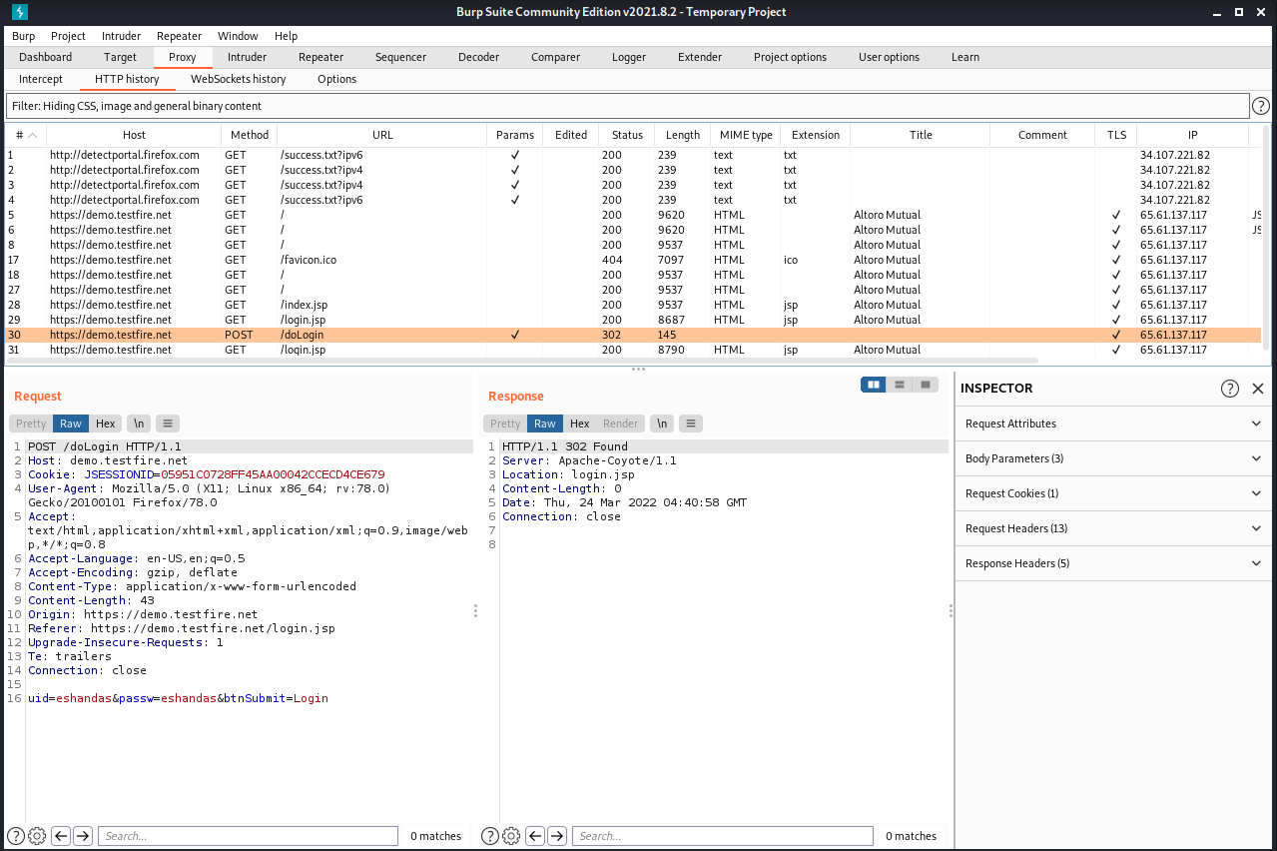

Demo website 4 attacks and Own website 4 attacks

Battering ram attack

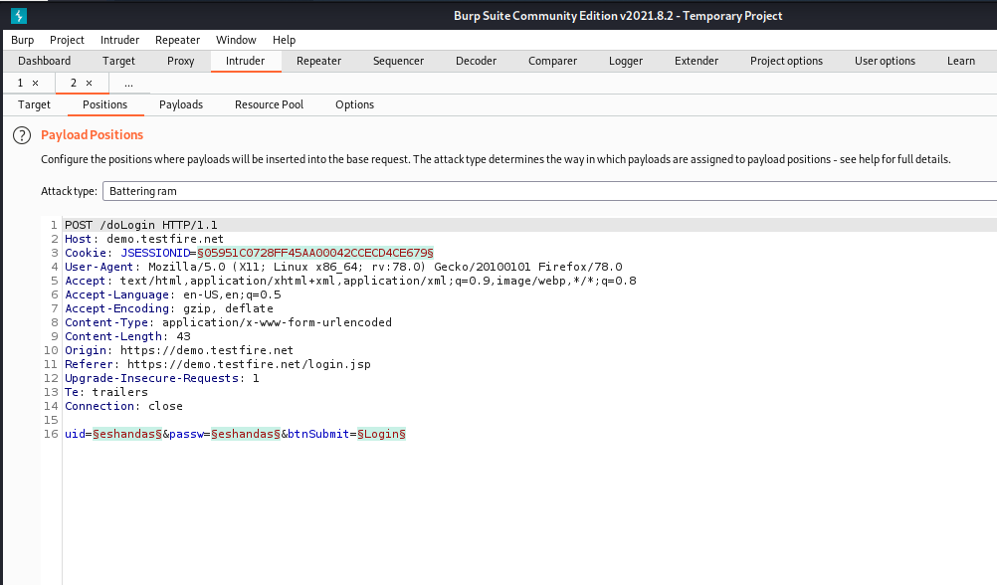

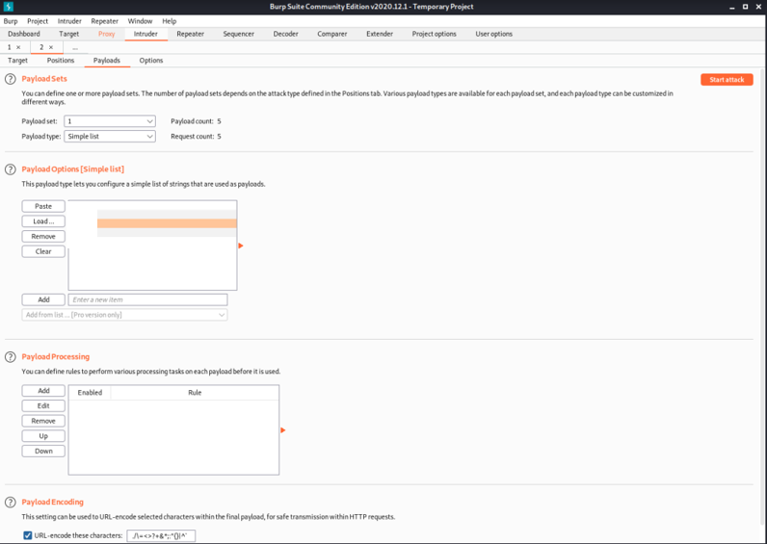

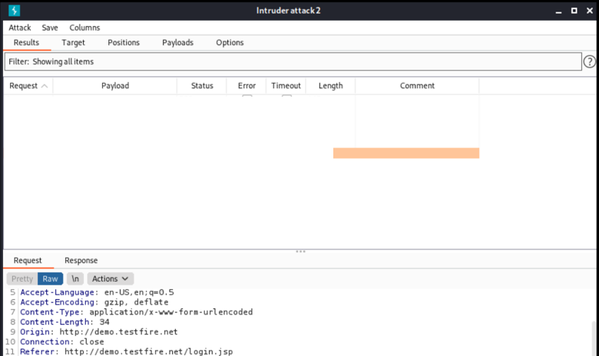

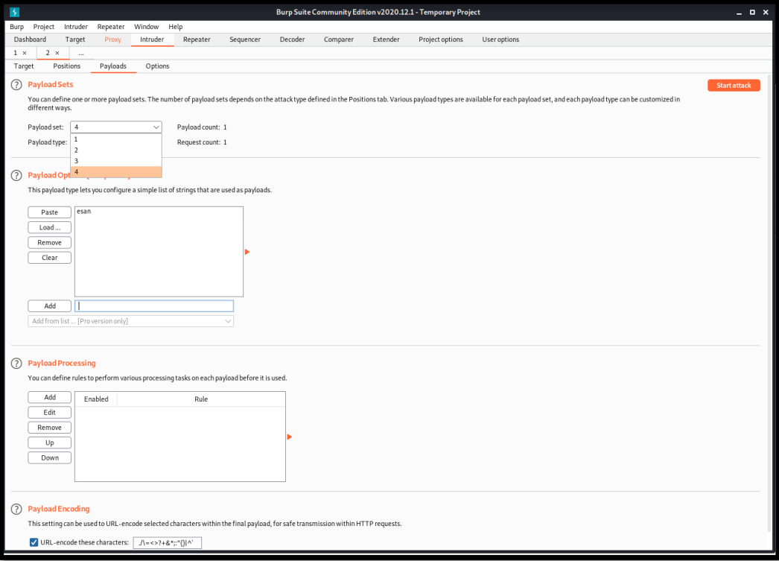

Pitchfork attack ()

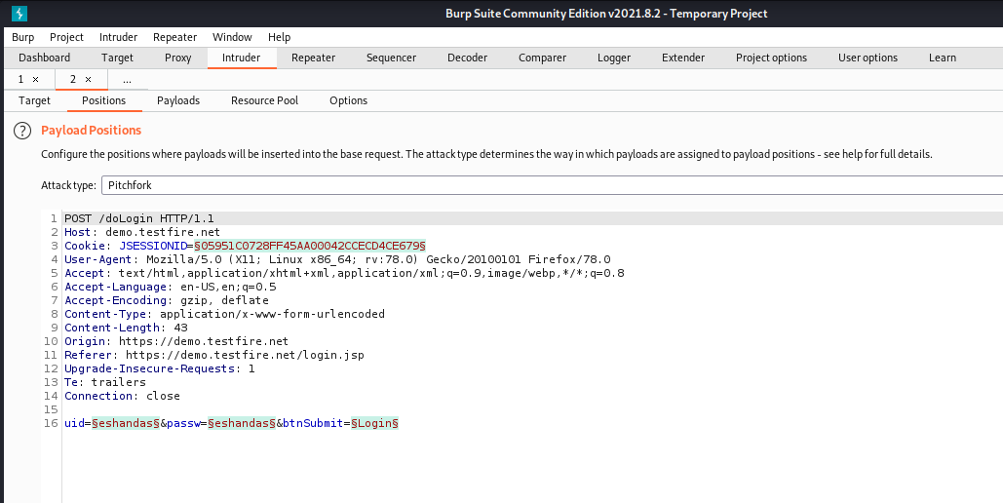

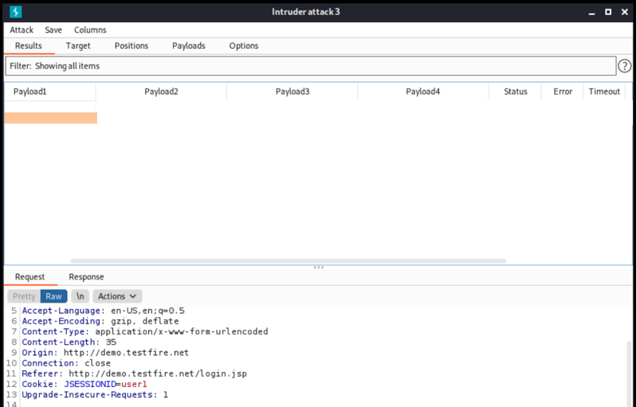

Clustering Bomb Attack

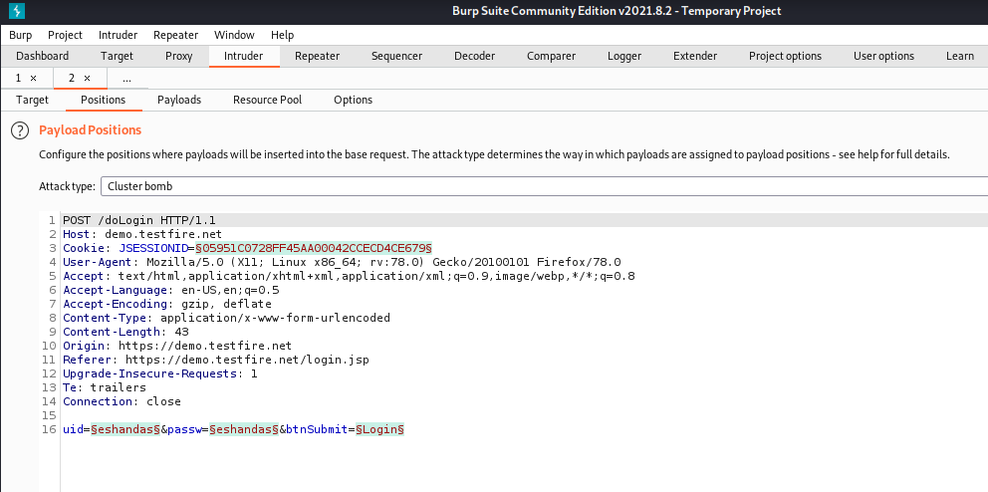

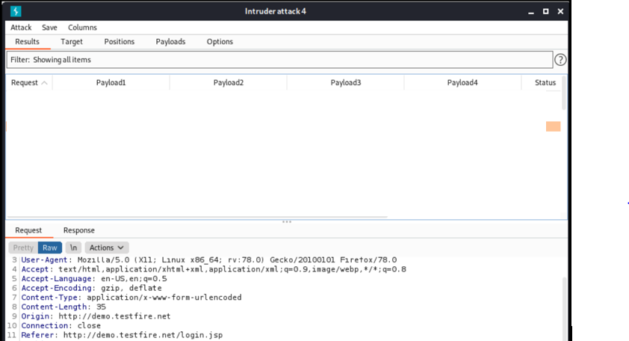

OWN website experiments

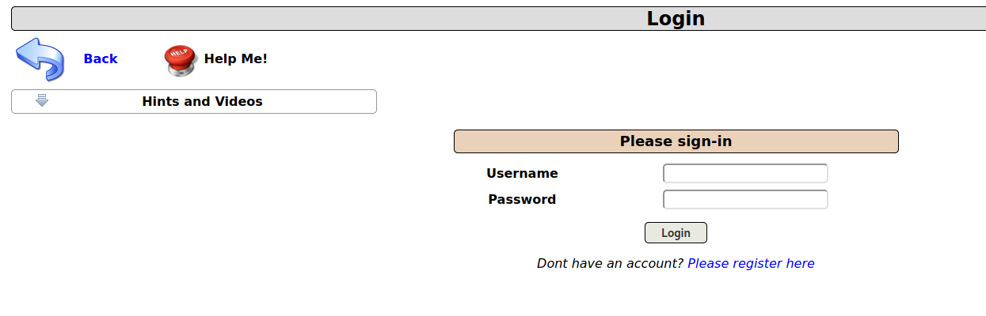

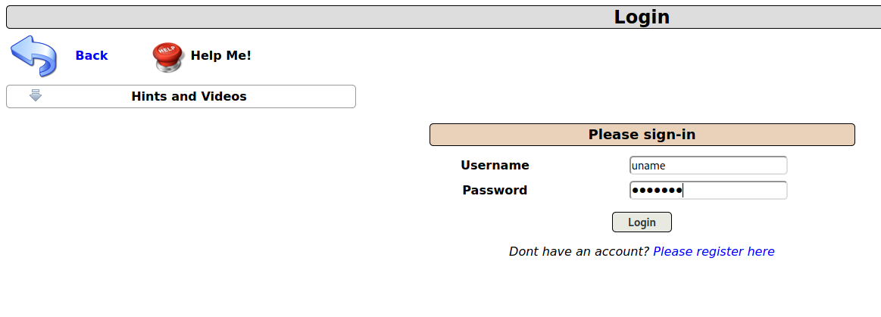

Username:uname

Password:pass123

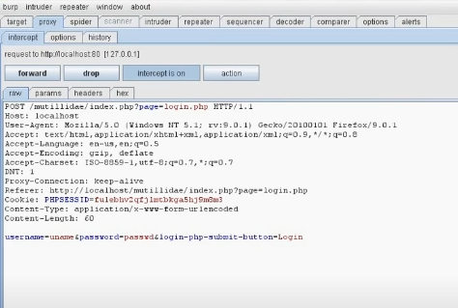

Click on ‘send to intruder.’ And turn intercept off.

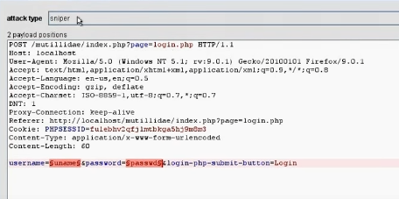

Login the website Quickstore Admin Portal (Self-made website)

Go to burpsuite then choose Intruder and then select target

Again set target host as 127.0.0.1

Port :80

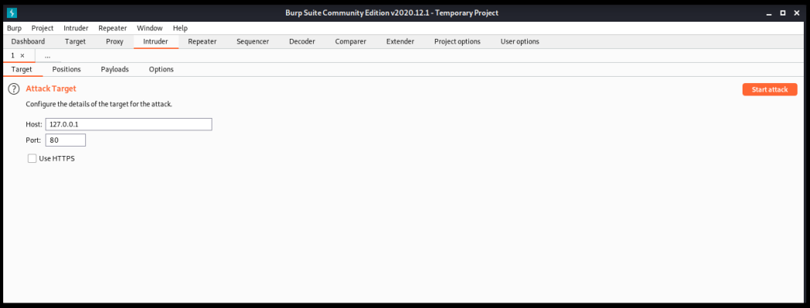

Go to payloads section and payloads as per attack type

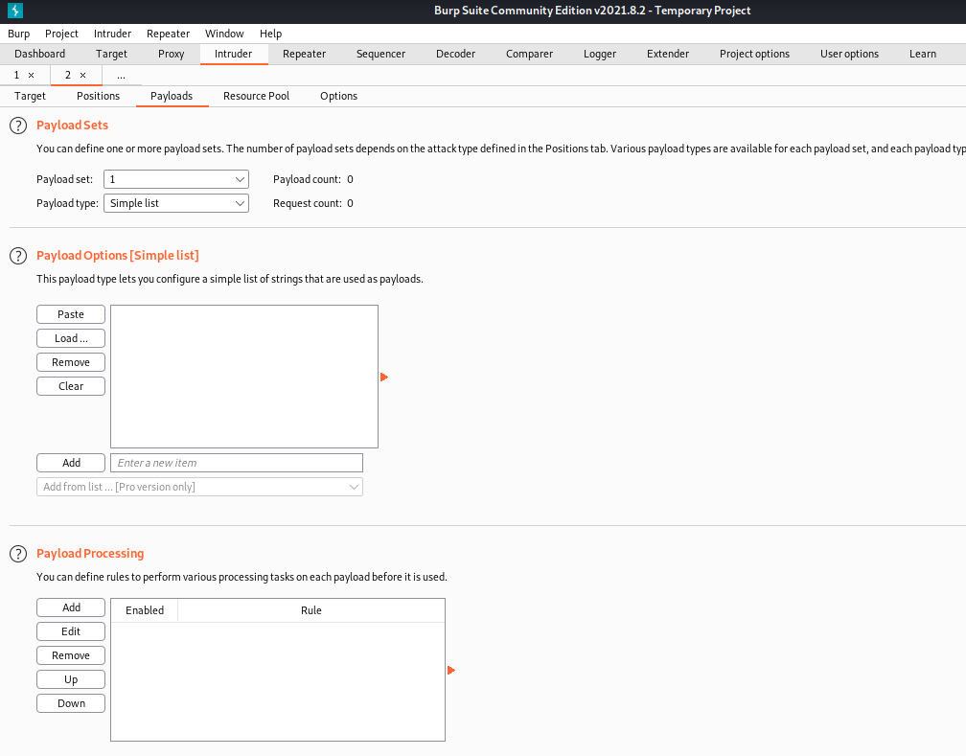

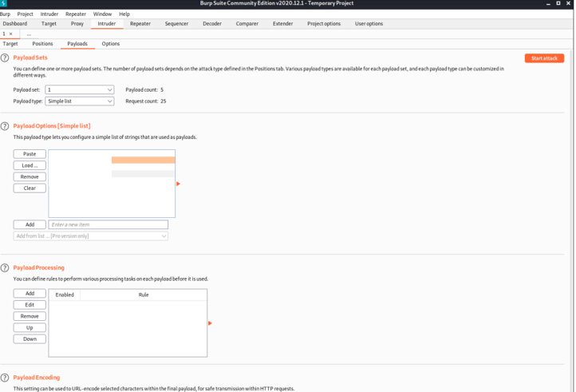

Set attack type: sniper

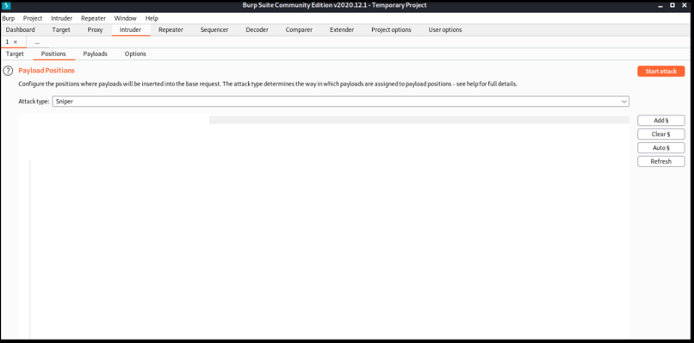

Start Attack

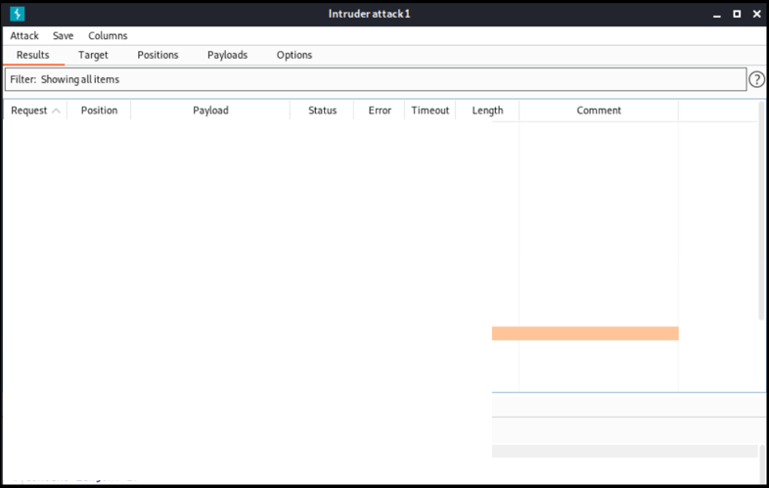

Battering ram attack

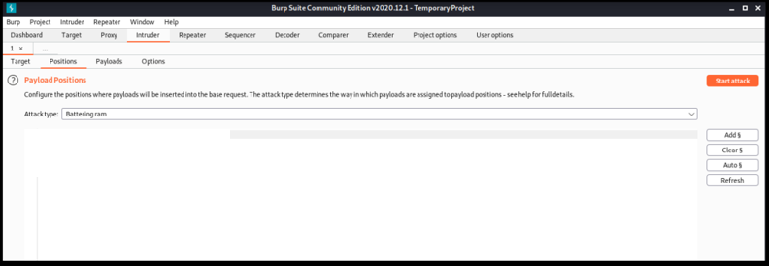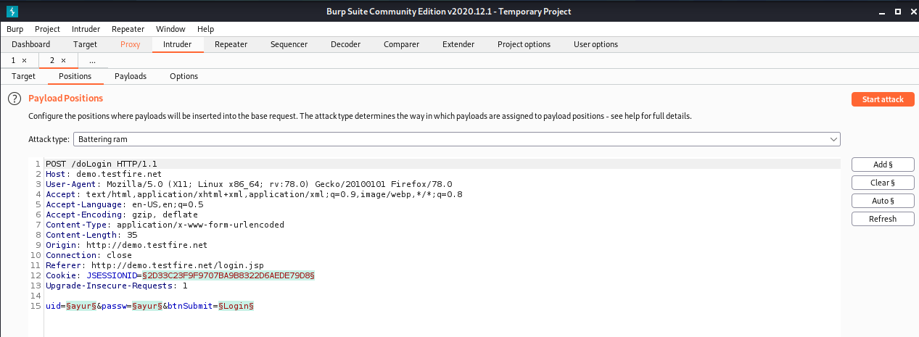

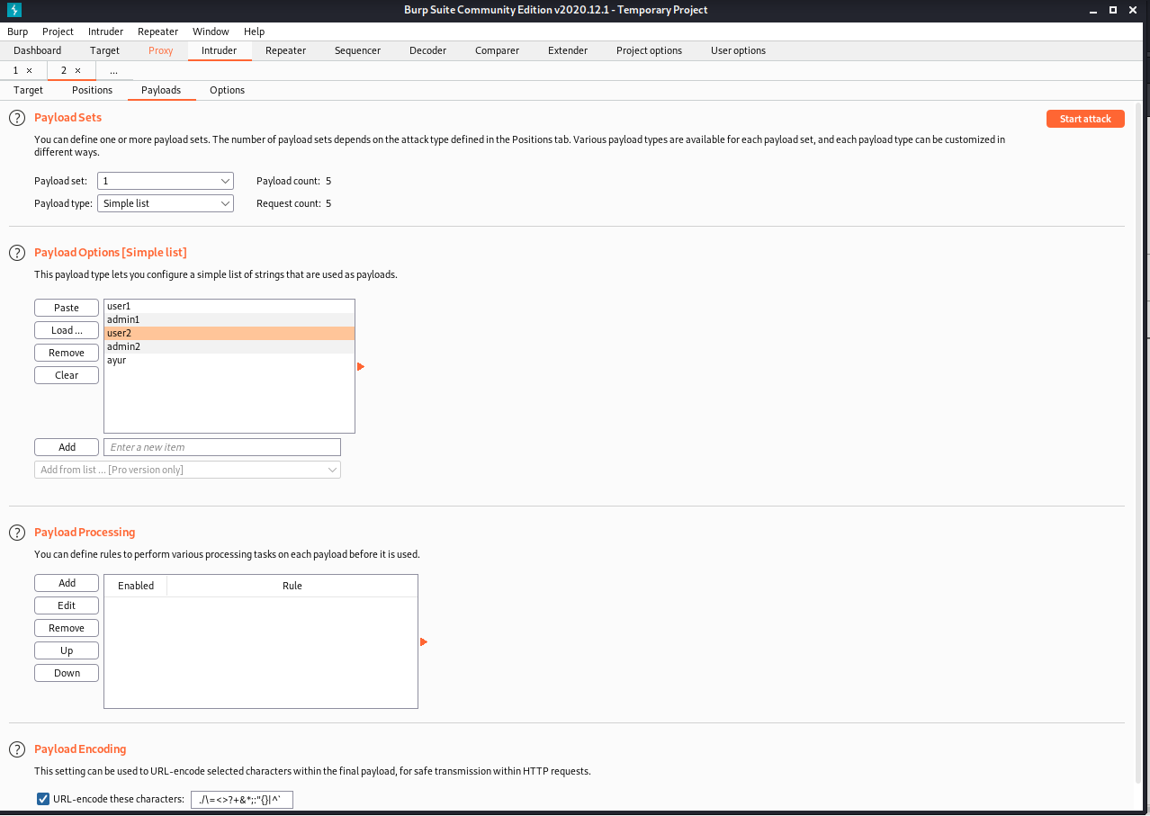

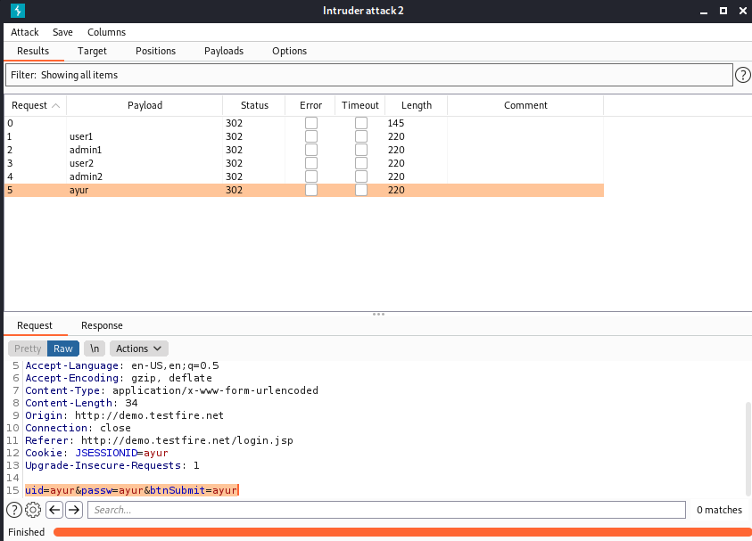

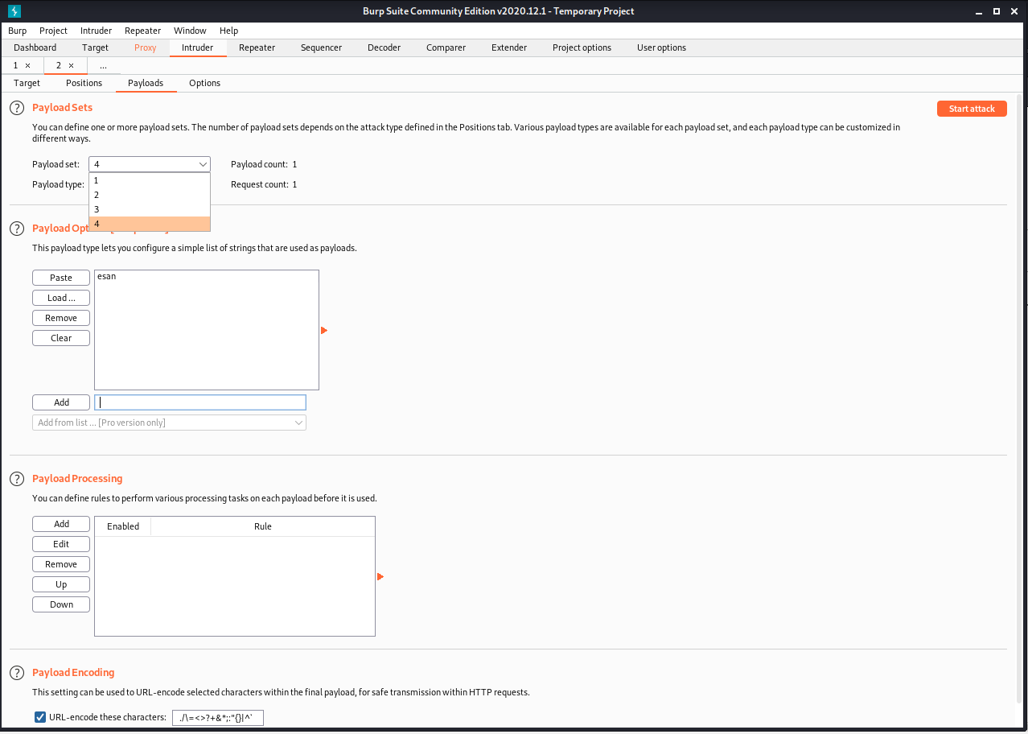

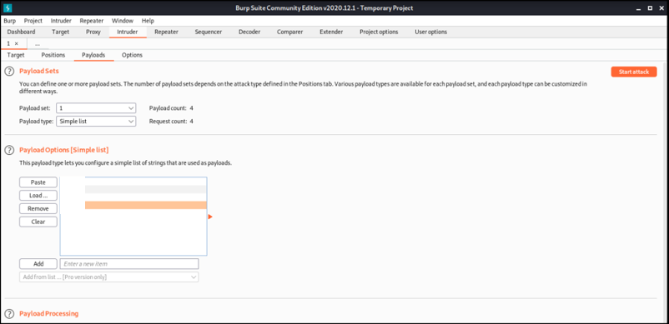

Pitchfork attack

Provide different values for payloads and click on start attack

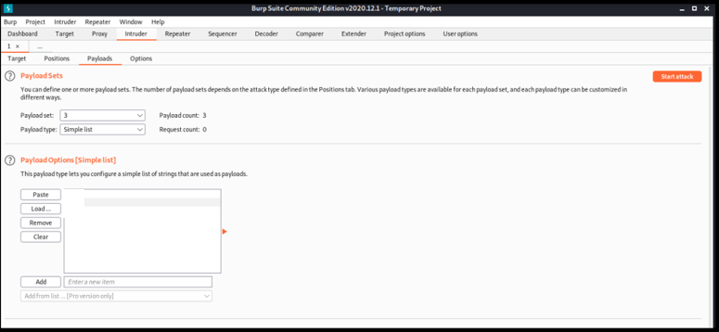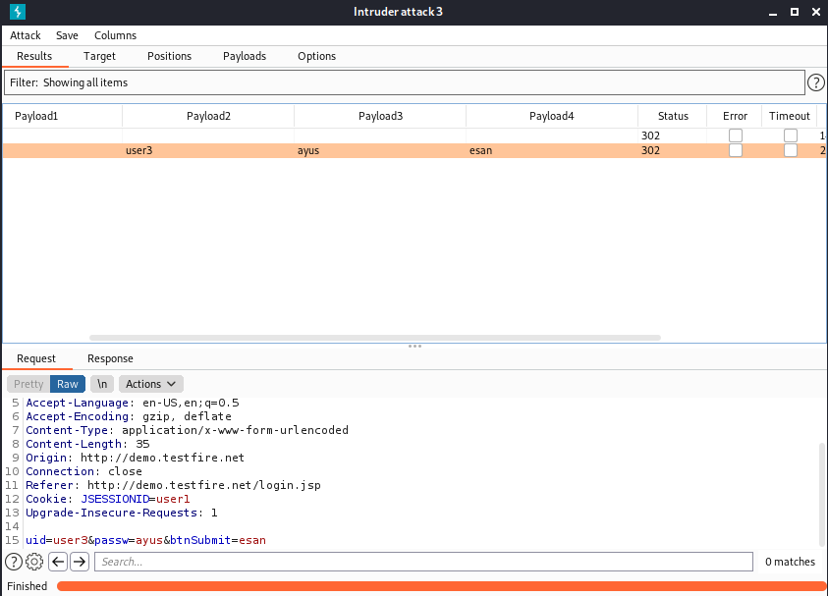

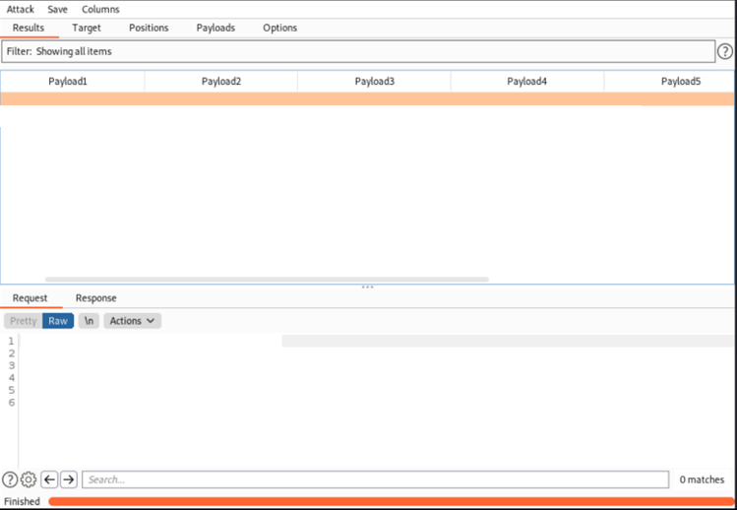

Clustering Bomb attack

Provide different values for payloads and click on start attack

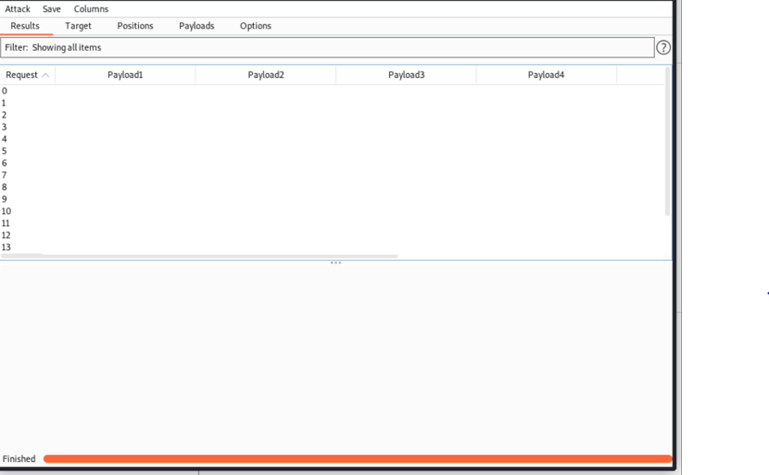

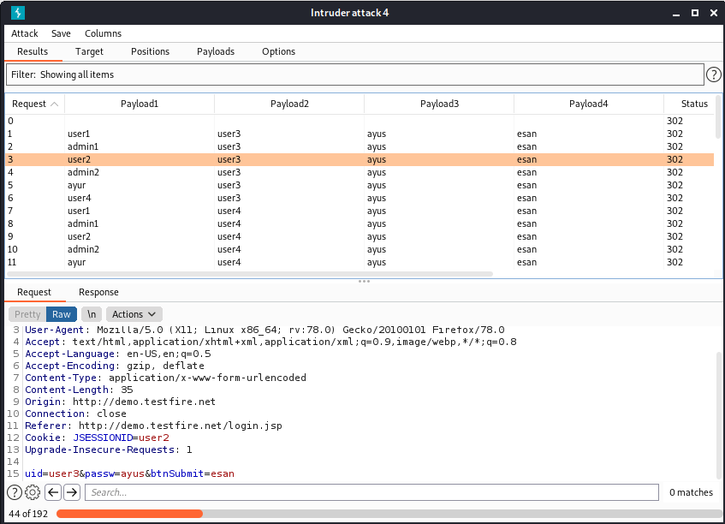

Result: **All the attacks were successfully executed on a demo website and a self- made demo website used for login.**

**LAB 10**

**Aryaman Mishra**

**19BCE1027**

DVWA is made with PHP and MySQL for security professionals or aspiring security professionals to discover as many issues as possible and exploit some of the most commons vulnerabilities of web platforms like **SQL injection**, **Cross Site Scripting** (XSS), **Cross Site Request Forgery** (CSRF), and more.

<https://github.com/digininja/DVWA.git>

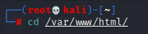

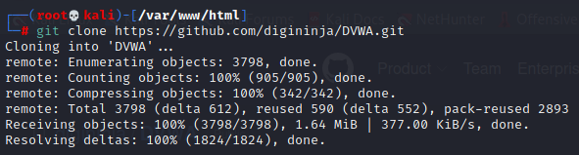

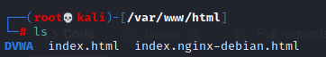

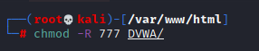

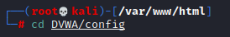

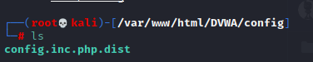

We will use the text editor to edit the configuration typing the following command:

sudo vim /var/[www/html/dvwa/config/config.inc.php.dist](http://www/html/dvwa/config/config.inc.php.dist)

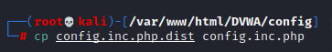

Change username and password as required by you. 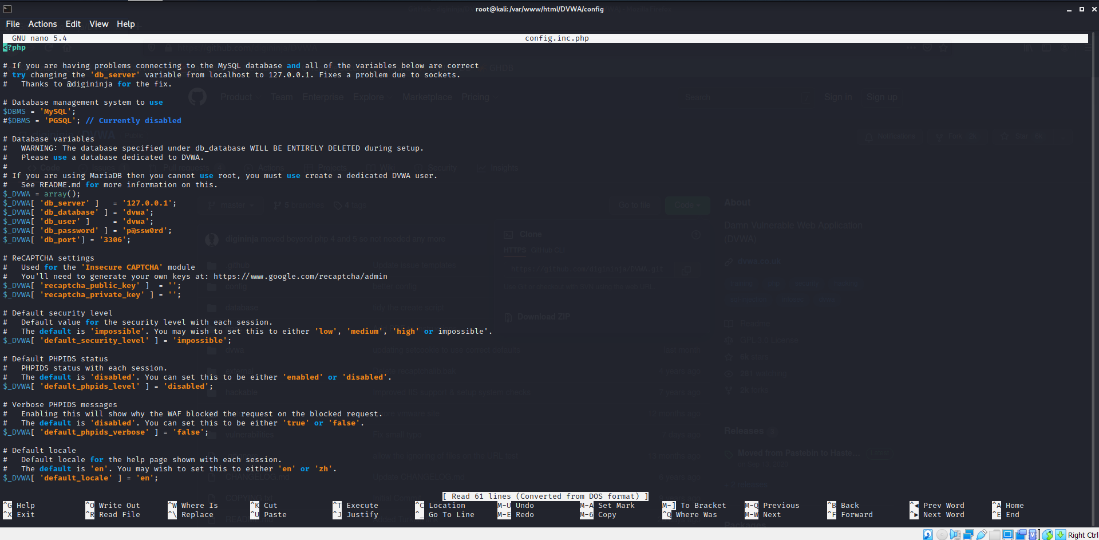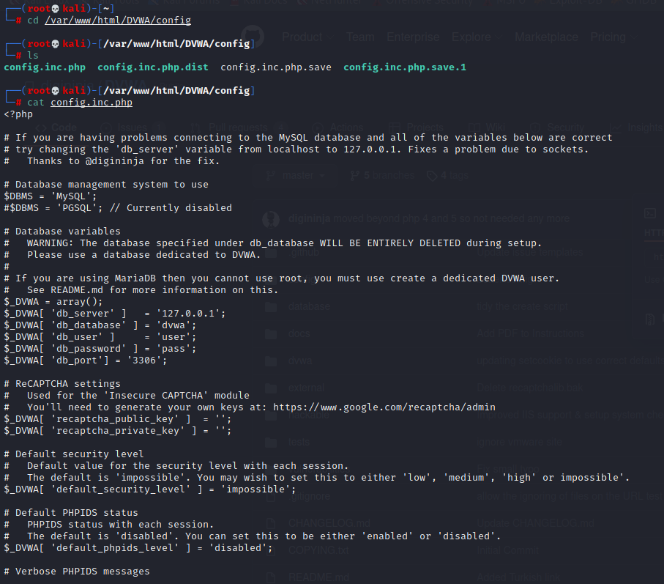

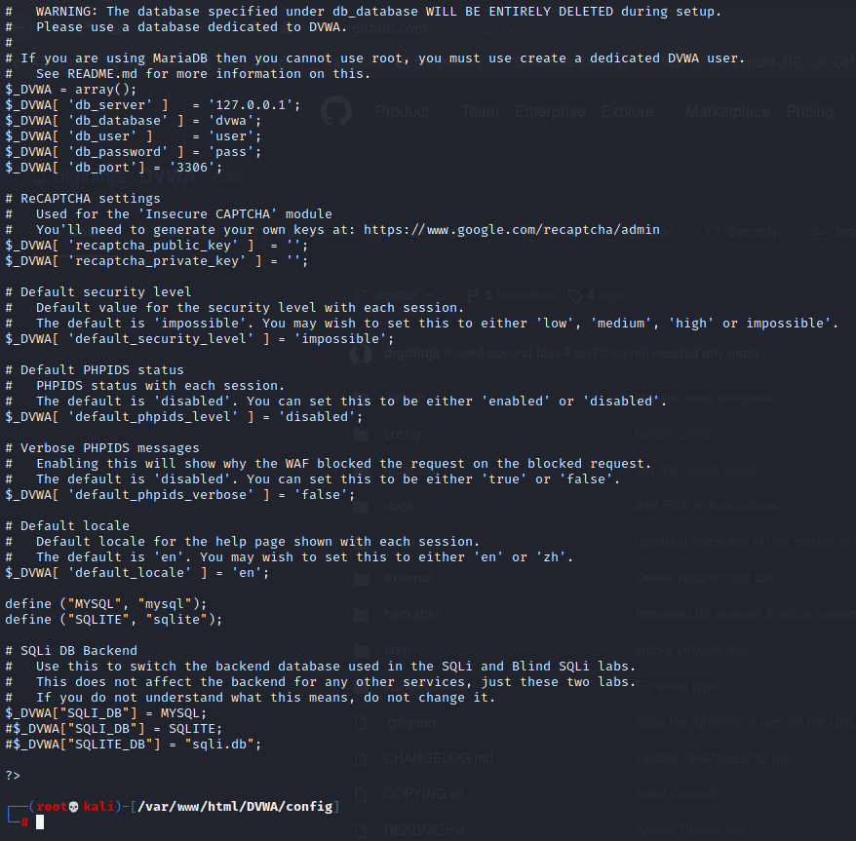

Start Mysql server.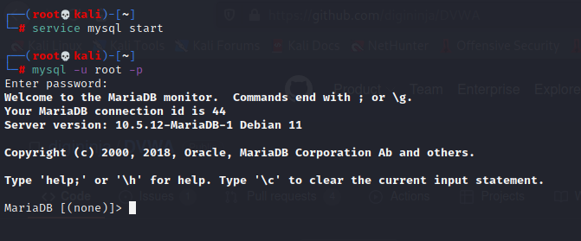

Create a user in MariaBD and grant all priviledges to ‘user’@127.0.0.1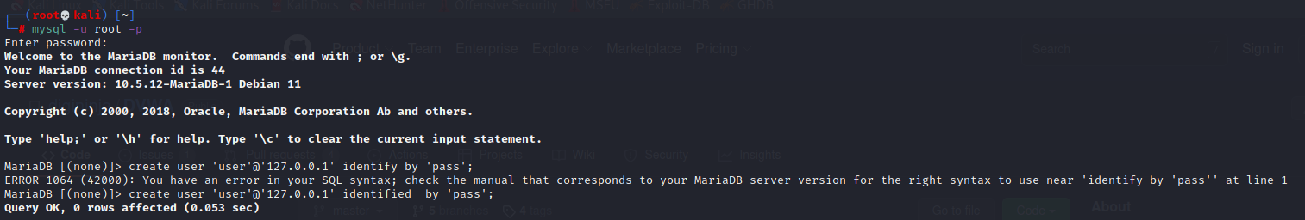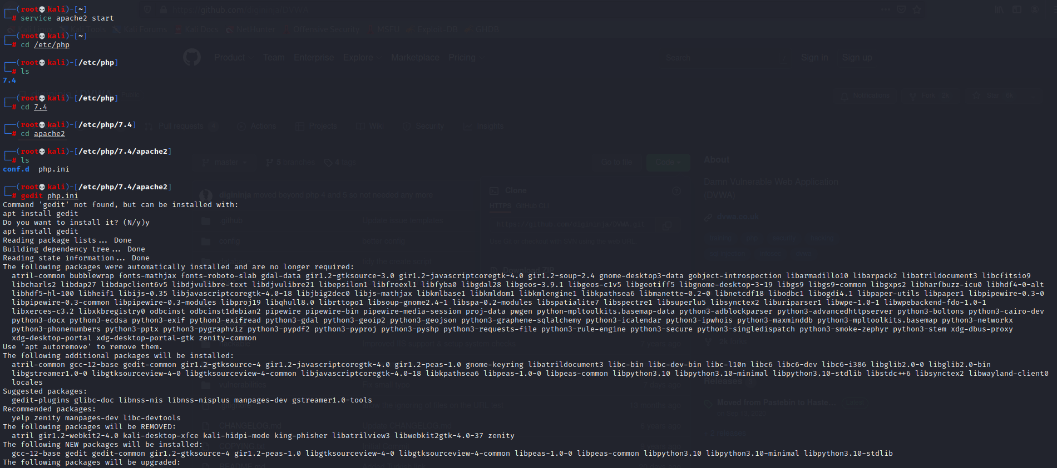

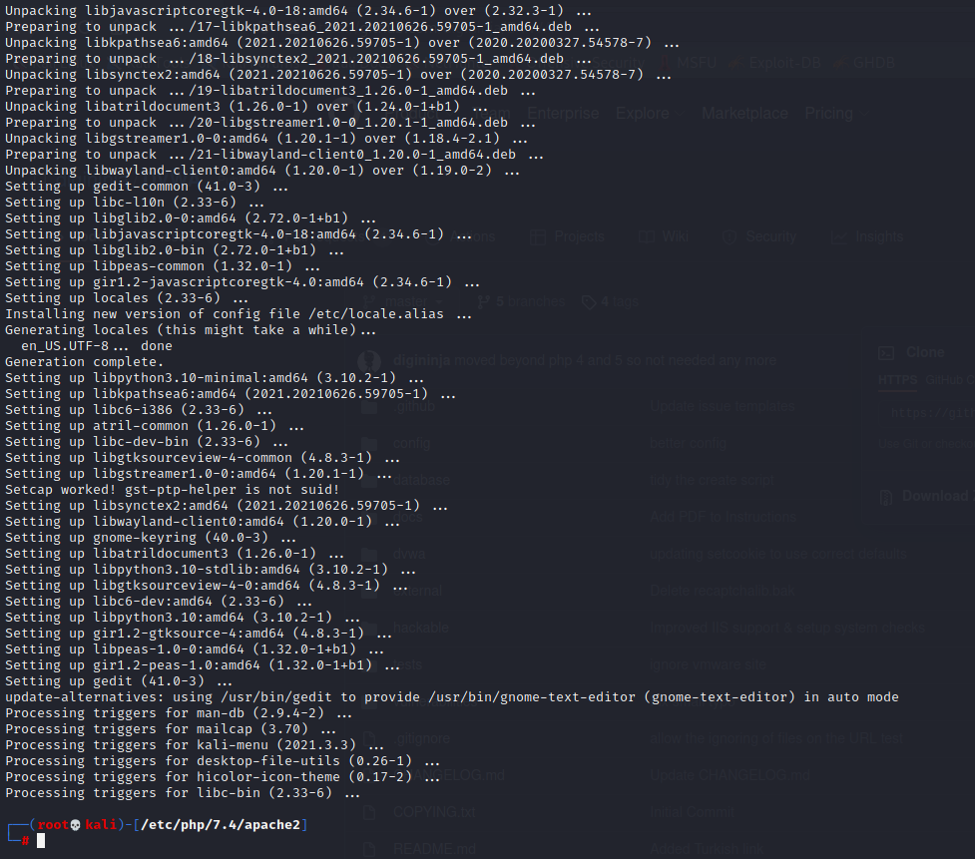

Once done, we need to edit the main config (***php.ini***) file for apache2, which is not correctly overridden for **DVWA** by default.

*sudo vim /etc/php5/apache2/php.ini*

* Enable Allow_url_fopen
* Enable Allow_url_include

This is necessary to exploit the file upload vulnerability. Here’s a screenshot for ***php.ini*** after making changes.

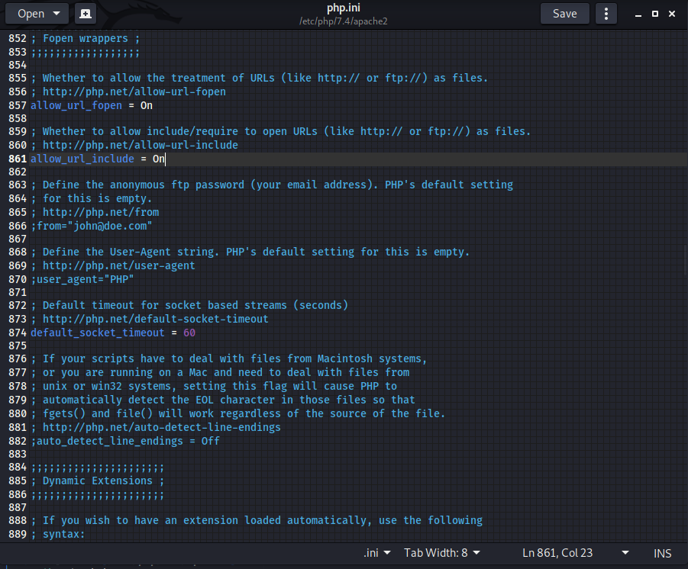

Access localhost/DVWA and work with DVWA Application.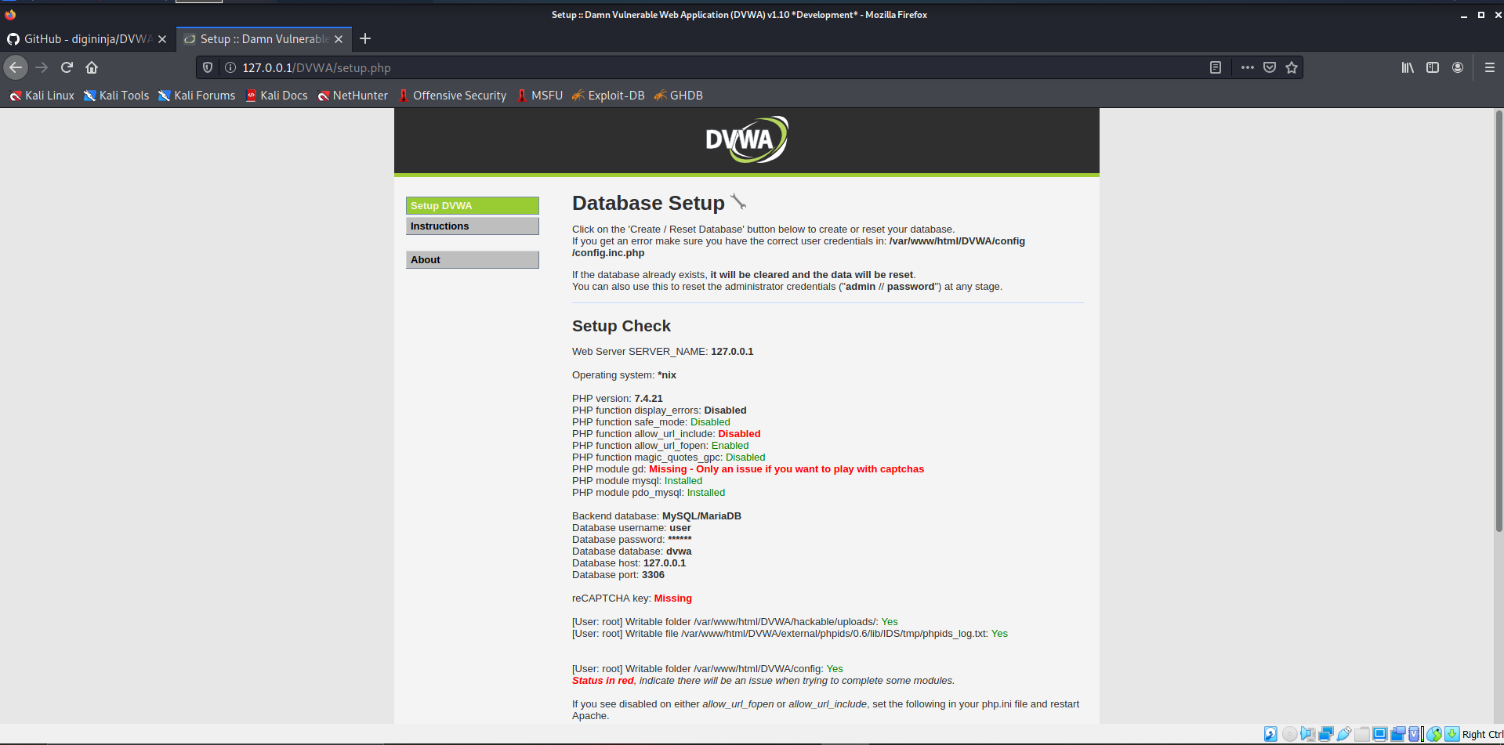

Scroll and click ‘recreate database’ option and you will be redirected to login page.

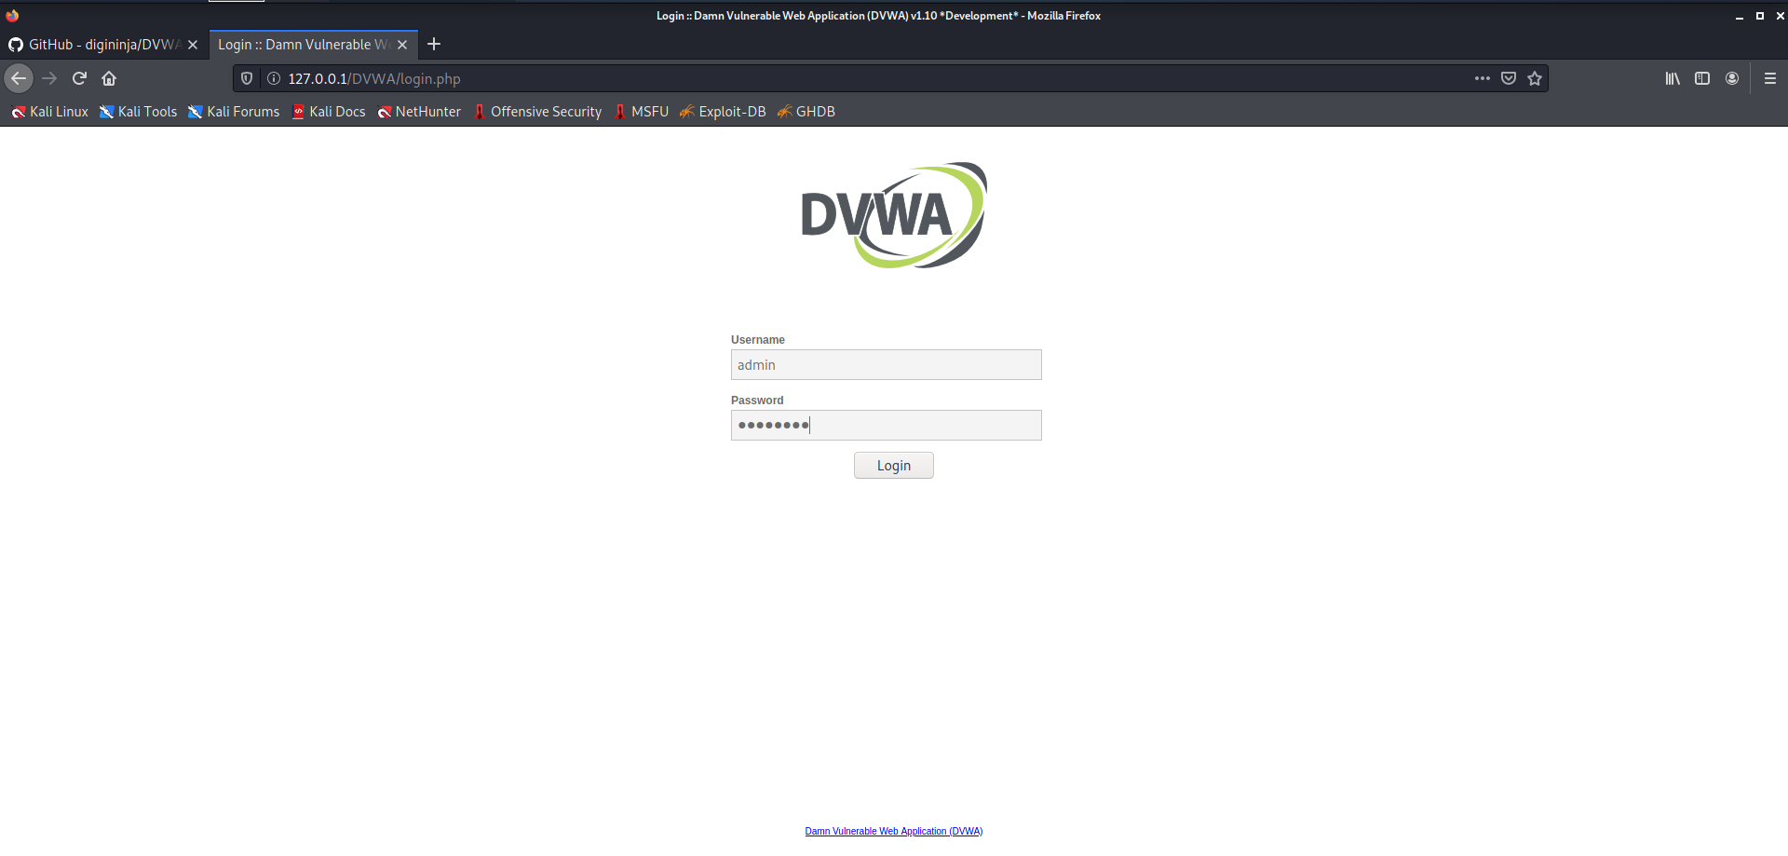

Username:**admin**

Password:**password**

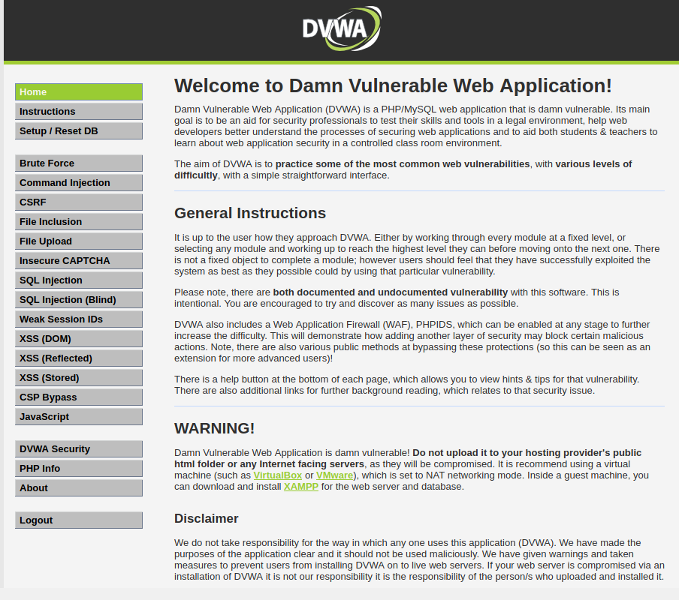

Now, login to change the strength of vulnerabilities by clicking on “DVWA Security”.

**Low Level:** Low-Level Security gives you the freedom to exploit all known vulnerabilities means there will be no security in a given framework and hence you can try all attacks if you are using it first Time.

**Medium Level:** Medium security will have all entry-level validations and filtration which can stop any script kiddie to get the benefit of available vulnerabilities.

**High Level:** High Level is kind of Zero Day environment and if you can breach it then that means you are on the right track to becoming a VAPT Expert.

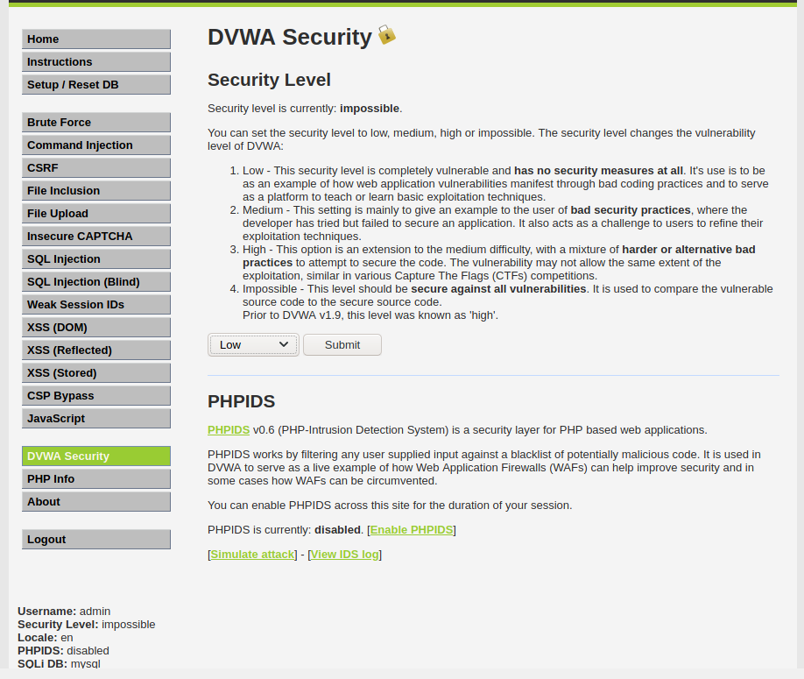

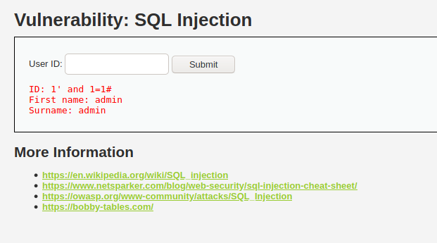

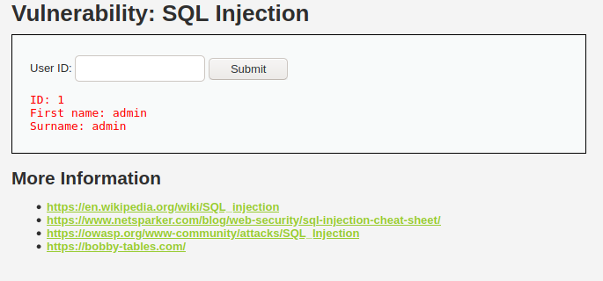

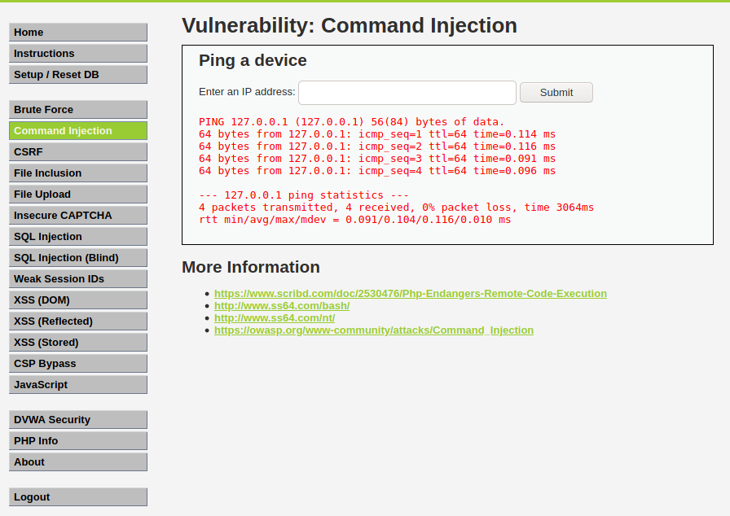

**Conclusion:**DVWA has been successfully configured and SQL and Command Injection can be implemented using the web tool.

**LAB 11**

**ARYAMAN MISHRA**

**19BCE1027**

Information hiding using Steghide and Stegsnow

Commands to execute

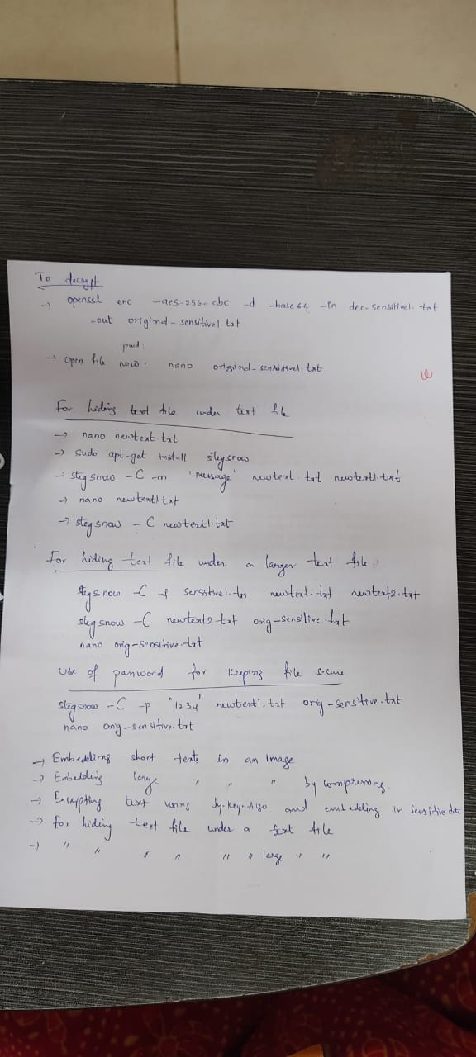

Steghide is a steganography tool that allows you to cover confidential records inside a

picture or sound record with a passphrase. Bolsters BMP and JPEG picture group, AU and WAV sound group. This device has its advantages and disadvantages. One upside is that it is much better at covering and can extend a lot without any type of document. It does this by using a propelled calculation to shroud it inside a picture (or sound) record without changing the form (or sound) of the document. This is additionally without using Steghide (or if there is not the same scientific method as Steghide) then it is difficult to remove the hidden documents from the picture.

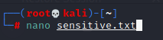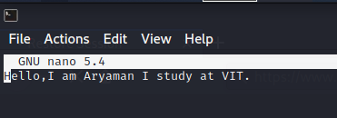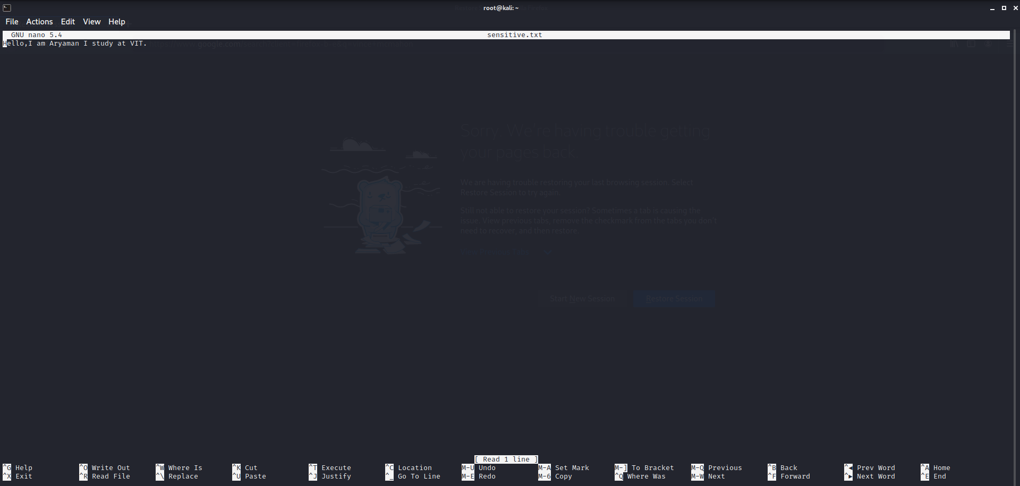



Install steghide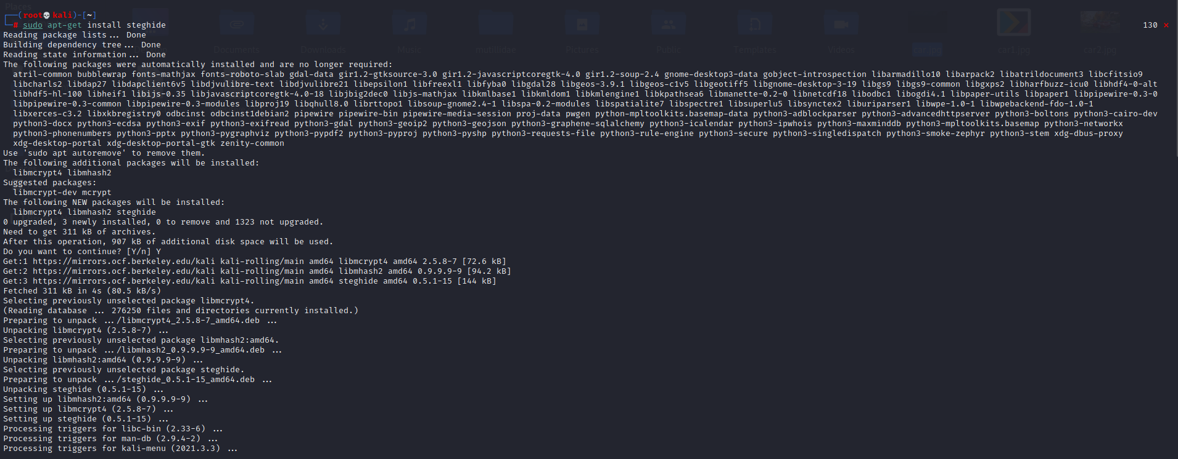

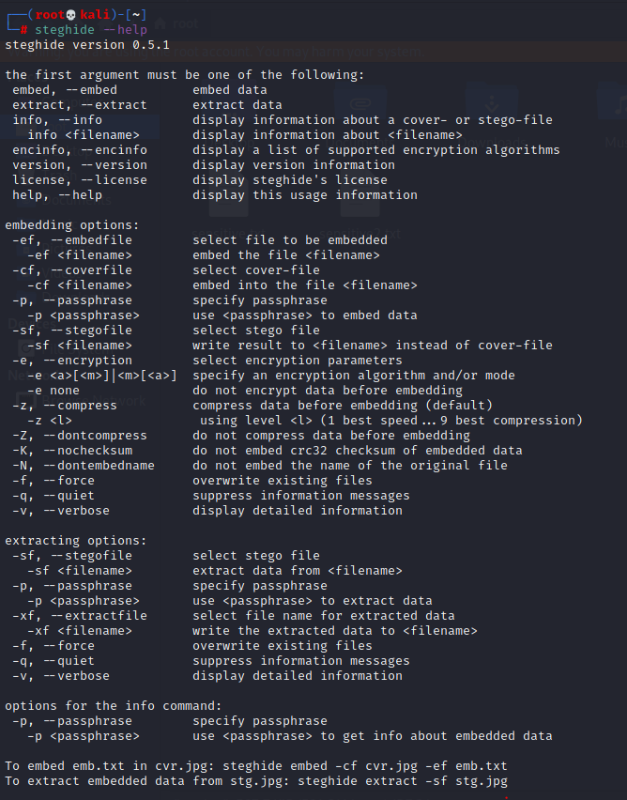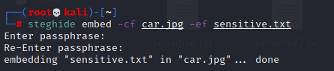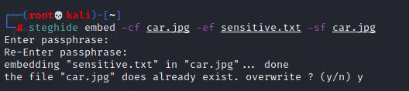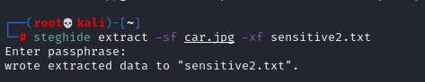

# Embedding data in the image:

We hide the data in the image using the Steghide so that only the person who accepts it can read it. Therefore, we created a text file named “sensible.txt”, in which we wrote our confidential data and images. JPEG is the file in which we are embedding our data.

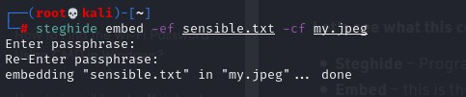

Here, ef and cf are termed as embedded files and cover files, respectively. Let’s see what this command is doing:

Steghide – Program Name Embed – this is the command

-cf – This flag is for the cover file (the file used to embed the data) filename – this is the name of the cover file

-ef – This flag is for the embed file (the file that will be embedded) Filename – This is the name of the embedded file

# Extraction of Data From Image Via Steghide:

Using Steghide adds an extra layer of security by allowing us to use a password for it. As long as you know the passphrase, it is quite easy to extract data from the image.

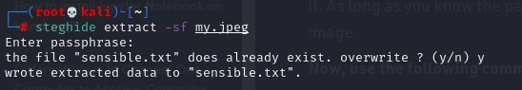

# Password Protect Files:

Now, we can also extract files using the following command. This command is different in that it specifies a password in the command itself, therefore, we do not need to specify it separately.

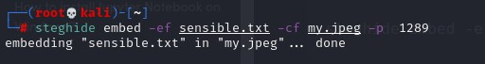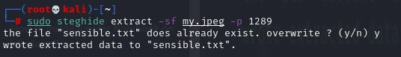

# Retrieve Information of Embedded File:

If we have an image in which the data is suspected to be hidden and if so, what algorithm is used to encrypt the data in the file?

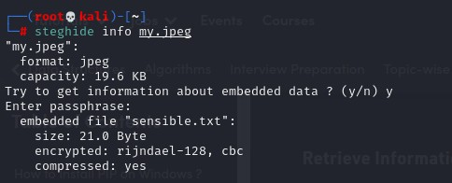

# Verbose Mode

To obtain every information of a file during extraction, we can use verbose mode. The verbose mode gives you detailed information.

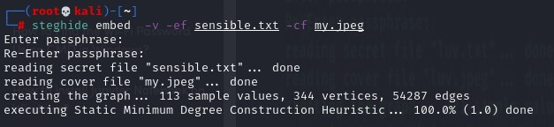

# Encrypting Algorithms:

We can encrypt the data we are hiding using encryption techniques.

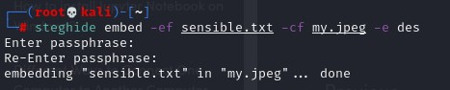

# Hiding text file under text file

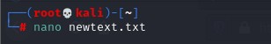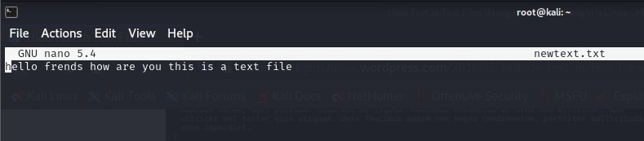Creating a new text file

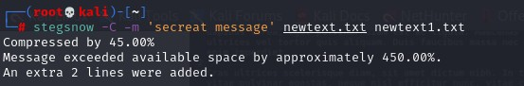This command encodes the message inside newtext.txt and saves the resulting file that contains the message in newtext1.txt.

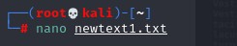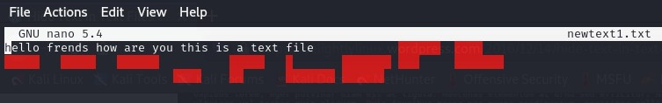Checking newtext1 file

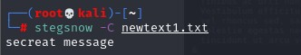Checking using stegsnow

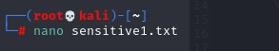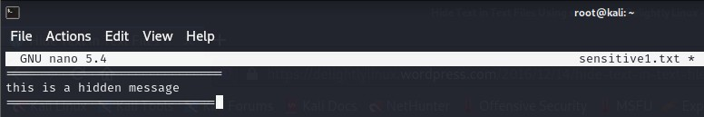Creating sensitive1 file

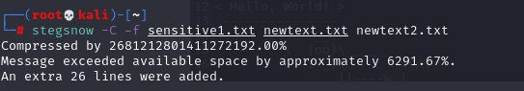Hiding text file under a layer text file

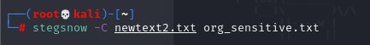Encode newtext2 file inside org_sensitive file

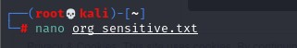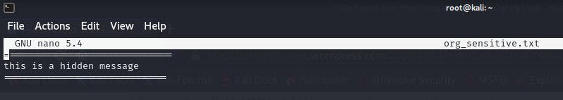Checking org_sensitive file

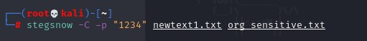Encoding using password for keeping file secure

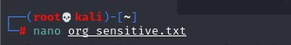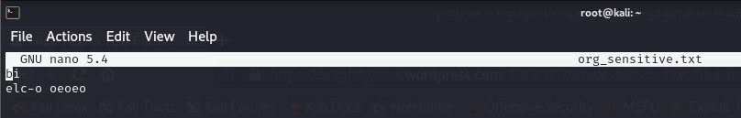Checking org_sensitive file

**LAB 12**

**ARYAMAN MISHRA**

**19BCE1027**

**LAB 12-Exploring Information Auditing Tool**

**Tool:Lynis**

Lynis is an open source security tool. It helps with auditing systems running UNIX-alike systems (Linux, macOS, BSD), and providing guidance for system hardening and compliance testing. This document contains the basics to use the software.

By running 'lynis' the program is started and will provide the basic parameters available. If you manually extracted Lynis (or used Git), then use './lynis' to start the program from the local directory.

The most common command to start Lynis is using **audit system** command. This still start the security scan.

To run Lynis you should meet one requirement: have write access to **/tmp** (temporary files)

The Lynis tool requires a minimum amount of parameters to run. If you are using it for the first time, just run lynis and see what output it provides.

$ ./lynis

Without any commands, Lynis will display its status, together with suggestions on how to start.

#### Audit

The audit command tells Lynis to perform an audit.

Targets include:

* **system** - audit the host system
* **dockerfile** - audit a dockerfile

#### Show

The show command informs Lynis to share information, like help or the value of something.

Examples:

* **help** - show help and tips
* **profiles** - show discovered audit profiles
* **settings** - show active settings
* **version** - show Lynis version

#### Parameters

In the table below, the most commonly used parameters are listed.

| Parameter | Abbreviated | Description |
| --- | --- | --- |
| --auditor "Name" |  | Assign an auditor name to the audit (report) |
| --checkall | -c | Start the check |
| --check-update |  | Check if Lynis is up-to-date |
| --cronjob |  | Run Lynis as cronjob (includes -c -Q) |
| --help | -h | Shows valid parameters |
| --manpage |  | View man page |
| --nocolors |  | Do not use any colors |
| --pentest |  | Perform a penetration test scan (non-privileged) |
| --quick | -Q | Don't wait for user input, except on errors |
| --quiet |  | Only show warnings (includes --quick, but doesn't wait) |
| --reverse-colors |  | Use a different color scheme for light backgrounds |
| --version | -V | Check program version (and quit) |

Installing Lynis on Kali Linux.

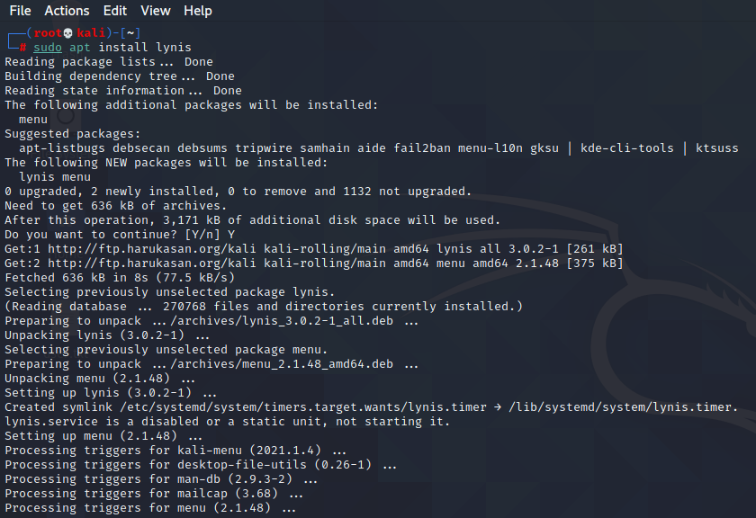

Execute Lynis -h for command details

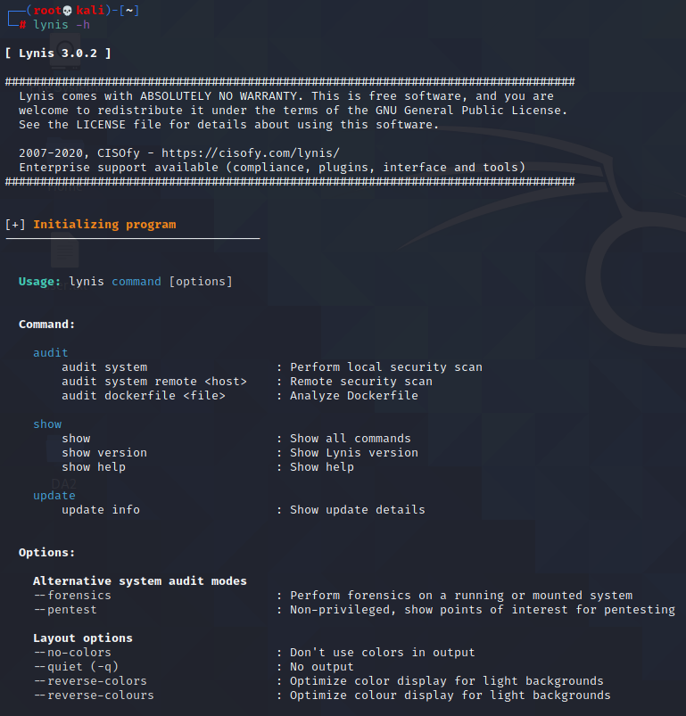

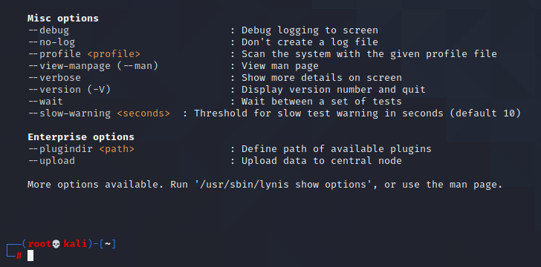

Lynis Audit System command execution:

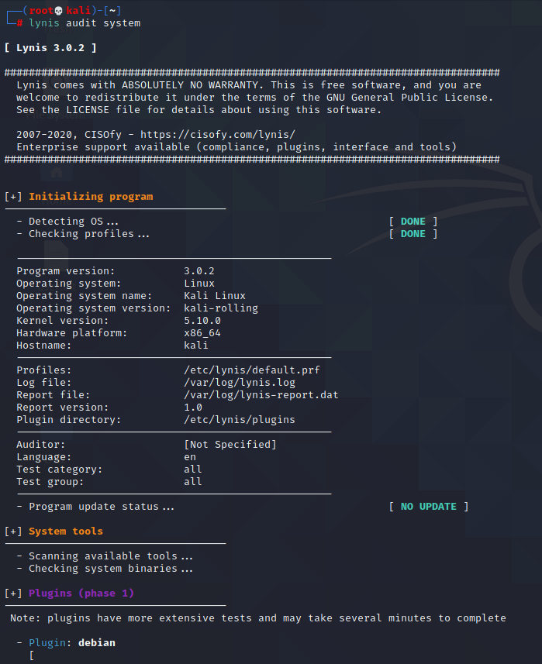

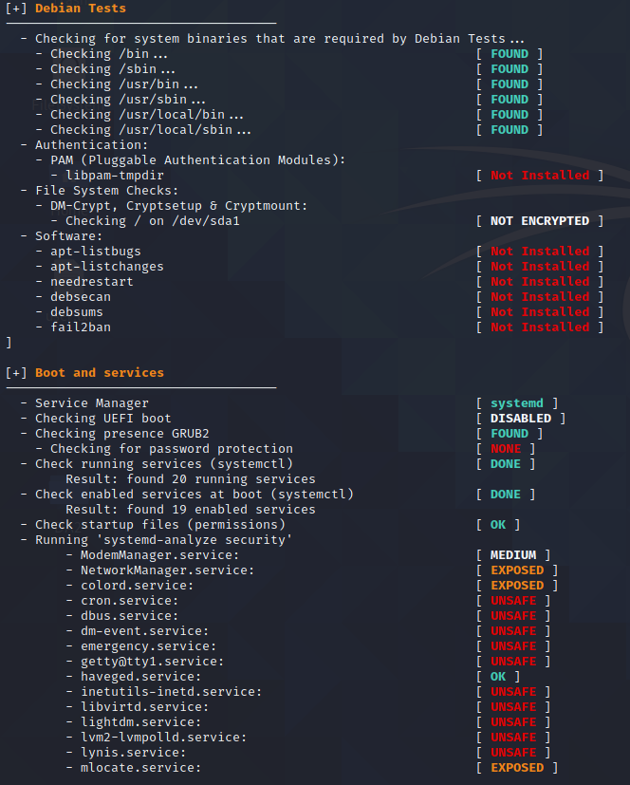

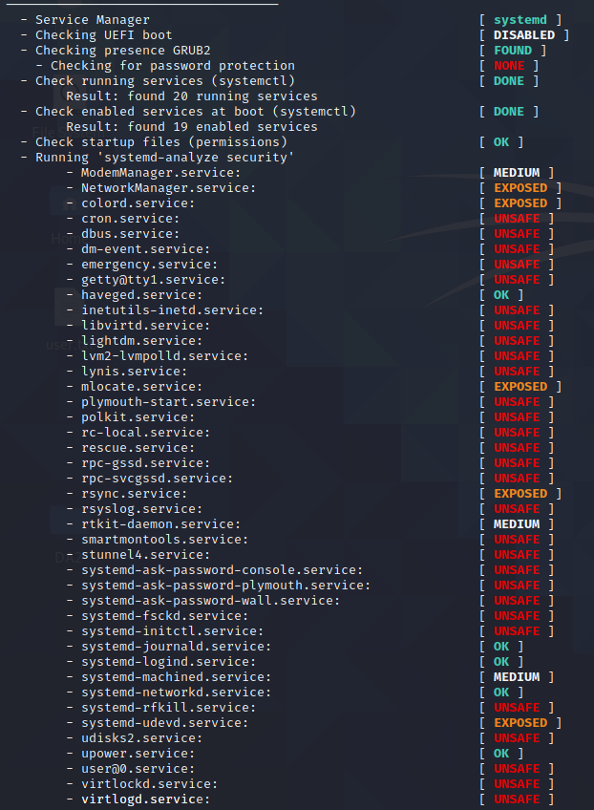

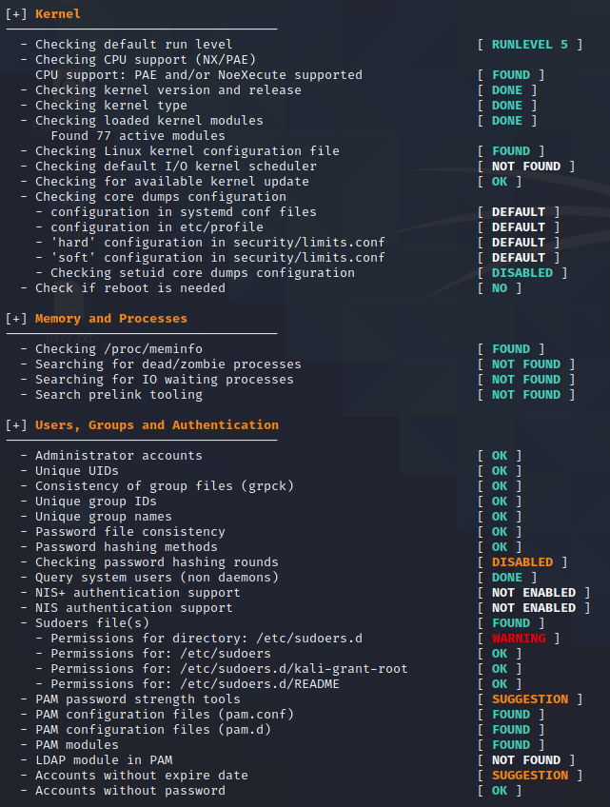

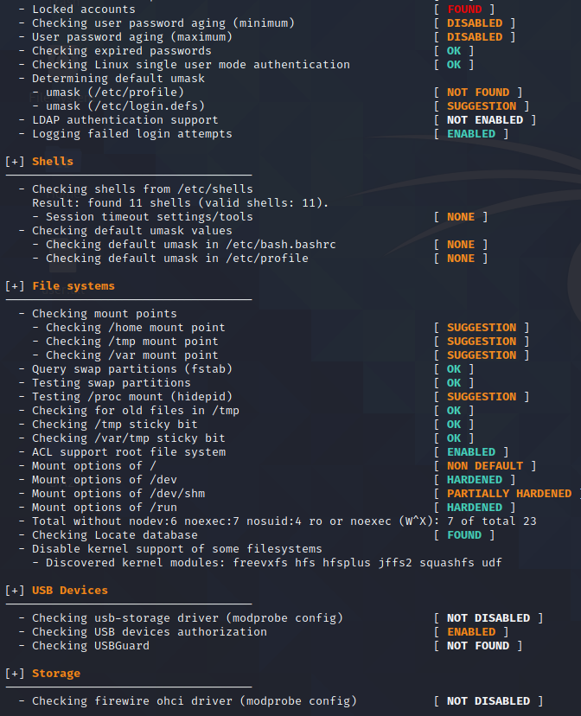

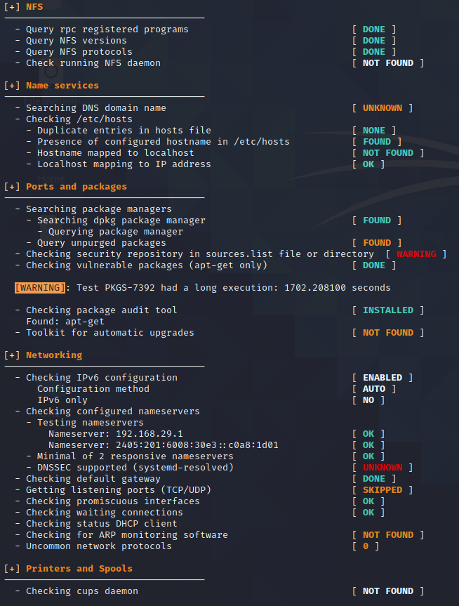

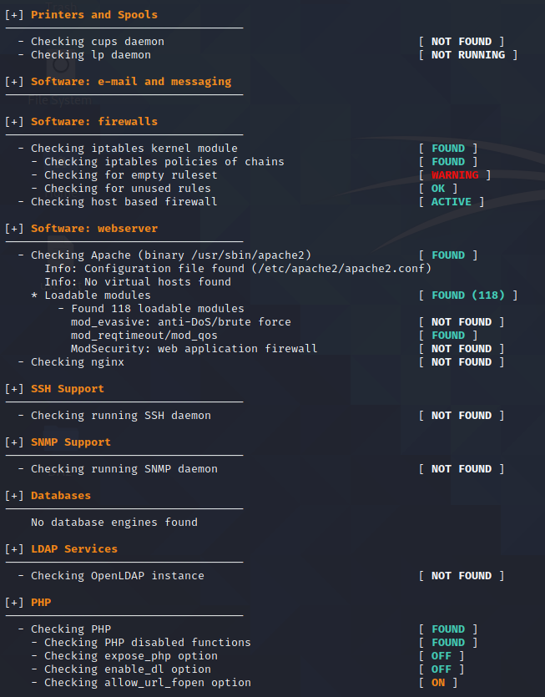

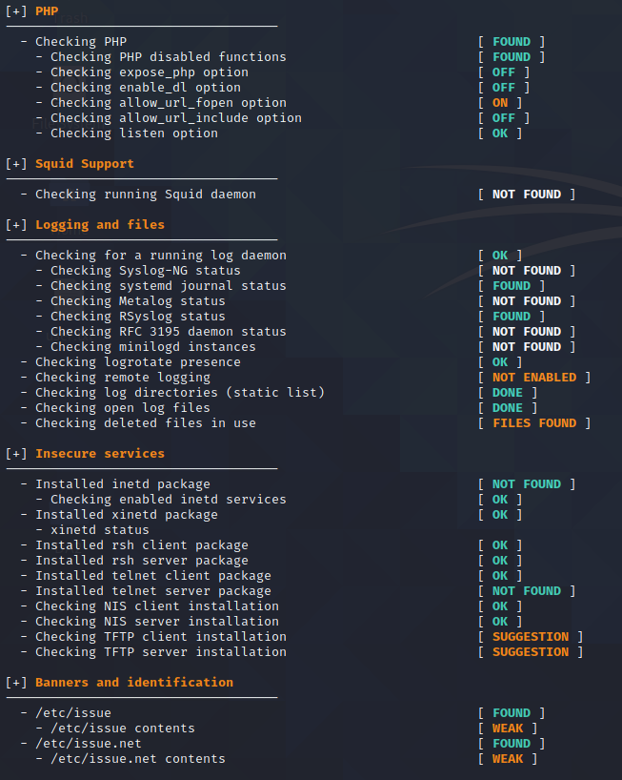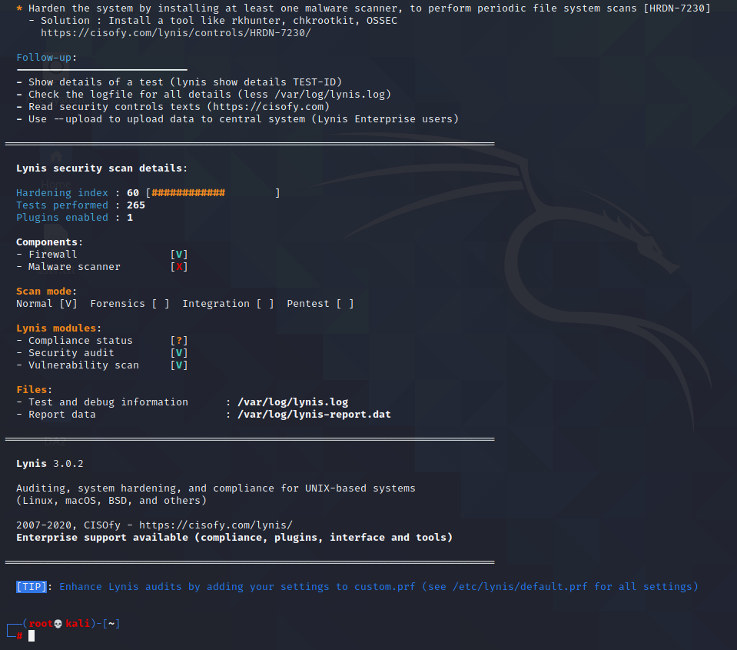

Executing lynis audit system --forensics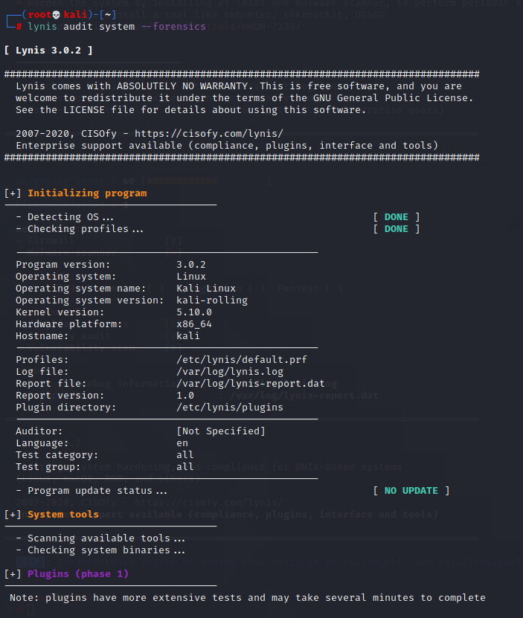

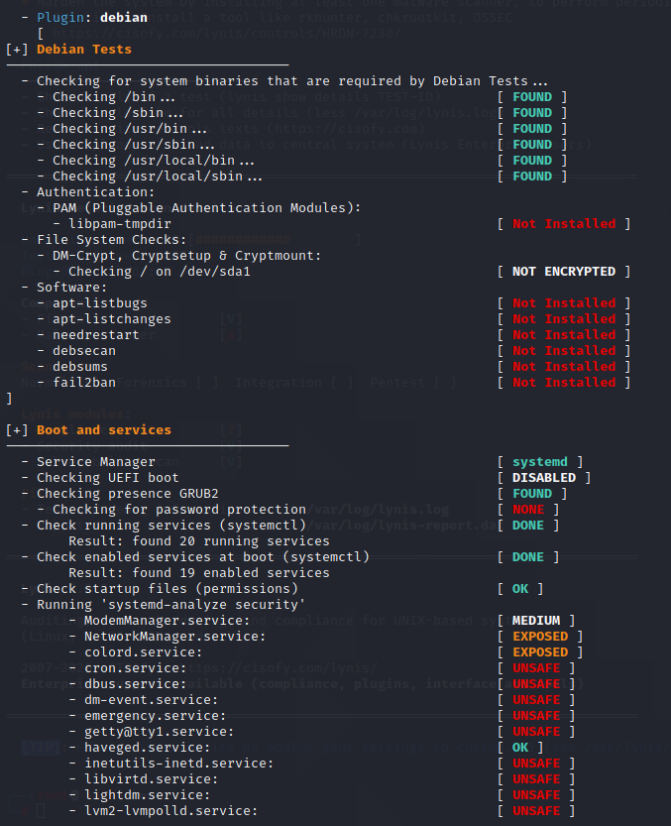

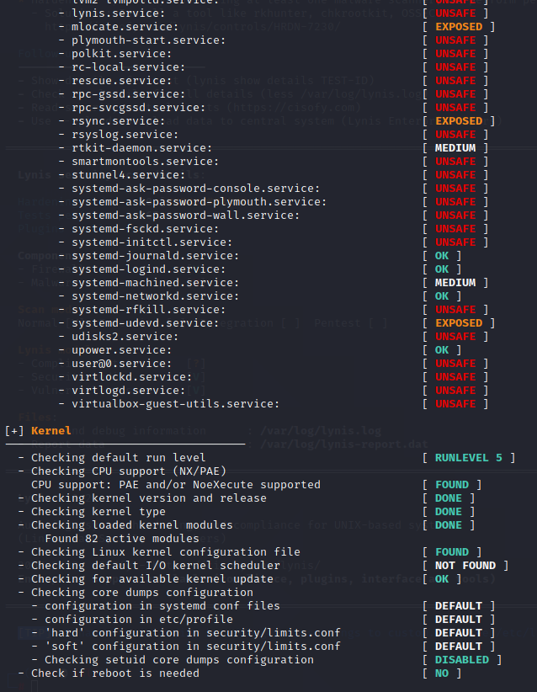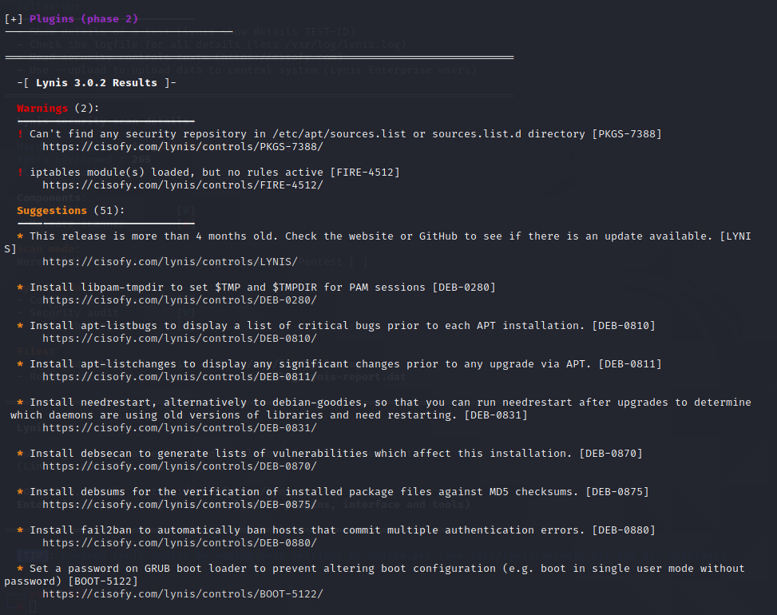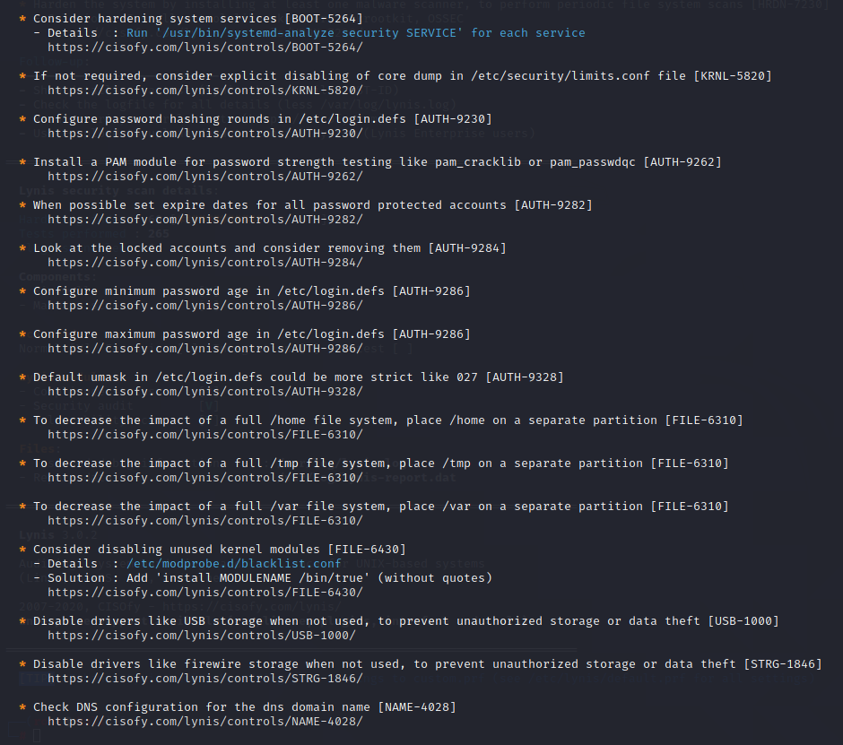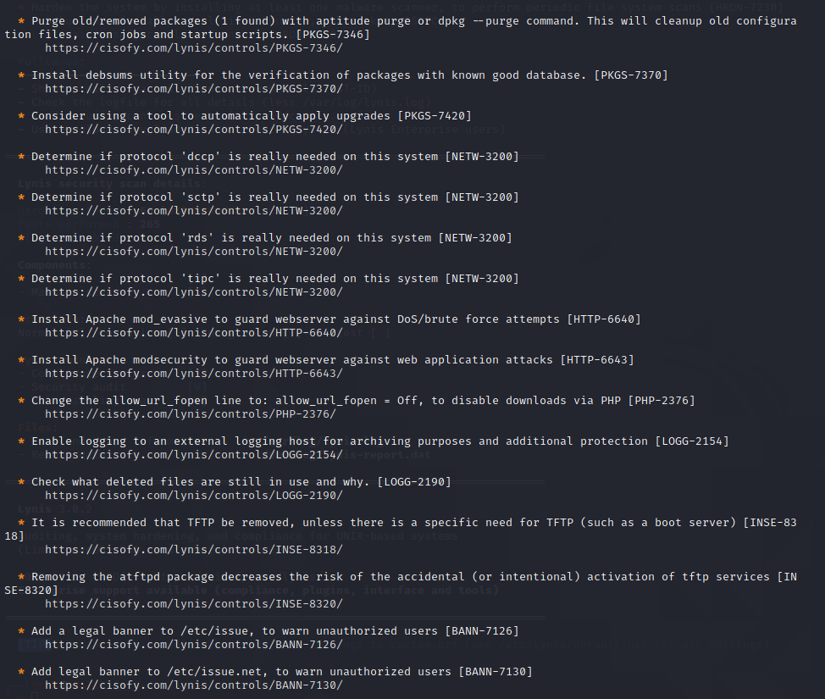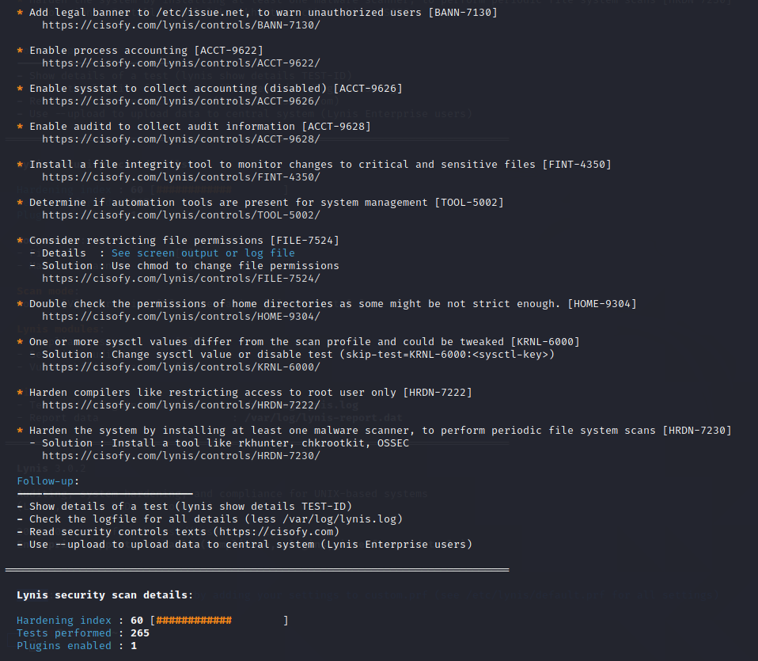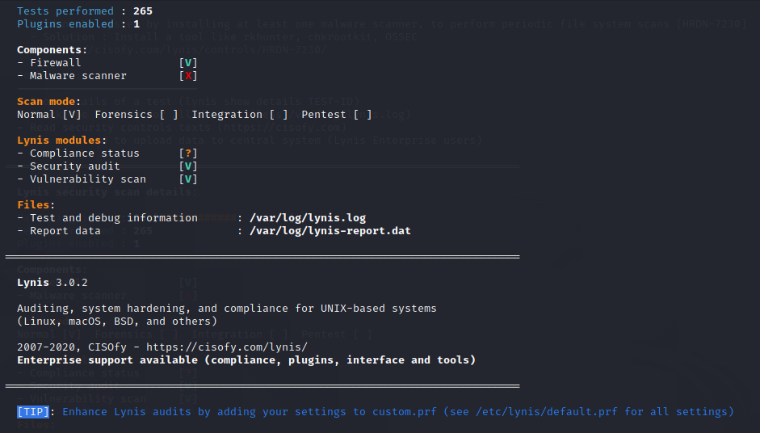

Executing Lynis Audit system –pentest command:

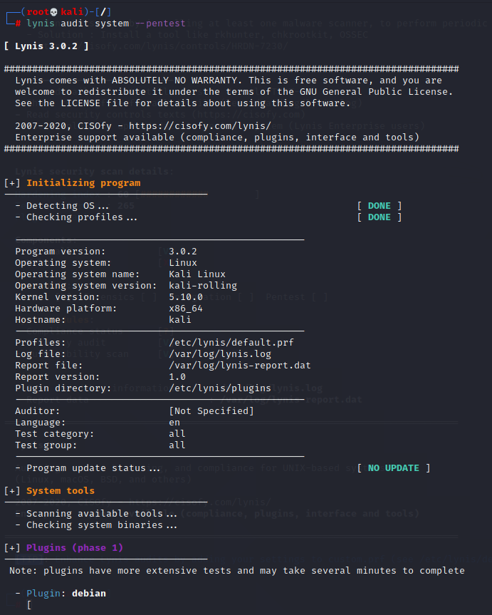

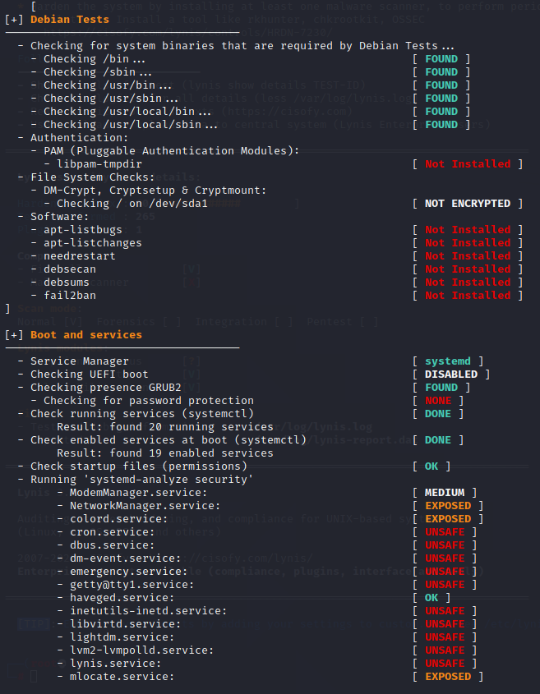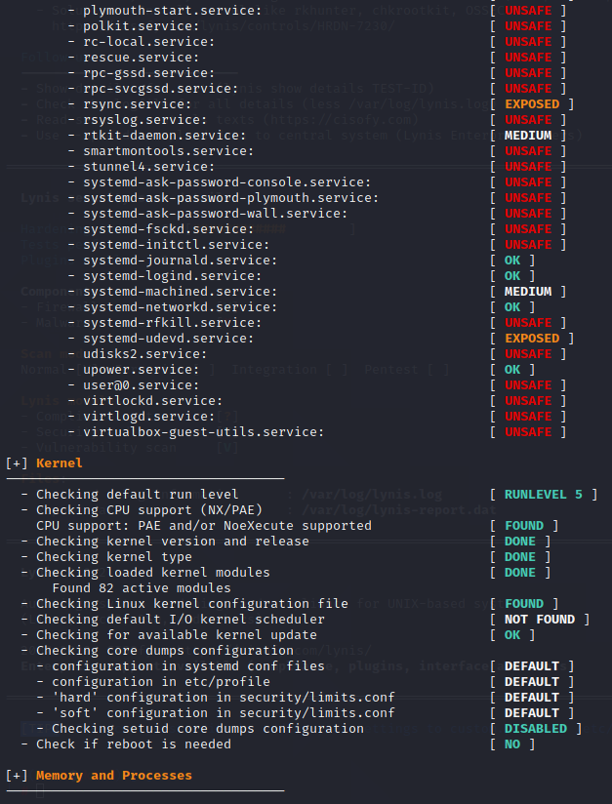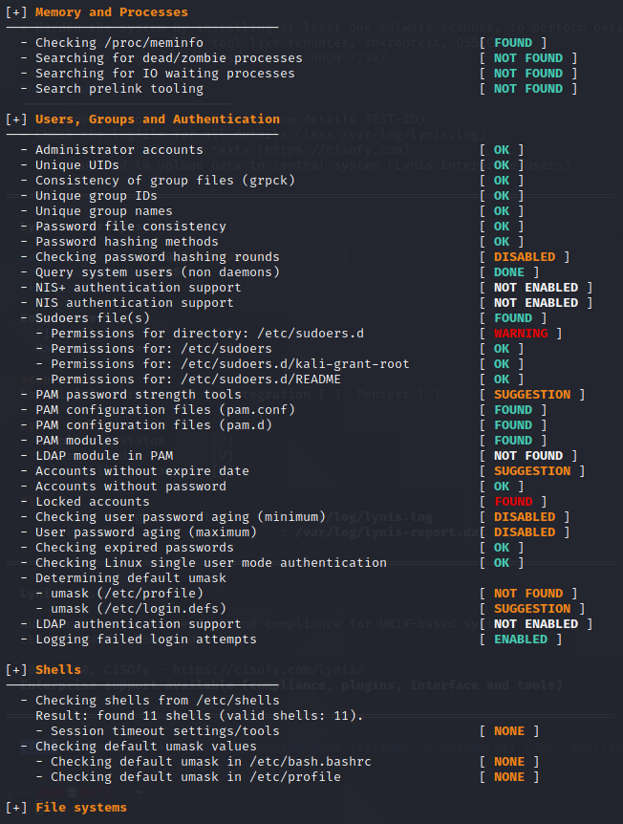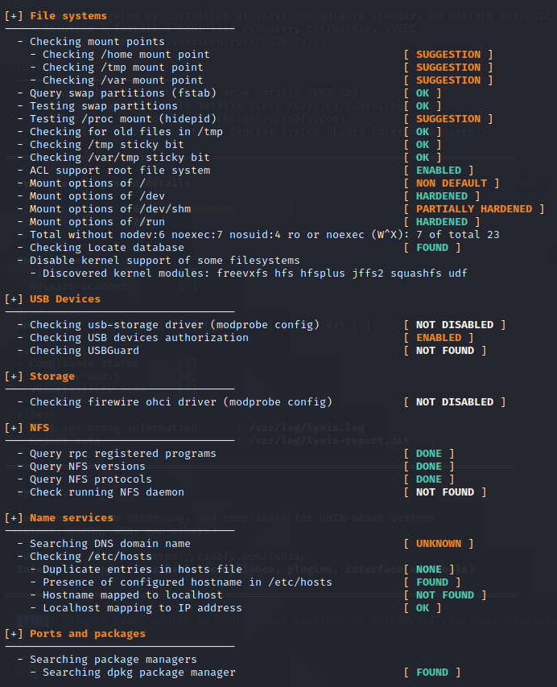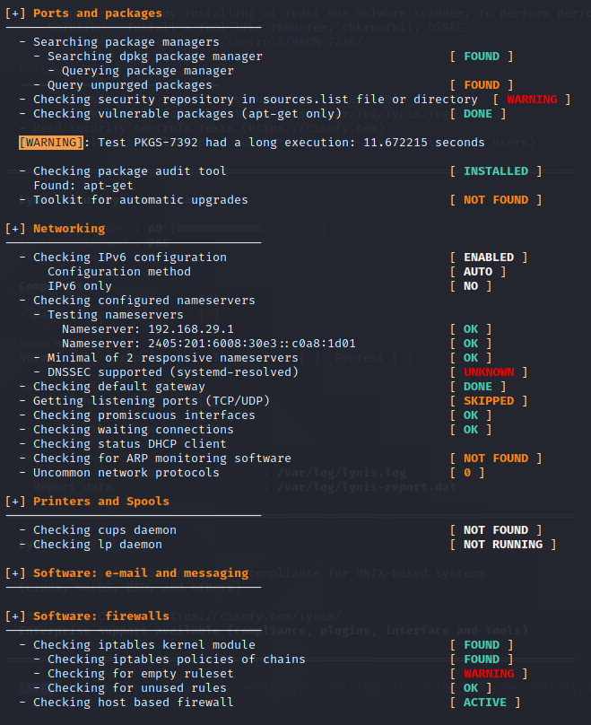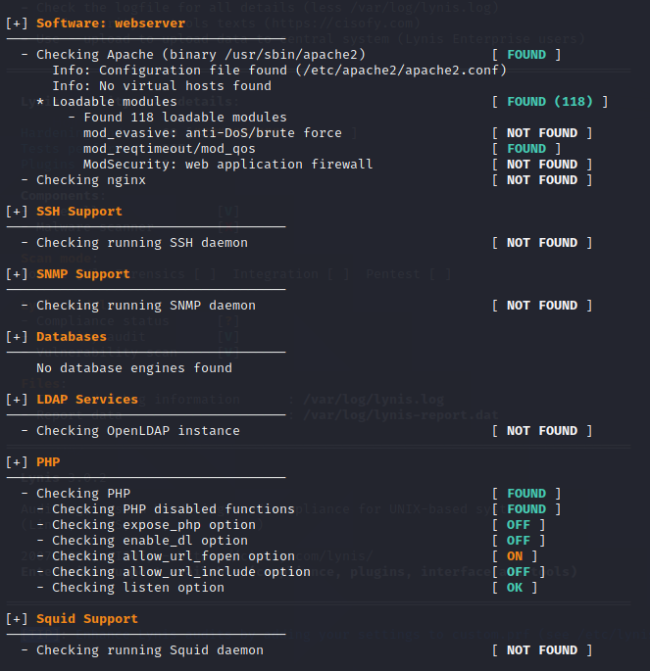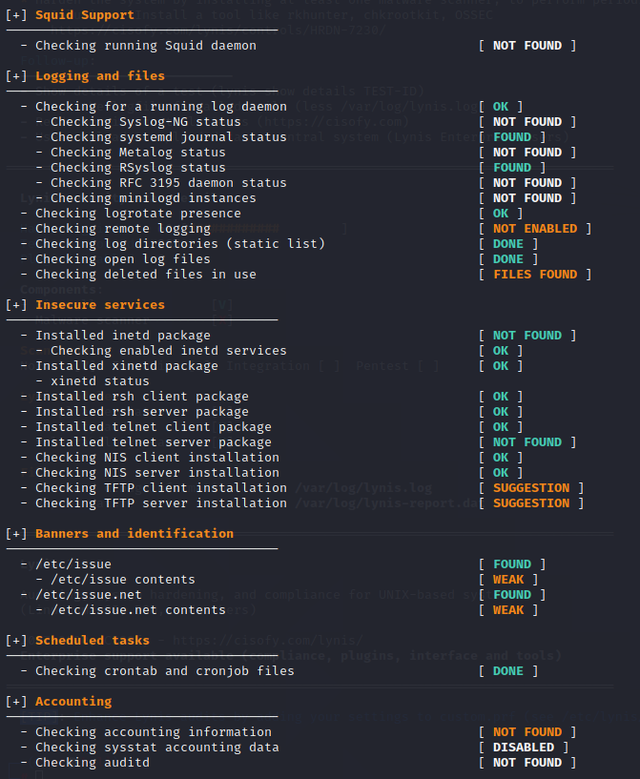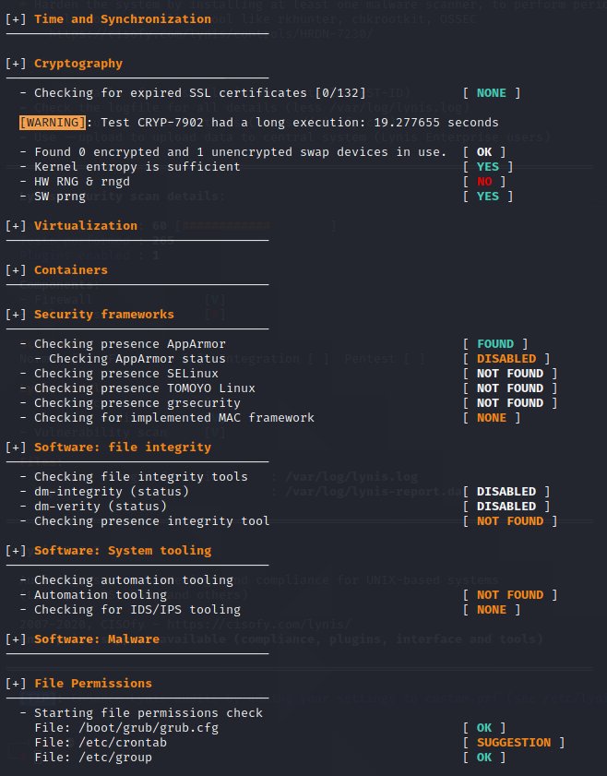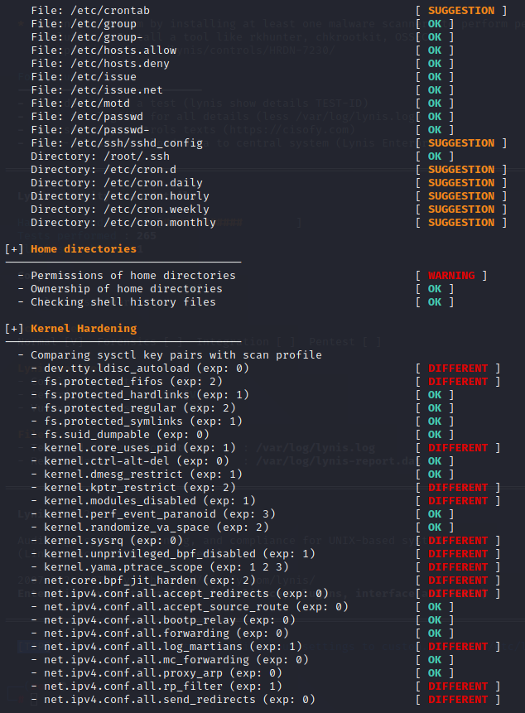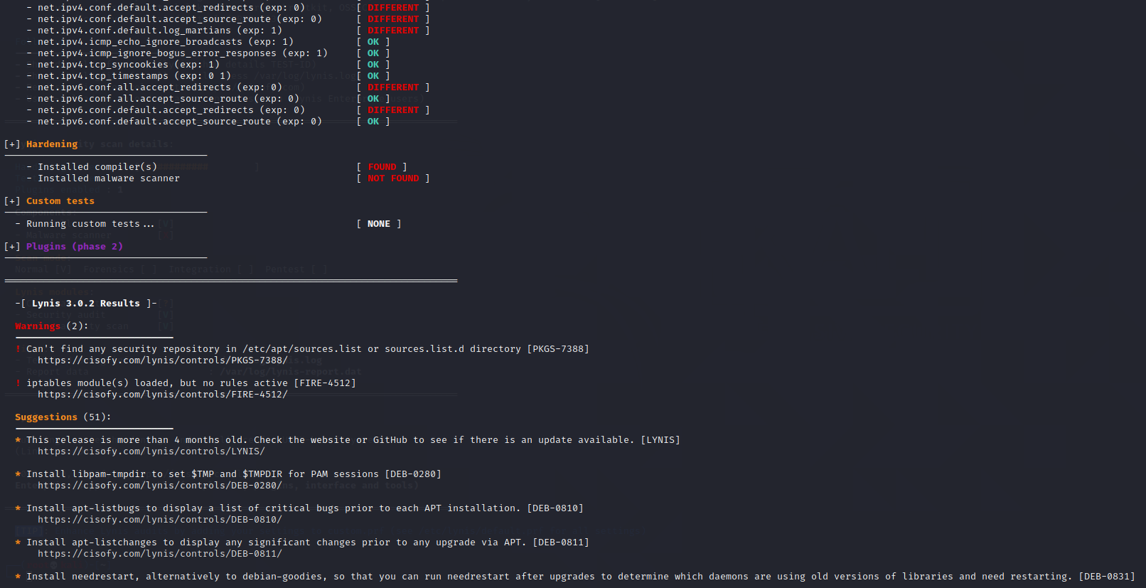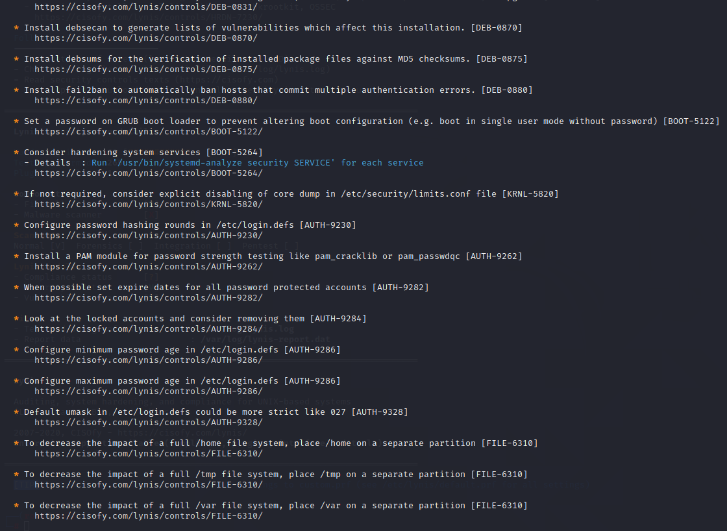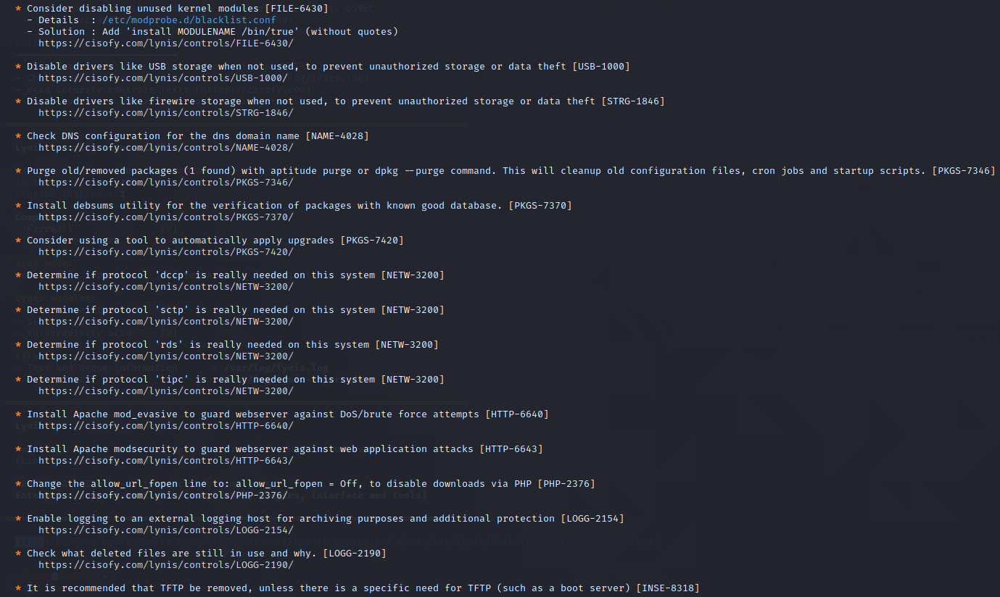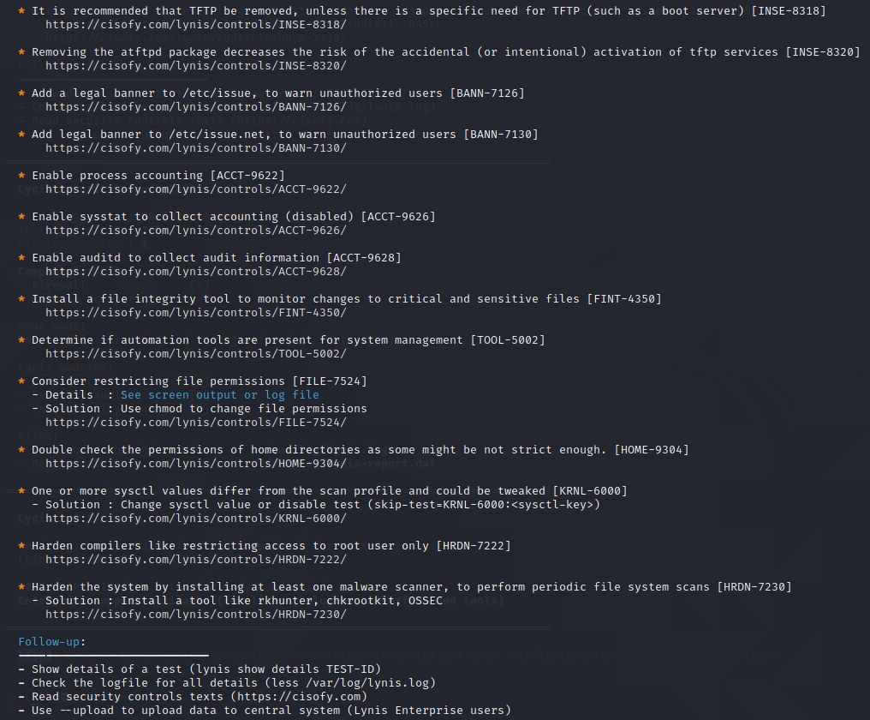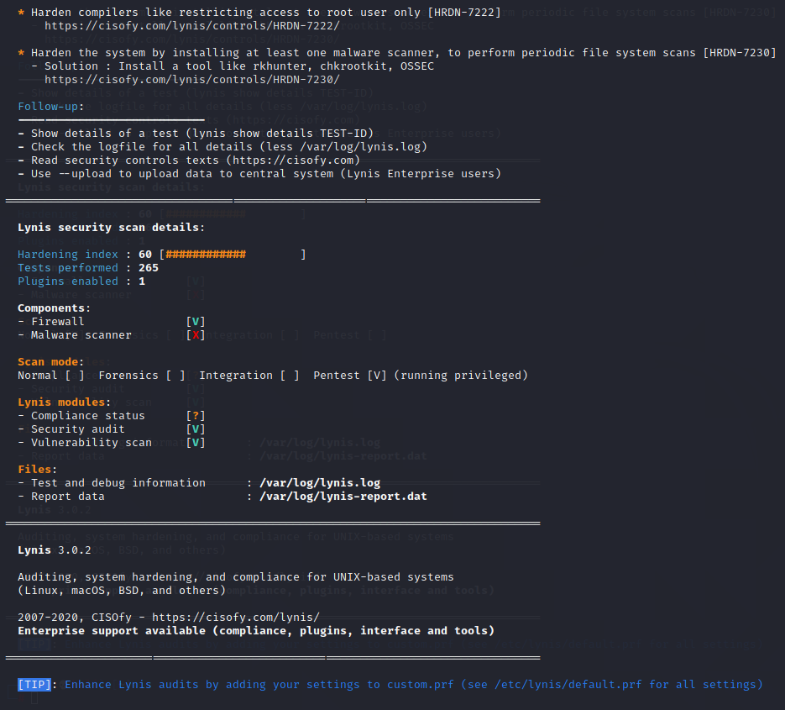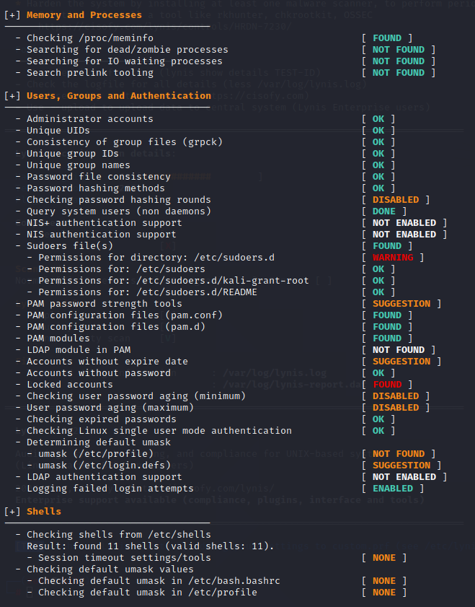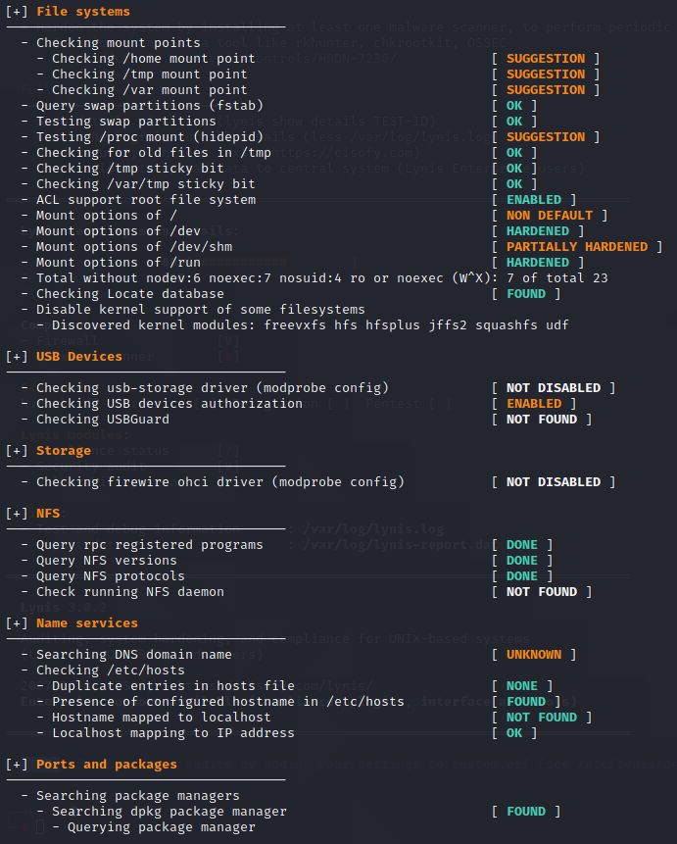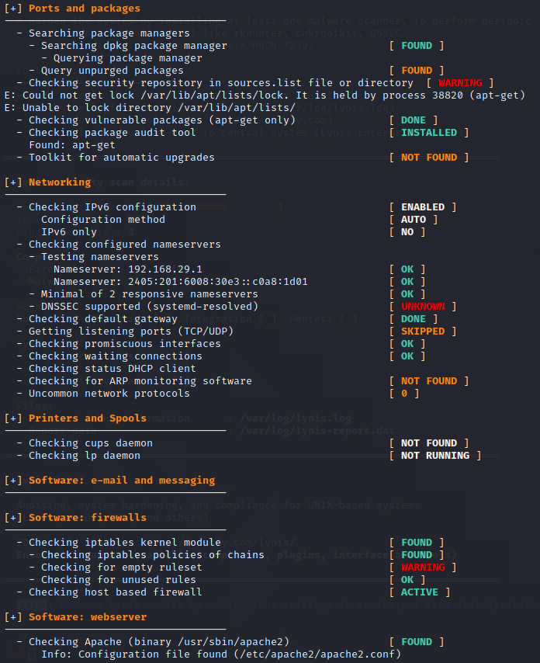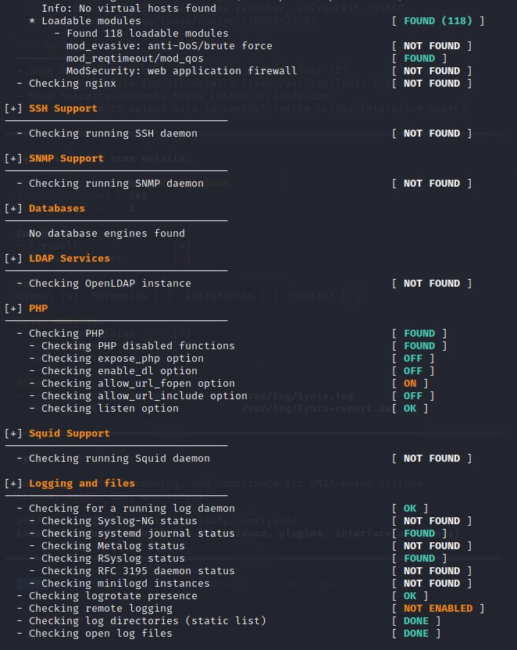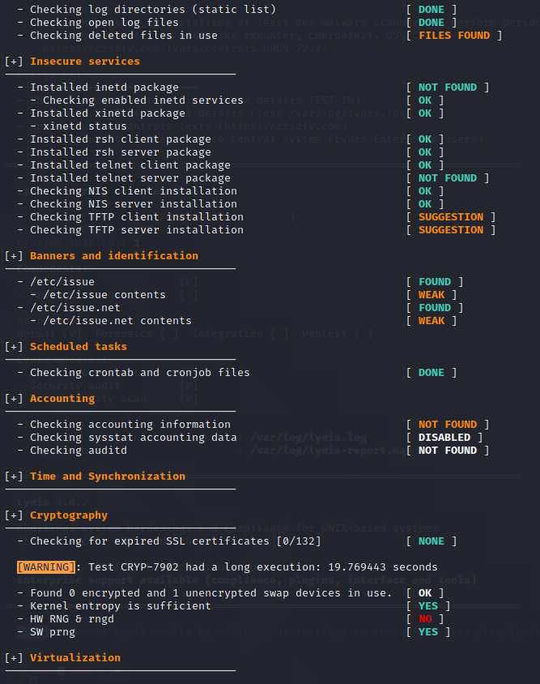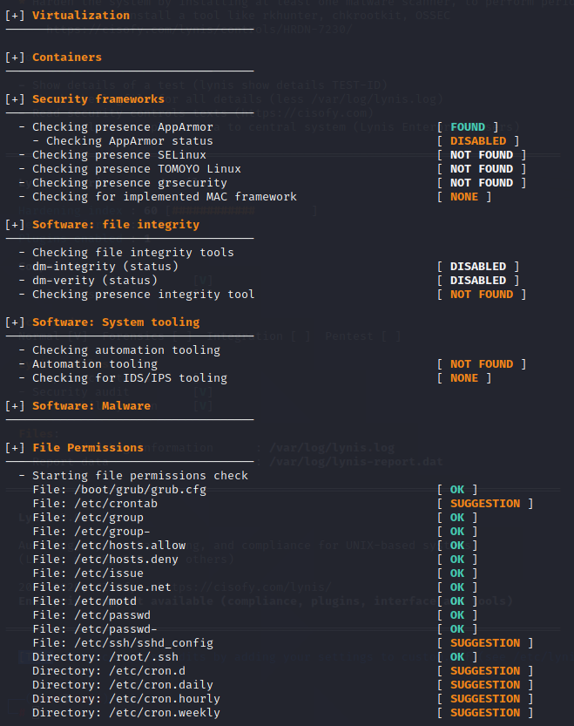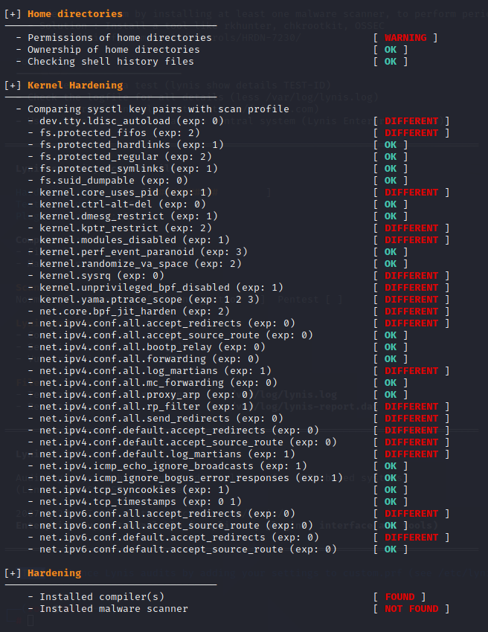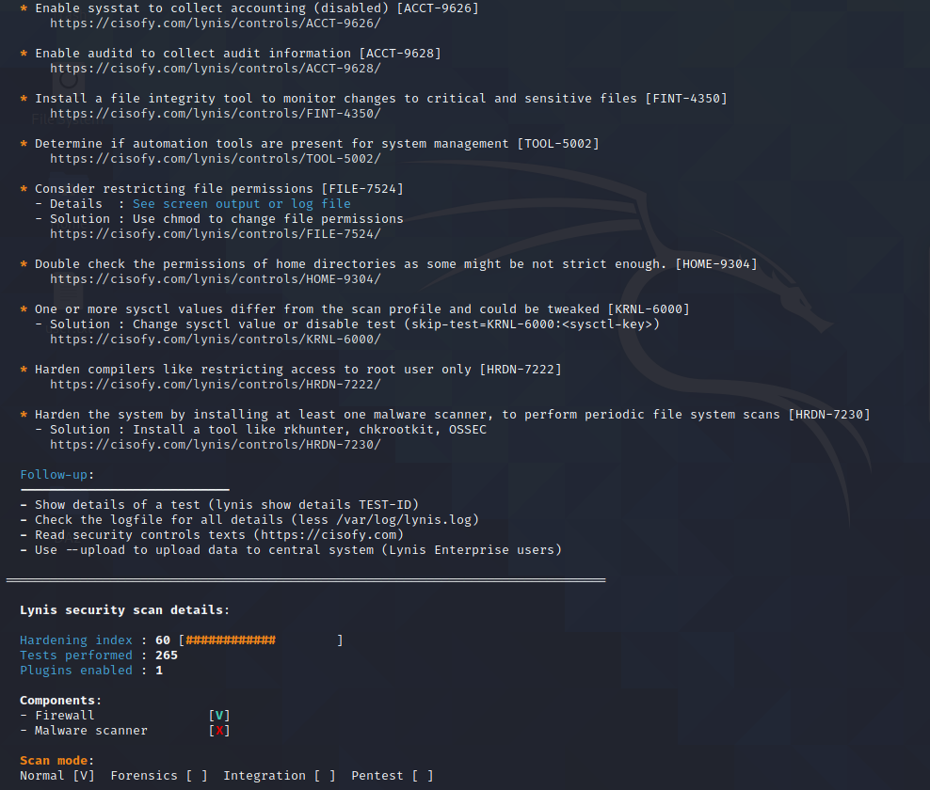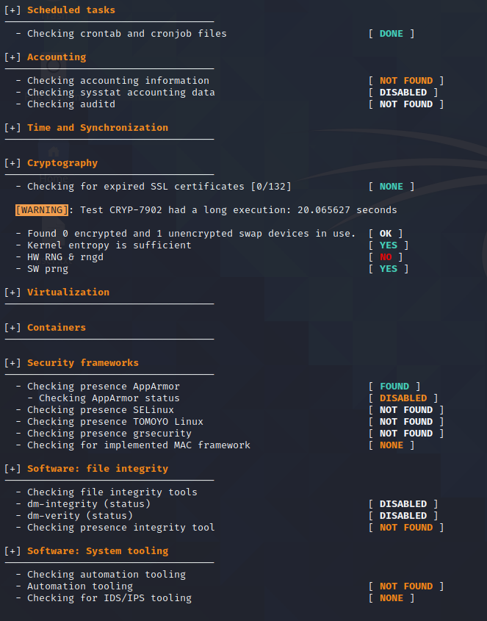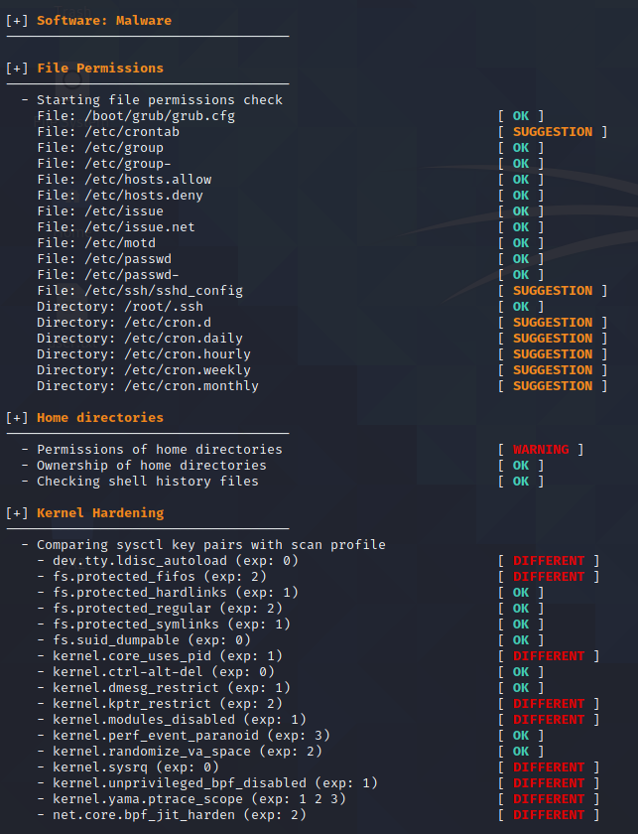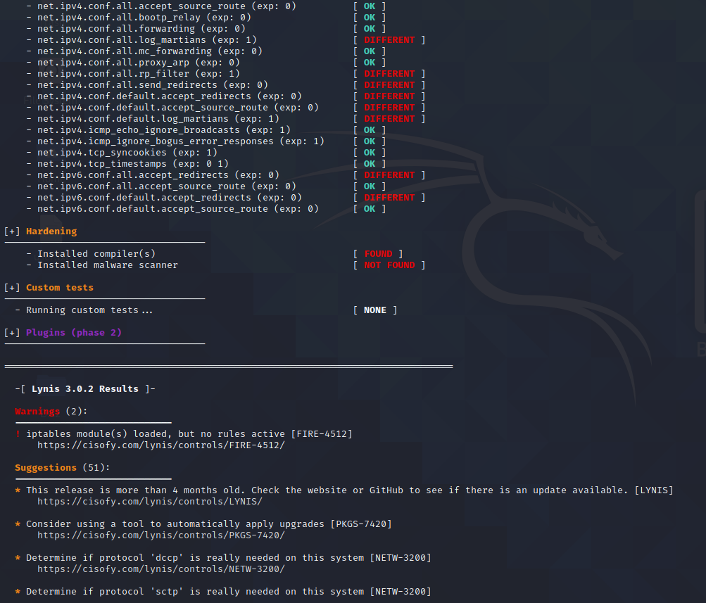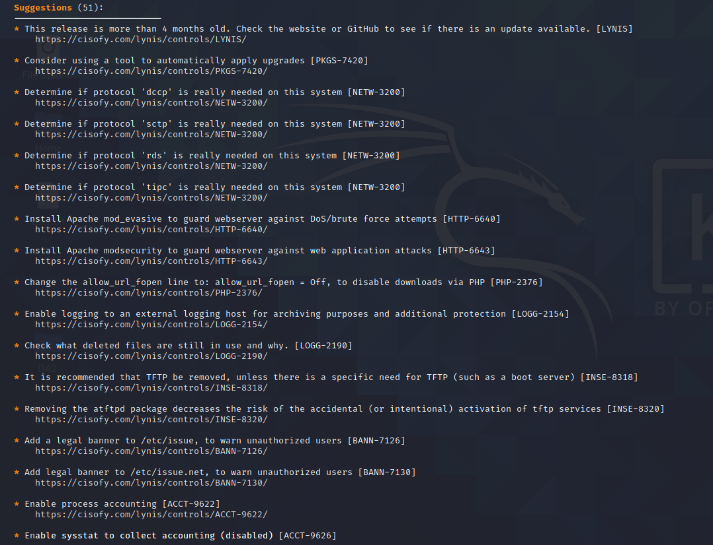

Remotely trying to access contents of phone on same network:

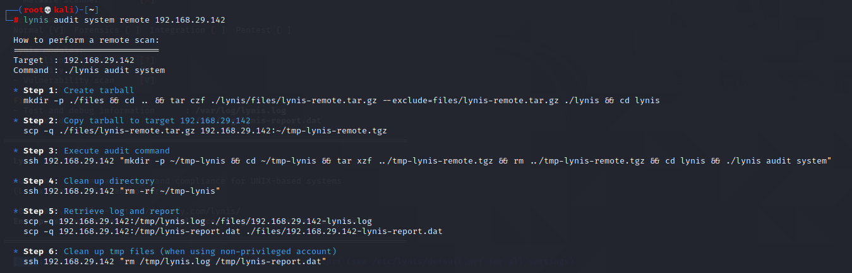

Executing suggestions: 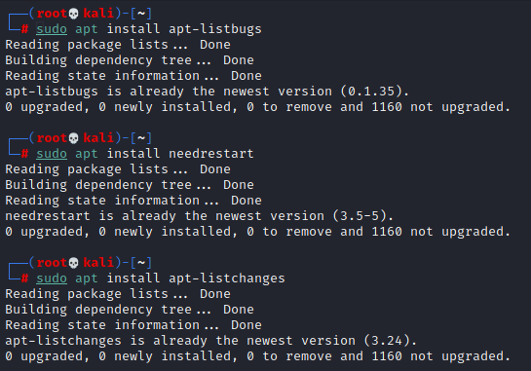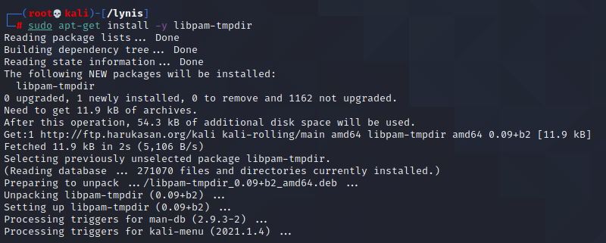

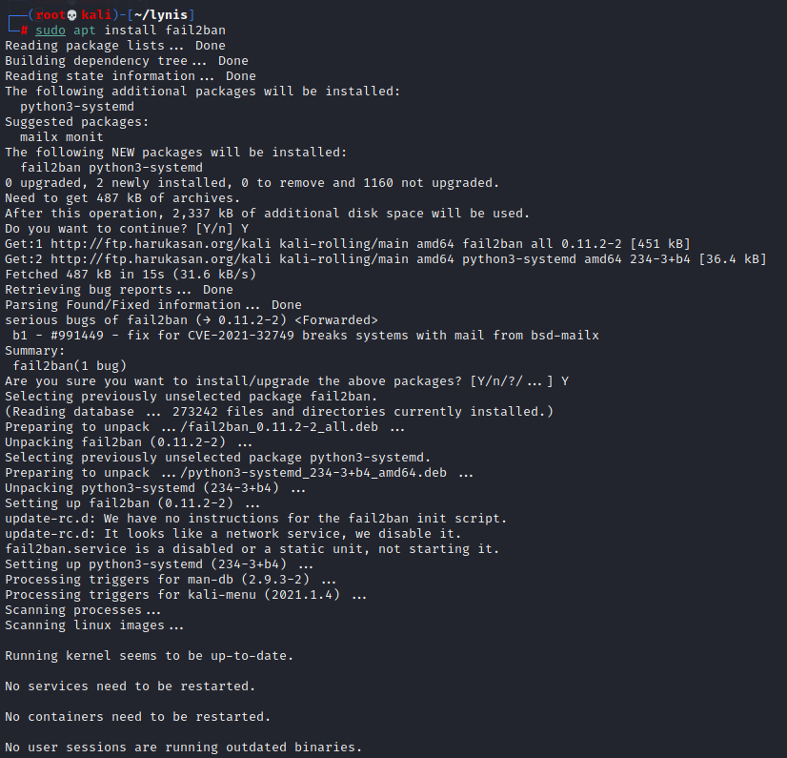 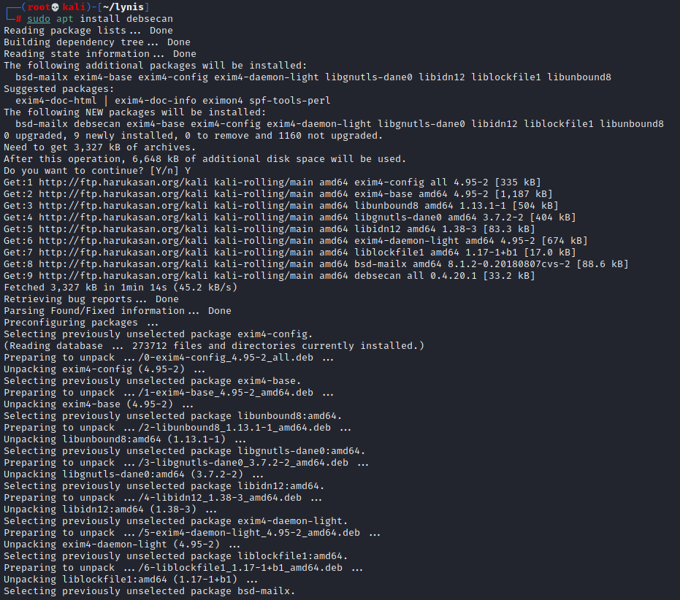 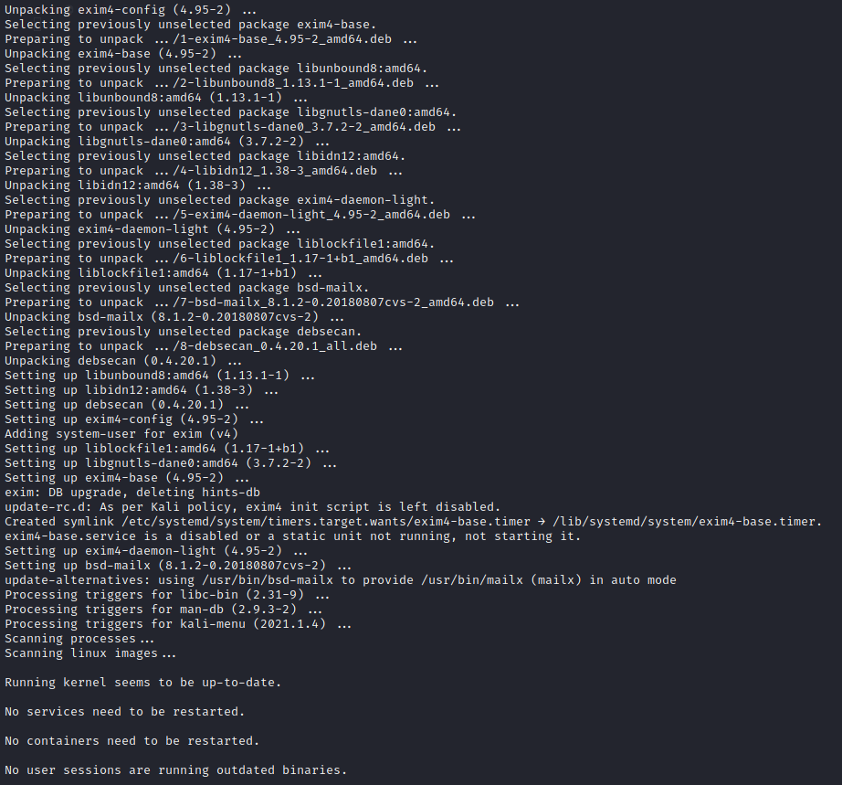 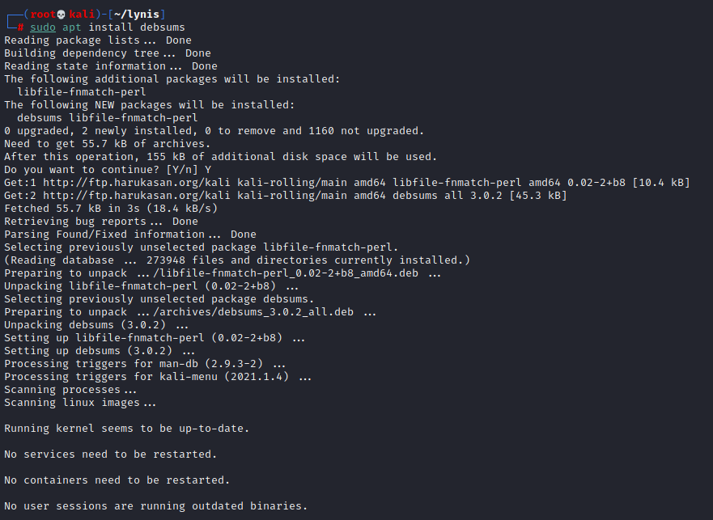

After installing all dependancies and installations,we will see this difference along with normal execution of all above executed commands:

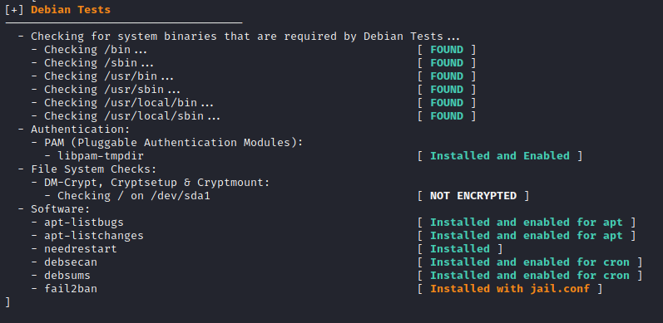

**Conclusion:All the experiments pertaining to Information Security Management has been successfully executed and recorded.**